An Imprecise Swiss Diagram
חד גיסא נגרא וחד גיסא נהרא
By: Eli Genauer
Note: I would like to thank Dr. Ezra Chwat and Marvin J. Heller for their ongoing assistance with my research
On the very top of Bava Batra 13a there is a 10 word section of Gemara which is the basis for the only diagram attributed to Rashi appearing in Bava Batra in the Vilna Shas. It reads as follows:
חד גיסא נגרא וחד גיסא נהרא פלגין לה בקרנא זול
If there is a channel on one side and a river on the other side, the field is to be divided diagonally.
Rashi explains
חד גיסא נגרא וחד גיסא נהרא
שדה של שני אחים שיש נהר על פני מזרח ונגר על פני צפונה
A field which is to be divided among two brothers which is bordered on the east by a river and on the north by a channel ….
פלגין לה בקרנא זול
לפי שהנהר טוב מן הנגר, והסמוך למים טוב מן הרחוק, ואם תחלקנה מן הצפון נמצא כל הנהר לאחד והשני אין לו אלא נגר בצפונו, ופעמים שהוא יבש. ואם תחלקנה מן המזרח למערב - יהיה לאחד הנהר על פני מזרחו ונגר על פני צפונו, ולשני אין לו אלא נהר במזרחו לפיכך יחלקום לשמונה חלקים, שיהא לשניהם בשוה סמוך לנהר ולנגר, וכאשר ירחק מזה ירחק מזה
Because a river is better than a channel, and the portion closer to water is better than one which is further….
Rashi continues by describing the problems that would arise if the property would be divided into two, which is that one brother would have better water access than the other. Therefore, the property needs to be divided into eight parts so that each brother has the same access to both sources of water.
The concept of dividing a field into eight parts is difficult to picture and it is hard to believe that Rashi would have written the words he did without including a diagram. It is clear to me that the word כזה and the diagram that appears are part of Rashi’s original composition.
The standard diagram we have in Rashi in the Vilna Shas ( Vilna 1883) looks like this
From Hebrewbooks.org
This diagram clearly illustrates the way the property is to be divided into eight parts between Reuven(ר )and Shimon(ש)
Thankfully this diagram has very good Yichus. We have a Rashi manuscript from the 14th century which depicts a diagram very similar to above. We have a similar diagram in the first printed edition of Bava Batra from the Soncino Peasaro printing in 1511. We also have a number of Torah scholars in the 16th century, Maharshal, Rav Yakov Kopleman and Maharam Lublin who use a similar diagram in clarifying Rashi’s words. By looking at these sources, we will see the history of the diagram through time and more importantly, perhaps understand a curious comment of Maharam Lublin.
The Rashi manuscript from the 14th century is known as Hamburg Cod Hebr.63 (used with permission of Staats und Universitätsbibliothek Hamburg). The main thing to consider is the division into eight parts which matches the diagram in the Vilna Shas. It also shows where the sources of water were located which matches Rashi’s words.( the north where the נגרא is located is on the left side as in the Vilna diagram above)
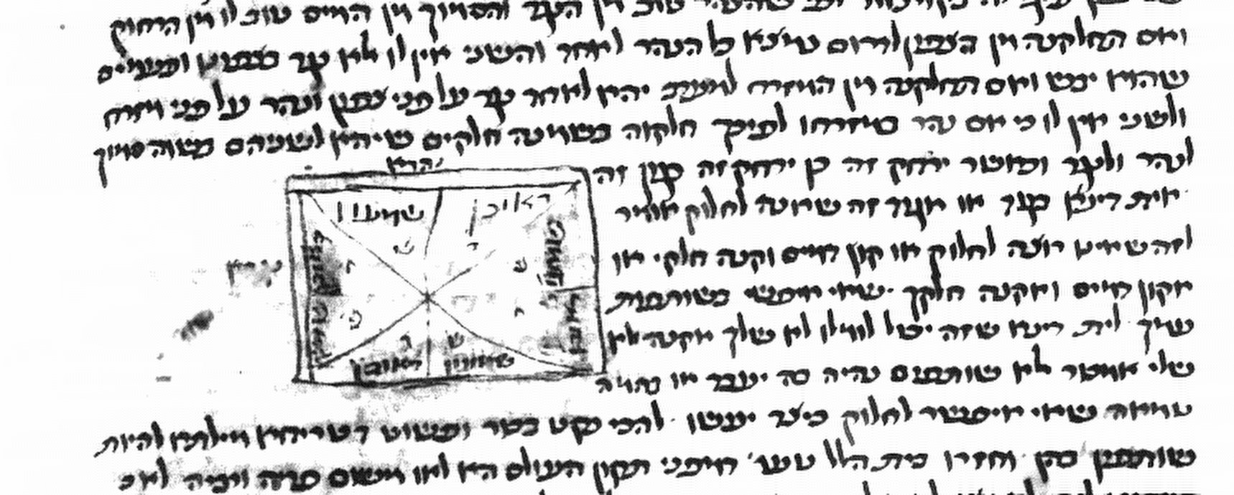

Our next source is the Soncino Pesaro 1511 Bava Batra where the diagram most likely came from a manuscript in possession of the printers. It is quite similar to the 14th century manuscript.
JNUL Digitized Books Website
Here is a closeup of the diagram

Next we visit Venice and see what this page looks like in the 1521 Bava Batra edition of the Bomberg Shas. As expected, there is no diagram as per Raphael Natan Nata Rabbinowicz, as was the case with all the Bomberg volumes aside from diagrams on Sotah 43A and Zevachim 53B. Sometimes the Bomberg press would leave a space where the diagram was supposed to be and such was the case here.
From JNUL Digitized Books Website

We travel now to Frankfurt an Der Oder to 1699 to look at the Berman Shas edition of Bava Batra. We would expect to see a diagram here because this was the first edition since 1520 to include diagrams (see note 5 above) It appears to me as if the typesetters did not leave enough room for a diagram and therefore it was left out.
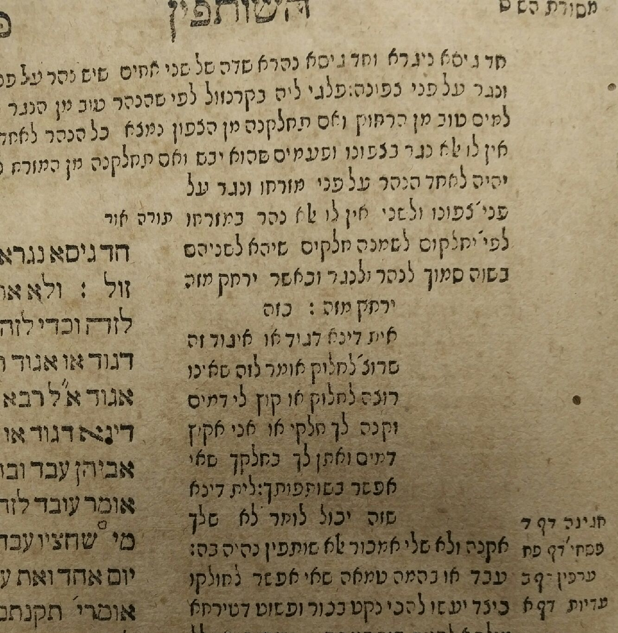
From private collection
We finally find the diagram in a printed version of the Talmud for the first time in 200 years in the Frankfurt am Main edition of Bava Batra of 1721. It looks quite familiar.
From Hebrewbooks.org

We will now look at the diagrams in books that were written to supplement and correct the new printed editions of the Talmud of the early to mid 1500’s and we will then deal with the problem arising from a statement of Maharam Lublin.

We first have Chochmat Shlomo of Maharshal ( Prague 1582 ) which was published by his sons after his death. He used the 2nd Bomberg edition ( circa 1528) as his base and made additions and corrections where he felt necessary. He also added many of the missing diagrams. As you can see, it is the same diagram that we have. Here he uses language which indicates he was looking at a manuscript with this diagram. "ואחר דבור זה מצוייר ציור זה"
Next is Omek Halcha ( Cracow 1592) written by Rav Yaakov Kopelman.(1555-1594). It’s a bit unsophisticated in terms of printing methods, but you can clearly see our diagram where it has the word "כזה" in the upper right hand corner of a diagram
From Hebrewbooks.org
We finally go to Meier Eini Chachamim ( Venice 1619) written by Maharam Lublin. Here we see the same diagram ( albeit with Darom and Tzafon reversed) but we also find a puzzling statement.
From Hebrewbooks.org
Maharam writes "בגמרא פלגינן בקרנזול.הציור המצוייר בספרים אין בו ממש והציור הנכון ל רש״י הוא זה"
“The picture that is illustrated in other books has no value, and the correct one of Peirush Rashi is this one.”

I was bothered by this because I couldn’t imagine what other Sefarim he was talking about. The Soncino Pesaro had the same diagram, and the Chochmat Shlomo and the Omek Halacha also had this diagram. I considered that he was referring to the directions of Tzafon and Darom which he reversed, but that goes against Rashi’s words which say that the Nagra was in the Tzafon. It is possible he was referring to another book with diagrams with which I am unfamiliar, but I thought that despite Rabbinowicz statement that diagrams did not appear in printed editions of the Talmud from 1520 to 1697,( see note 5) there might be an edition of Bava Batra printed before 1619 that did have a diagram on this Daf. It also had to be an incorrect diagram.

Fortunately, Rabbinowicz himself gives a possible clue to solving this problem. Considering the Basel edition of 1578-1581, he writes
וגם בדפוס זה נשמטו הציורים, מלבד במסכת בבא בתרא דף י"ב ס"ב ופ"ג
There is no diagram on דף י"ב, but we do find this one on 13a.
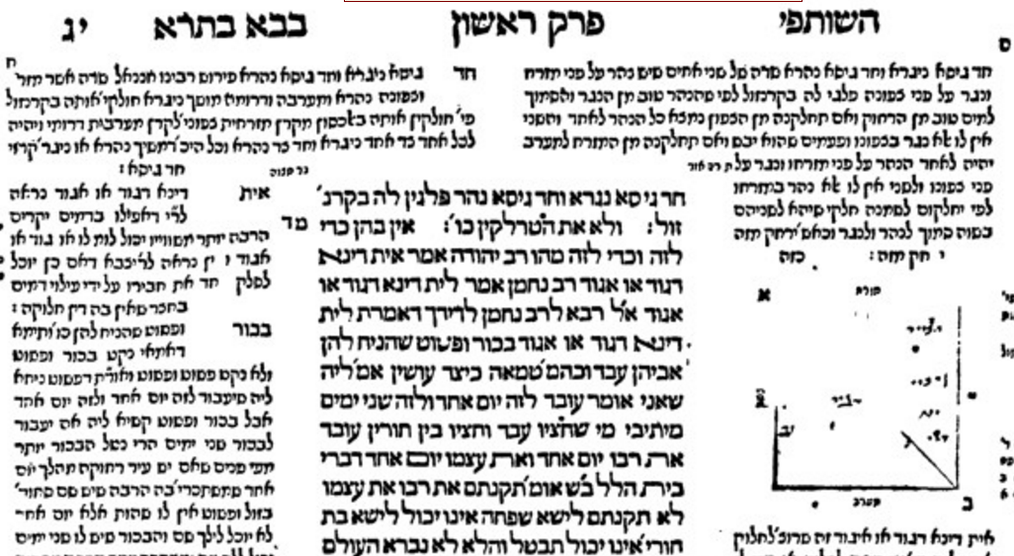
It looks as if the printer started to make a diagram but didn’t finish. Perhaps this was the incorrect diagram to which Maharam referred. We usually expect precision from the Swiss, but this time it seems they fell a bit short.

There are some diagrams later on in the Masechta but they are in the commentary of Rashbam
My translation follows the Soncino English edition of the Talmud
Whether Rashi himself included diagrams in his commentary to Talmud Bavli is not known because we have no autograph manuscripts of Rashi ( as opposed to Rambam where we have manuscripts written by Rambam). I believe very strongly that Rashi’s original commentary did include diagrams and use this as an example of a situation where it is difficult to believe that Rashi left us with just his words and no diagram. For a more complete discussion of this matter, please see my article in Hakirah volume 16 pp.188-189 http://www.hakirah.org/Vol%2016%20Genauer.pdf
About Chochmat Shlomo( Prague 1582) by Maharshal, Encyclopedia L’Toldot Gedolei Yisroel ( Tel Aviv Yehoshua Checkik publishing, 1950 p.1298) writes “with great precision Maharshal compared the compared the text of the Bomberg edition of the Talmud with manuscripts of Gemara Rashi and Tosafot that he had” One major shortcoming of the Bomberg Shas was its lack of illustrations and in many cases, Maharshal added them. ( see note 5 below) Rav Yakov Kopelman wrote Omek Halacha on difficult Sugyot in the Mishneh and Talmud( Cracow 1592) which included many diagrams. Maharam Lublin wrote Meier Eini Chachamim ( Venice 1619) on the Talmud which also included diagrams. The fact that these three were all scholars and lived at a time when there were still many manuscripts extant makes them reputable sources for diagrams. This is in contrast to the very late 1600’s and early 1700’s (when diagrams became common in the printed text after an absence of almost 200 years,) when very few manuscripts were around.
Raphael Natan Nata Rabbinowicz Maamar 'al hadpasat ha-Talmud with Additions, ed. A.M. Habermann, Mossad ha-Rav Kook, Jerusalem: 1952 p.41 ״ובכל התלמוד (וכן בכל הדפוסים הישנים עד דפוס בערמן) נשמטו הציורים בגמרא, רש״י ותוספות,ונשאר מקומם חלק, מלבד בסוטה מג. שישנו הציור ברש״י דפוס בערמן refers to the Frankfurt an der Oder edition of 1697-1699 underwritten by Issachar Berman. Rabbinowicz does not mention the diagram on Zevachim 53b in the 2nd and 3rd Bomberg editions. Rabbinowicz also states that by the time diagrams were included in printed editions of the Talmud, there were very few manuscripts extant. ( Maamar,p.8 end of note 1)
In the Oz Ve’hadar edition of the Talmud, the directions are corrected in the Maharam’s diagram
Rabbinowicz, p.76. The reference to a diagram on ס"ב, refers to six diagrams on 62a and two on 62b. The other one is on 83b. After 83b, I observed empty spaces left with no diagrams on 99a,101a,101b,102a,103b. This is consistent with the Bomberg editions.
As to the source of the diagrams in the Basel edition of Bava Batra, Rabbinowicz ( p.78) writes that the editors had a manuscript of Rashi on Pesachim, so it is possible they had manuscripts of commentaries on other tractates.

