פליגי בה בקרנזל
Bava Metziah 108B
How Do You Sell One Field to Four Neighbors?
Eli Genauer
The Gemara discusses the situation where a person wants to sell his field…to whom should he offer it first? Normally, the person owning a neighboring field has priority (בר מצרא), but what if his field is bordered on each side by a field owned by a different owner?
At the very bottom of the page, the Gemara concludes ״פליגי בה בקרנזל״ - each neighbor gets to buy that portion of the field which is closest to him and that it is divided diagonally.
Rashi explains:
פליגי בה בקרנזל: בארבע אלכסונות שיהא כל אחד נוטל בה על פּני כולה סמוך לו, כזה
“Diagonally four ways, so that everyone gets the entire portion of the field closest to him…like this”
We do not have an autograph copy of this Rashi to know for certain whether Rashi included a diagram in his commentary, but we do have a manuscript written within a century of his death. It looks like this:
The British Library England London Or. 73
[א]תק"א לשטרות (1190)
https://web.nli.org.il/sites/NLIS/en/ManuScript/Pages/Item.aspx?ItemID=PNX_MANUSCRIPTS990001210440205171&SearchTxt=%D7%AA%D7%9C%D7%9E%D7%95%D7%93%20%D7%91%D7%91%D7%9C%D7%99%20%D7%91%D7%91%D7%90%20%D7%9E%D7%A6%D7%99%D7%A2%D7%90%20Or.%2073
The diagram shows that Reuven ,Shimon, Levi and Yehuda owned fields adjacent to the field being offered for sale and that each one can buy the diagonal pie slice closest to him.
Another Rashi manuscript depicts it in a similar manner
Vatican ebr.131.. 81v- 14th Century Courtesy of Polonsky Digitization Project
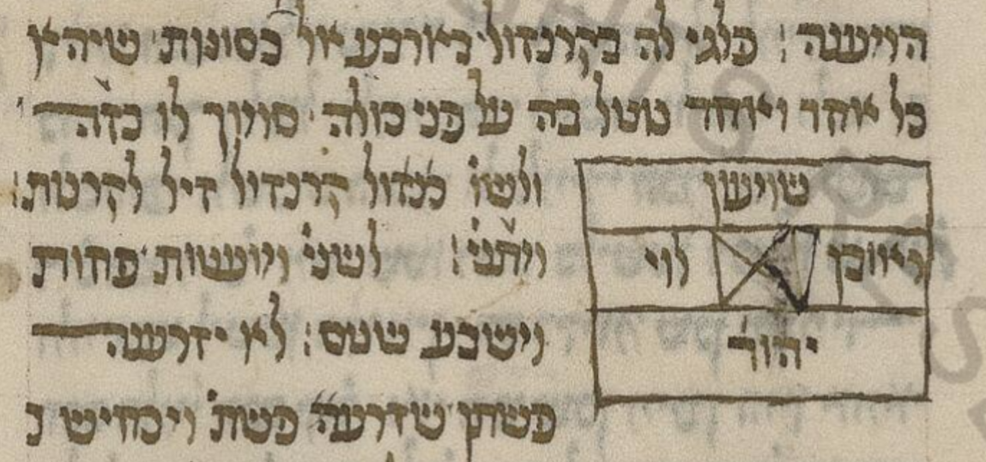

This last manuscript depicts it in a slightly different manner. It eliminates the depiction of the fields surrounding the field for sale but keeps the names of the owners of the fields surrounding it.
The British Library Add 27916

The diagram looks similar in modern editions of the Talmud, however the names of the owners of the adjacent fields have been eliminated, and only the diagonal division of the property offered for sale is maintained.
This is how it appears in the classic Vilna Shas (1883).
We don’t know if including the area around the middle field was important to Rashi, (as in the first two manuscripts) or whether he felt it was important to show how the four different owners were positioned around the field. But it certainly seemed to be part of the copyist’s work.
The pagination and Tzurat HaDaf of the Vilna Shas come from the first complete edition of the printed Talmud, that of the Bomberg Shas of 1520-1523. However, that edition did not contain the diagrams that were extant on manuscripts, rather it left blank spaces on the page where the diagram was supposed to be. (1)
Here is how the bottom of our Daf looked in the Bomberg Talmud
It is clear that the Bomberg editors were working from a manuscript that had the word “Kazeh”, and they even separated the word “Kazeh” from the text of the Rashi to indicate the presence of a diagram. The three manuscripts shown above prove that such manuscripts did exist.
The Frankfurt an der Oder edition of 1698 (The Berman Shas) was the first edition after Bomberg to contain diagrams on some sections of the Talmud, but this diagram is not included in Bava Metziah 108b.

We finally find the diagram in the Frankfurt am Main edition of 1720, present again in the printed text of the Talmud after an absence of 200 years. It is positioned properly right after “Kazeh”, but leaves out the neighboring fields and the names of those who owned them. Whether this was important to Rashi we will never know, but we can assume that if Rashi’s handwritten commentary included this, it was there for a reason.
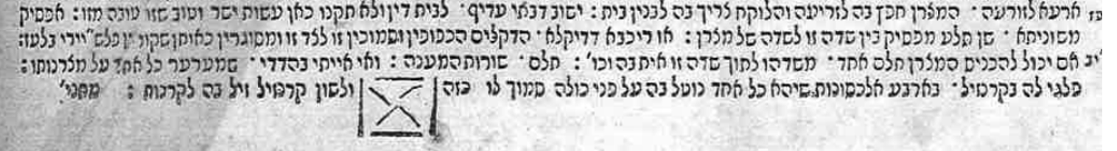
What was the source of this “X” shaped diagram in the Frankfurt Shas? The introduction to the Nehardea edition of the Shas (Vagshal, Jerusalem, 2008) states that at the time that diagrams were included in the printed editions, 200 years had passed since printed editions became the norm for study. It then states that because of that, most likely the editors in the early part of the 18th century did not have manuscripts on which to base the diagrams. Concerning the 1720 Frankfurt am Main edition, the introduction to the Nehardea edition then states
מעיד הרב המדפיס כי לקח הציורים מתוך ספרי המהרש״ל
By that he meant, from the Sefer Chochmat Shlomo printed in Cracow in 1582. Maharshal restored many of the diagrams missing from the Bomberg Shas.
However, there is no diagram included in the Chochmat Shlomo, eliminating that as a possible source.
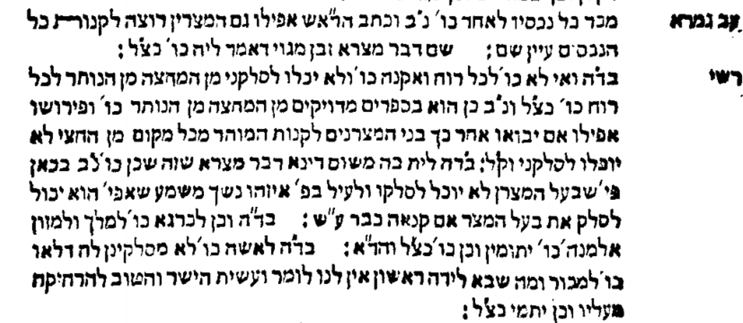

The editor of the Frankfurt am Main 1720, in his introduction to Masechet Brachot, also states that the diagrams he included sometimes were "לפי הבנת הפשט ".
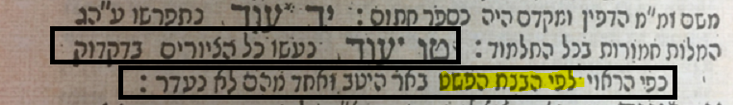
On the Shaar Blatt of this edition, the editor states that he also was “Magiah” the text from a book called “Chochmat Manoach”. (Prague 1612)
Like Chochmat Shlomo, it often supplied diagrams which were missing from the Bomberg Shas. One can clearly see that the Frankfurt Gemara contains the same “X” shape as the Chochmat Manoach.
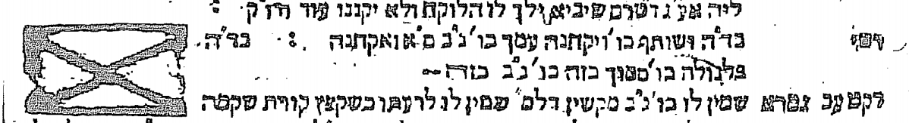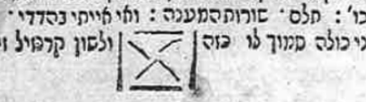
Chochmat Manoach Prague 1712 vs Bava Metziah Frankfurt 1720
- Maamar 'al hadpasat ha-Talmud with Additions, ed. A.M. Habermann, Mossad ha-Rav Kook, Jerusalem: 2006, p.41

