. דקיימא) חנות ( בקרן זוית “
Bava Kamma 21a
By: Eli Genauer
Mishna on 19b
מתני׳: כיצד השן מועדת לאכול את הראוי לה הבהמה מועדת לאכול פירות וירקות אכלה כסות או כלים משלם חצי נזק במה דברים אמורים ברשות הניזק אבל ברשות הרבים פטור ואם נהנית משלמת מה שנהנית כיצד משלמת מה שנהנית אכלה מתוך הרחבה משלמת מה שנהנית מצדי הרחבה משלמת מה שהזיקה מפתח החנות משלמת מה שנהנית מתוך החנות משלמת מה שהזיקה
.Gemara 21a
כיצד משלמת מה שנהנית וכו: אמר רב ובמחזרת (turns its head), ושמואל אמר אפילו מחזרת נמי פטור; ולשמואל היכי משכחת לה דמחייב? כגון דשבקתה לרחבה ואזלה וקמה בצידי רחבה; ואיכא דמתני להא שמעתא באפי נפשה, מחזרת רב אמר חייבת ושמואל אמר פטורה, ולשמואל משלמת מה שהזיקה היכי משכחת לה דמחייבא? כגון דשבקה לרחבה ואזלה וקמה בצידי רחבה.
מתיב רב נחמן בר יצחק, מפתח החנות משלמת מה שנהנית, היכי משכחת לה? פשיטא במחזרת וקאמר)מר(מה שנהנית, מה שנהנית אין מה שהזיקה לא? הוא מותיב לה והוא מפרק לה, דקיימא בקרן זוית
Rav Naḥman bar Yitzḥak raises an objection: The Mishna says that if the animal ate produce from the entrance of the store, its owner pays for the הנאה that the animal derived. What are the circumstances? It is obvious that this case concerns an animal which turns its head, and Mar says that the owner of the animal pays for the הנאה which the animal derived. For the הנאה that the animal derived, but not for that which it damaged!? He asked the question, and he answered it by explaining that the case in the Mishna is one where it (the store) is located on a corner
Rashi explains what the expression “it is located on a corner” means
דקיימא - חנות בקרן זוית כגון מבוי קטן הכלה במבוי גדול וקיימא חנות בראש מבוי קטן ומשוך קצת כלפי פנים, וכשנכנסה בהמה ממבוי גדול לקטן פגעה בפירות מיד דרך הלוכה דלאו מחזרת היא:
Rashi first adds the word חנות to the Gemara’s statement of דקיימא בקרן זוית and then explains that it is where there is a small alleyway which ends when it reaches a larger one. There is a store which starts out at the “ראש” of the small alley in the corner and extends further into the smaller מבוי. The store is on a corner where the large מבוי narrows, such that if the animal would walk from the מבוי גדול to the מבוי קטן , it could walk straight and still encounter the store on the side of the narrower part without turning its head.
Here is a good illustration of this case 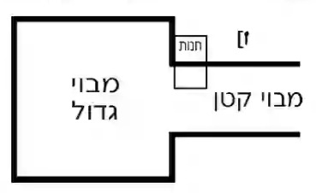
There is a diagram included in this Rashi in the Vilna Shas of 1882
This diagram shows the small alley leading into the large one, but no illustration of the store from which the animal eats. This seems to be the main point of the Gemara and of Rashi
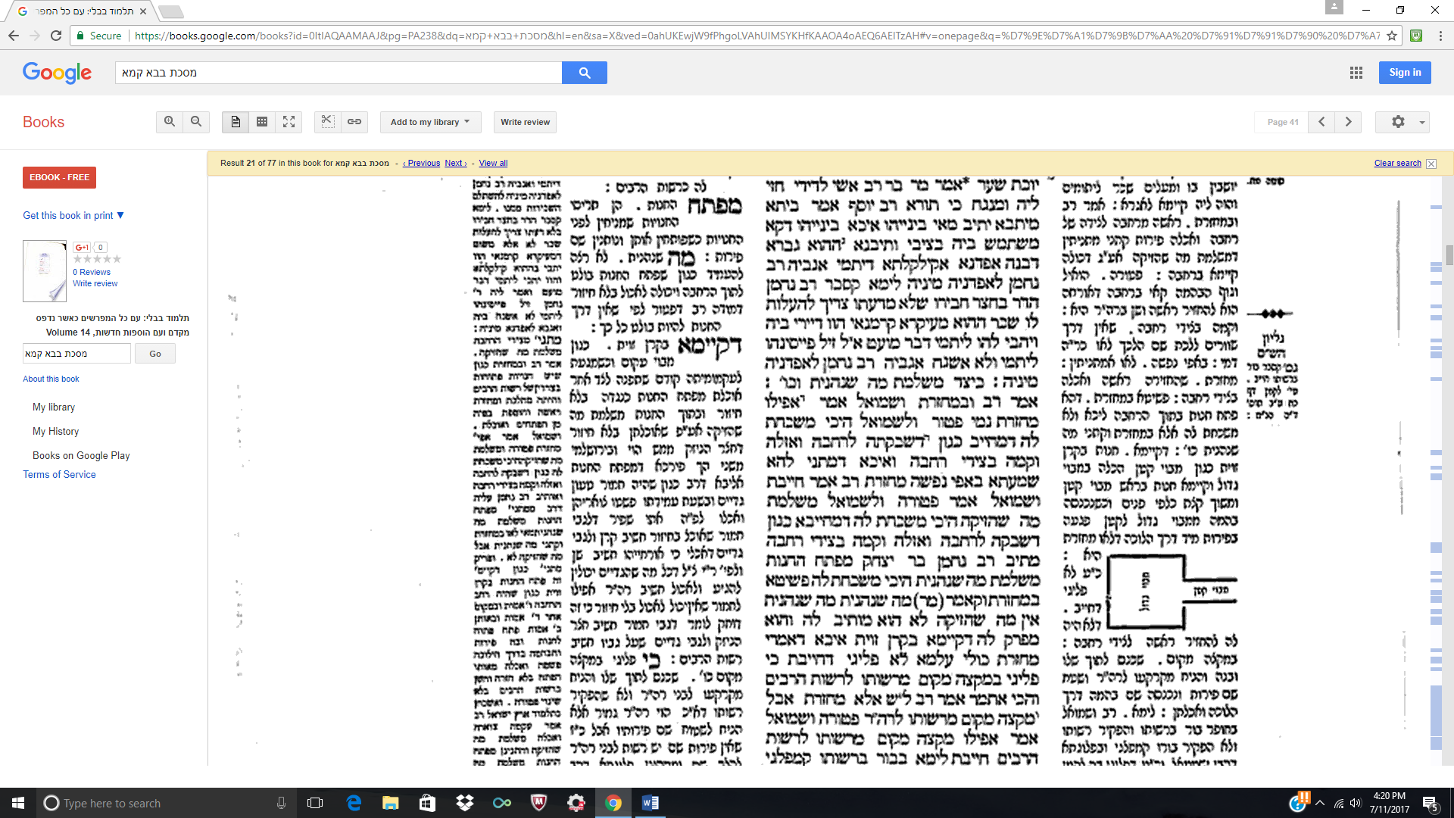
Let us trace the history of this diagram in Rashi. Firstly, we notice the Vilna Shas has a diagram but there is no word “כזה”
Here is the Soncino edition (1489) There is no diagram, but it does say “כזה“ at the end of the third line indicating that the manuscript they used had a diagram. [The text of Rashi has the word בתווך (in the middle) after דקיימא חנות]
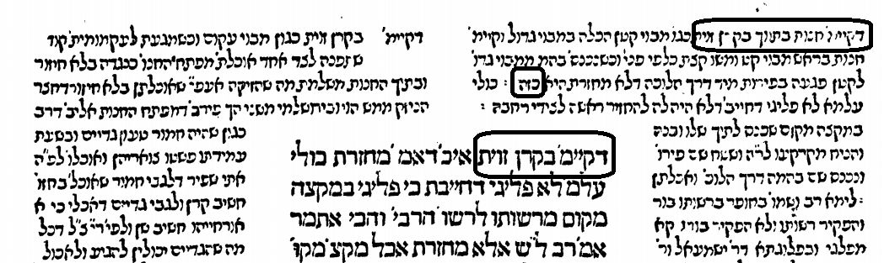

Here is the Bomberg Venice 1521 edition, which drops the word "כזה" and also leaves no space for a diagram. This edition also has בתווך.
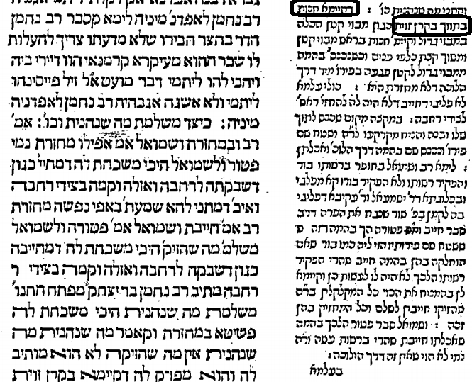
No edition from Bomberg 1521 onwards to Frankfurt am Main of 1722 contains a diagram, a space for a diagram or the word "כזה". The Frankfurt am Main includes this diagram without the word "כזה". This edition was known for including diagrams in many places for the first time since the Bomberg Shas. We notice that the diagram does not include the very important “חנות”.
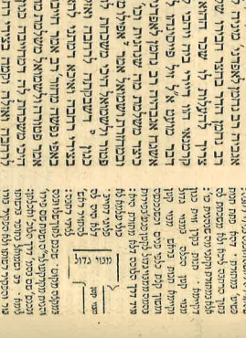
The editors of this edition did not have access to manuscripts of Rashi, so from where did they get the idea to include this illustration? One of the sources they used for the inclusion of diagrams was the חכמת שלמה printed in Cracow in 1582. Most likely it came from here. Here is what that looked like and as you can see, it included the all-important location of the חנות
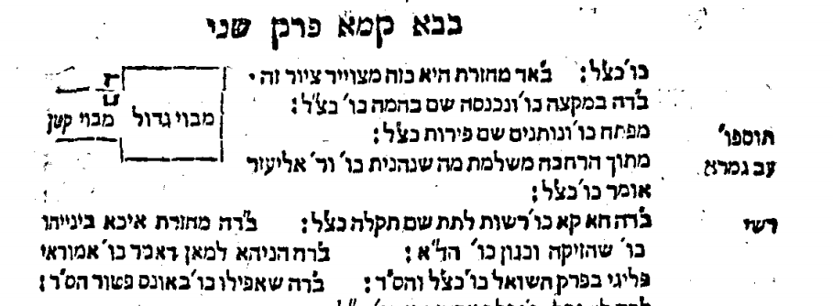
It looked fairly similar in the Amsterdam 1691 edition of Chochmat Shlomo. I circled the חנות.
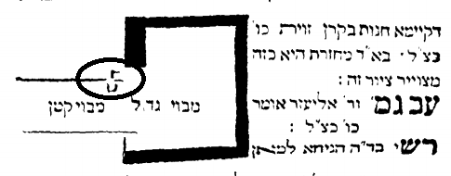
The Oz VeHadar Murchav (2017) in its presentation of חכמת שלמה makes it even more clear
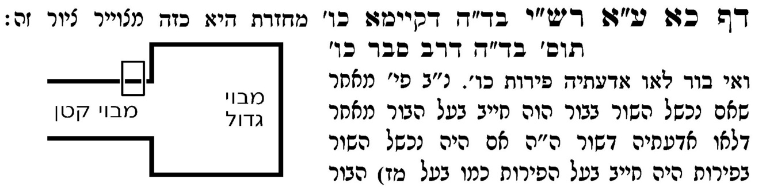
The Vilna Shas on Bava Kamma for some reason leaves out the חנות in its depiction of the illustration in the חכמת שלמה 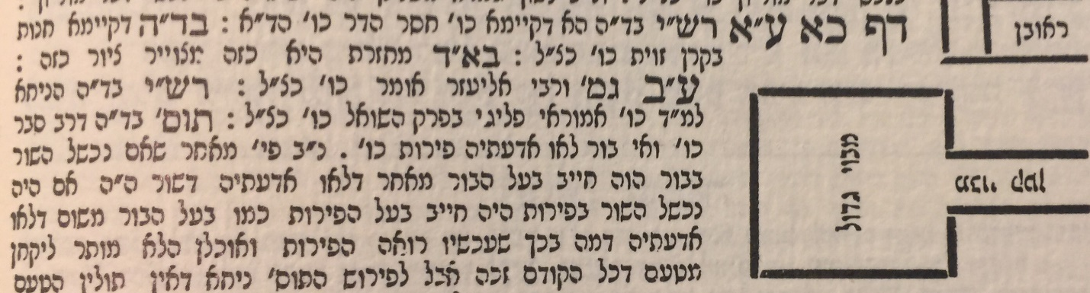

From Frankfurt am Main1722 to the Vilna Shas, the diagram did not change much.
Amsterdam 1722 Vilna Shas
We do not know why the Frankfurt edition left out the חנות, but because it did, subsequent editions were also missing this important part.
Of the newer editions, both Vilna HaChadash and Vagshal Neharda have the exact same diagram as the Vilna Shas. The only new edition to include a picture of the חנות is Oz Vehadar (referenced above). It also includes a diagram of what it calls Ktav Yad Romi on the side noting that it seems to be the Shita of Tosfot. The key addition though is sidenote "ז" where it notes that the diagram they used inside the Rashi is attributed to the Maharshal, Dfus Rishon ( first edition, Cracow 1582) This is most likely because this diagram as depicted in the חכמת שלמה in the Vilna Shas does not have the חנות
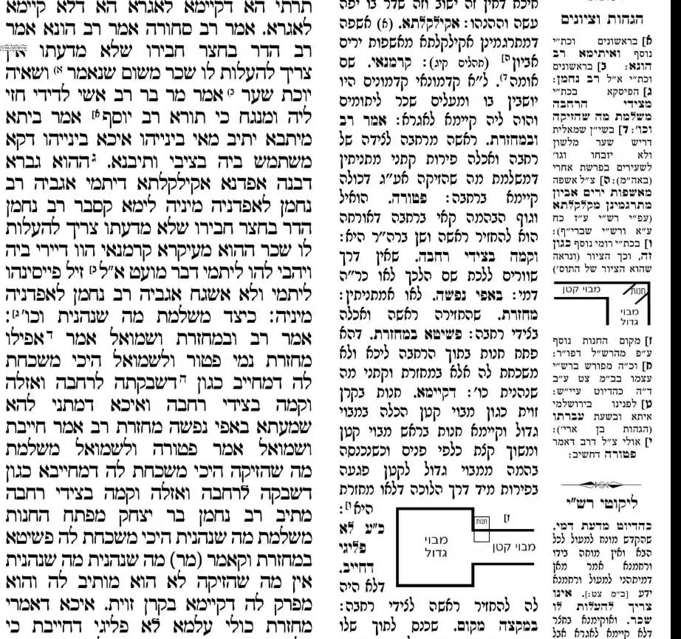
The Artscroll Daf Yomi edition (2010), in an effort to improve upon the diagram in the Vilna Shas, changed the diagram in the text of the Rashi, but unfortunately placed the חנות in the מבוי גדול instead of the מבוי קטן. Their “Notes” section depicts it correctly.
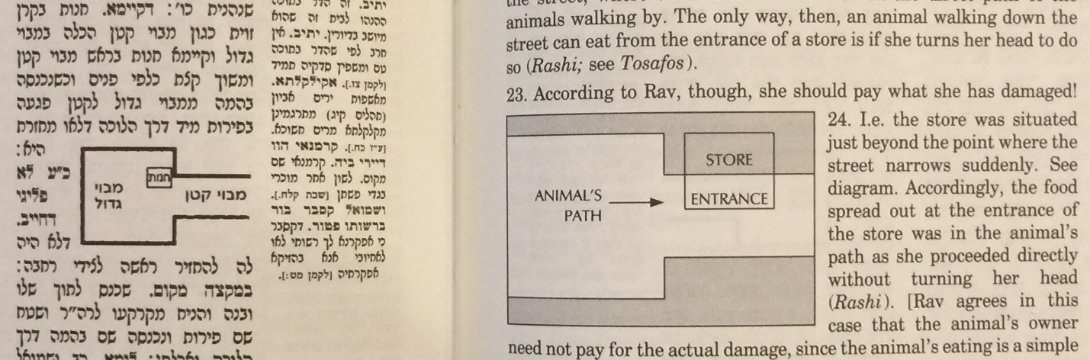

As noted, Oz Vehadar references a Ktav Yad Romi which includes the words “כגון זה” and includes a picture. Oz Vehadar states that it seems that the picture is aligned with the view of Tosfot.
Here is Tosfot who say that the case involves a “מבוי עקום”, which is an alleyway which is bent (“L”shaped)
דקיימא בקרן זוית - כגון מבוי עקום וכשמגעת לעקמומיתה קודם שתפנה לצד אחר אוכלת מפתח החנות כנגדה בלא חיזור ובתוך החנות משלמת מה שהזיקה אע"ף שאוכלתן בלא חיזור דחצר הניזק ממש הוי
Here is the Ktav Yad cited by Oz Vehadar. It is known as Vatican 132
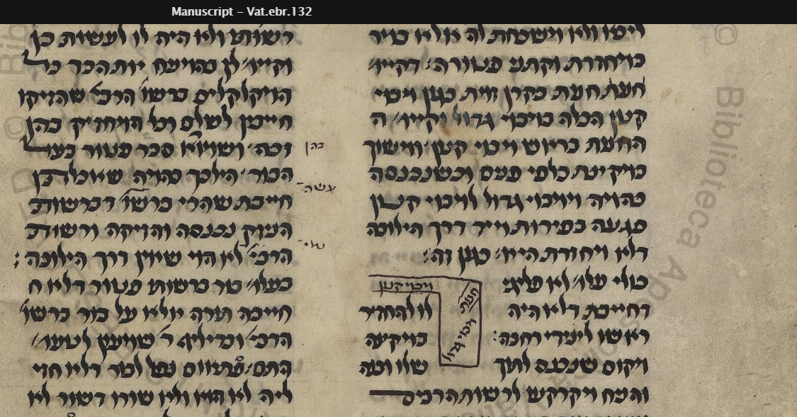
As you can see it says כגון זה and the illustration is the same as in the Hagahot V’Tziyunim section dealing with our Rashi
Here are some other manuscripts which show a similar illustration.
The British Library London England - Add. 27196
This manuscript and all the others that have a diagram show the חנות in the corner but they seem to show the underlying case to be one involving a מבוי עקום (“L” shaped alleyway) which is Tosfot Shita
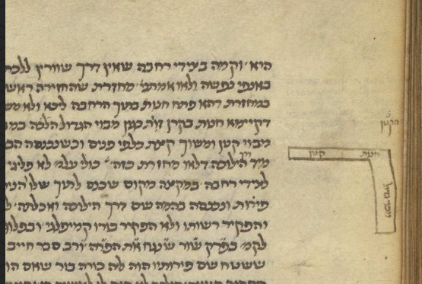

The British Library London England Harley 5585
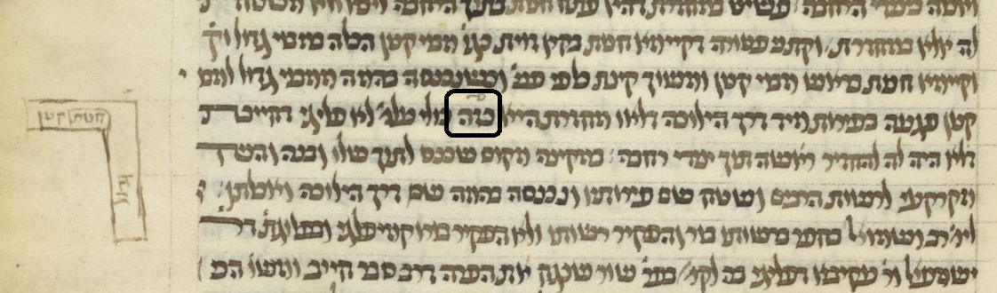
Cambridge 478 –
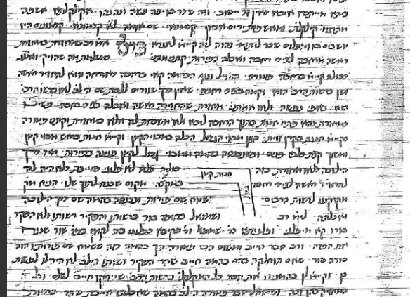
Vatican ebr. 157 – also has the חנות at the corner

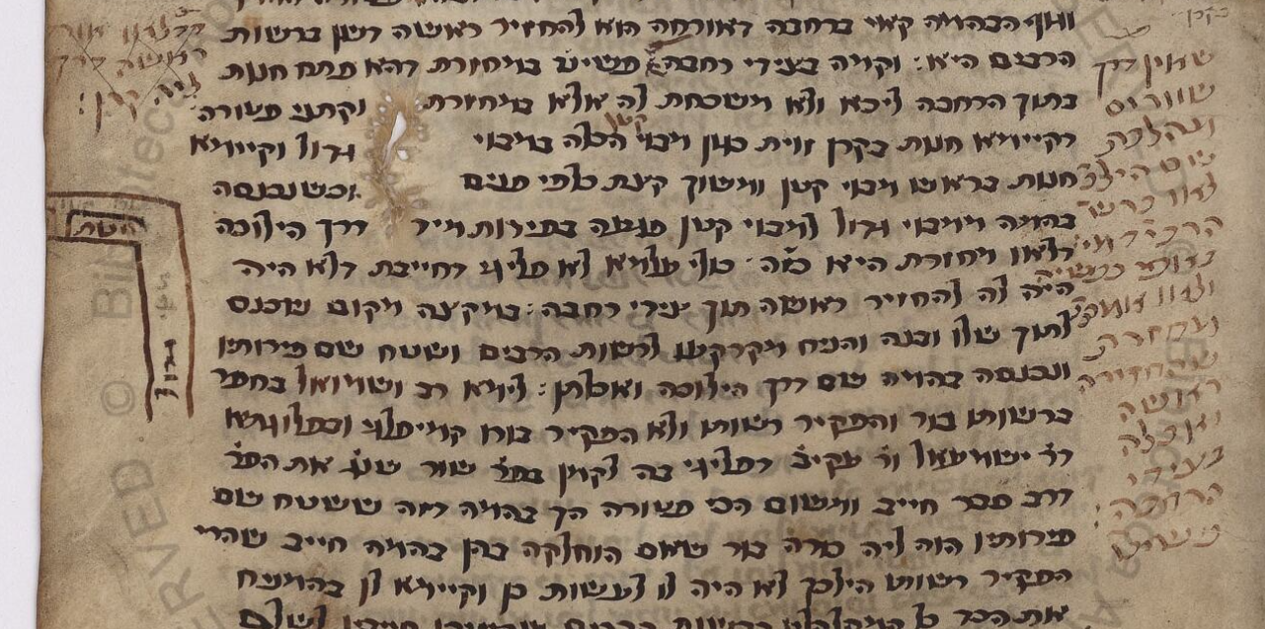
In Summary:
We have the diagram in the Vilna Shas which is missing the חנות, even though it is included in the illustration of Maharshal. The Vilna Shas also misrepresents the diagram in the Chochmat Shlomo section in the back. The absence of the חנות from the Frankfurt 1722 edition carried forward and affected subsequent editions. We have diagrams in the manuscripts that don’t really show what Rashi is describing, which is a larger מבוי coming to an end and continuing on as a small מבוי. As a matter of fact, the diagrams in the Rashi manuscripts seem to be illustrating Tosfot Shita of a מבוי עקום.

There is no Chochmat Manoach, or Omek Halacha, two other sources of diagrams, on Bava Kamma . Maharam Lublin also does not include a diagram for 21a.

