Beitzah 11A – Rashi- בְּקֶרֶן זָוִית
Eli Genauer
The Mishna in Maseches Beitzah on 10b discusses a case where before Yom Tov, certain birds are designated to be slaughtered on Yom Tov. However, there is a Safaik on Yom Tov whether the birds that appear in front of the nest are those from the nest which were designated, or whether they flew in from somewhere else. The Mishna states:
בְּתוֹךְ הַקֵּן וּמָצָא לִפְנֵי הַקֵּן — אֲסוּרִין, וְאִם אֵין שָׁם אֶלָּא הֵם — הֲרֵי אֵלּוּ מוּתָּרִים.
If one designated them inside the nest and the next day he cannot find them there, and he found fledglings before the nest, they are prohibited, as they might be fledglings other than the ones he designated and left inside the nest. But if there are only those fledglings in the immediate vicinity, they are permitted, as it can be assumed that these are the ones he designated inside the nest.
The Gemara on 11a analyzes the statement of the Mishna that if he only found the birds in the immediate vicinity, they are permitted.
וְאִם אֵין שָׁם אֶלָּא הֵן — הֲרֵי אֵלּוּ מוּתָּרִין. הֵיכִי דָמֵי? אִילֵּימָא בִּמְפוֹרָחִין, אִיכָּא לְמֵימַר: הָנָךְ אֲזַלוּ לְעָלְמָא, וְהָנֵי אַחֲרִינֵי נִינְהוּ. אֶלָּא בְּמִדַּדִּין. אִי דְּאִיכָּא קֵן בְּתוֹךְ חֲמִשִּׁים אַמָּה — אִדַּדּוֹיֵי אִדַּדּוֹ, וְאִי דְּלֵיכָּא קֵן בְּתוֹךְ חֲמִשִּׁים אַמָּה — פְּשִׁיטָא דְּמוּתָּרִין, דְּאָמַר מָר עוּקְבָא בַּר חָמָא: כׇּל הַמְדַדֶּה — אֵין מְדַדֶּה יוֹתֵר מֵחֲמִשִּׁים אַמָּה
The mishna states that if there are no others there apart from them, they are permitted. The Gemara asks: What are the circumstances? If we say that the mishna is dealing with fledglings that are already able to fly, it is possible to say that those that he designated went to the outside world, and the ones that are present are other ones. Rather, the mishna must be referring to fledglings that can only hop from one place to another. However, if it deals with a case where there is another dove nest within fifty cubits, the fledglings might have jumped and come from that nest; and if there is no nest within fifty cubits, it is obvious that they are permitted, for from where could they have come? As Mar Ukva bar Ḥama said: With regard to any creature that hops, it does not hop more than fifty cubits.
The Gemara then concludes that the case of the Mishna is where one nest is around the corner from the other one.
לְעוֹלָם דְּאִיכָּא קֵן בְּתוֹךְ חֲמִשִּׁים אַמָּה, וּכְגוֹן דְּקָיְימָא בְּקֶרֶן זָוִית. מַהוּ דְּתֵימָא: אִדַּדּוֹיֵי אִדַּדּוֹ, קָא מַשְׁמַע לַן כׇּל הֵיכָא דְּמִדַּדֵּה וַהֲדַר חָזֵי לְקִנֵּיהּ — מִדַּדֵּה, וְאִי לָא — לָא מִדַּדֵּה.
The Gemara answers: Actually, it is referring to a case where there is another nest within fifty cubits, and it deals with a situation where the additional nest is situated around a corner from the first nest, rather than in a straight line from it. Lest you say: The fledglings jumped from one nest to the other, the mishna therefore teaches us that anywhere that a fledgling hops and turns and sees its nest, it will continue to hop. But if it can no longer see its original nest, it will not hop any farther.

Rashi explains what בְּקֶרֶן זָוִית means
בקרן זוית - שזוית הבית בולט להלאה מן השובך וקן זה שזמן בו עומד לצדדין דאי הוה אתי להכא לא הוה חזי לקניה שהזוית של בית עומדת לפניו:
The corner of the house protrudes forward from the nest, and the bird which he designated is standing by the side (meaning in the portion before the corner) , because where it is now standing, it cannot see the other nest, because the corner of the house blocks its view.
The Vilna Shas includes the following diagram in Rashi. It does a good job of showing two nests separated by the corner of a house. (קרן זוית) However, we do not find the word “כזה “ in Rashi leading us to question whether there was such a picture in the “original Rashi”.

It turns out that we have three “עידי נוסח “which testify to the antiquity of the diagram.
Here is Bavarian State Library, Munich, Germany Cod. hebr. 216 - 13th century
https://www.nli.org.il/en/discover/manuscripts/hebrew-manuscripts/itempage?docId=PNX_MANUSCRIPTS990001278630205171&vid=MANUSCRIPTS&scope=PNX_MANUSCRIPTS&SearchTxt=%D7%A8%D7%A9%D7%B4%D7%99%20%D7%91%D7%99%D7%A6%D7%94
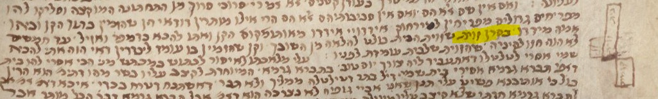
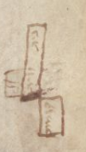
The area in the middle is the house with a corner which has nests on either side of it.
The next עד נוסח is JTS Ms. 6654 – 14th-15th century. It is not a very good representation of the words of Rashi but it does indicate that there was a diagram present.
https://www.nli.org.il/en/discover/manuscripts/hebrew-manuscripts/itempage?docId=PNX_MANUSCRIPTS990001128750205171&vid=MANUSCRIPTS&scope=PNX_MANUSCRIPTS&SearchTxt=%D7%A8%D7%A9%D7%B4%D7%99%20%D7%91%D7%99%D7%A6%D7%94
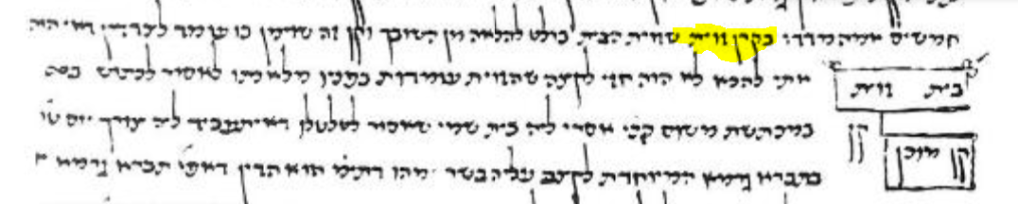

Finally, we have the first printed edition of Beitzah, that of Soncino 1484. It has a rudimentary diagram showing the different elements of the situation but does not show a nest on either side of the corner. Since this was the first printed edition, the source must have been a manuscript which had a diagram.
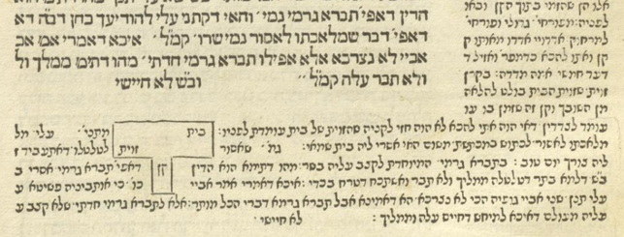
In all subsequent printed editions from 1521 to 1717, an empty space for the diagram was left. Here are some examples:
Bomberg Venice 1521
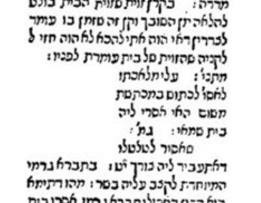
Cracow 1603
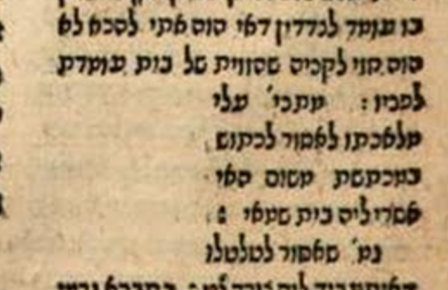
Frankfurt an der Oder 1697
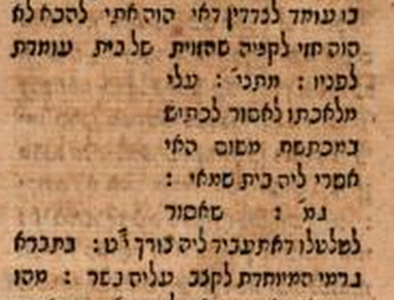
As mentioned, the first time a diagram appeared since Soncino 1484, is more than 200 years later in an edition printed in Amsterdam in 1717
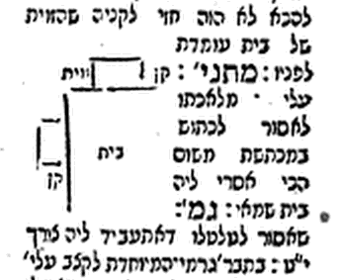
Since it is unlikely that the publishers of this Amsterdam edition had a Rashi manuscript or the Soncino 1484 edition, from where did they derive their diagram?
It most likely came from the Chochmas Shlomo, written by Rav Shlomo Luria (Cracow 1582). Maharshal made notes in his Gemara which corrected or added to the 2nd Bomberg edition of 1528 and often he would include pictures which were missing. As you can see, the diagram in Amsterdam 1717 is almost exactly the same as the one in Chochmas Shlomo

Amsterdam 1717 Chochmas Shlomo ( Maharshal)
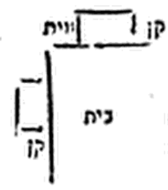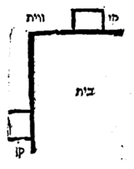
The diagram in the Vilna Shas is also quite similar, although I would argue that the one in the Chochmas Shlomo is more precise

Vilna. The nest on the bottom left is a bit confusing Chochmas Shlomo
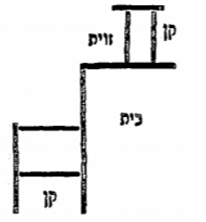
The diagram in the Shas Neharda, 2008 is even more clear, thus completing the journey of this diagram which began with the pen of Rashi.

It should be noted that there are other manuscripts which do not contain this diagram. Among those are Parma 2244, Parma 2903, JTS 6653, and Frankfurt Ub Oct.158

