ברכות ס״א: "הנפנה ביהודה"
טעות סופרים במפה של מהרש״א
Eli Genauer
תנו רבנן, הנפנה ביהודה לא יפנה מזרח ומערב אלא צפון ודרום, ובגליל לא יפנה אלא מזרח ומערב. ורבי יוסי מתיר, שהיה רבי יוסי אומר לא אסרו אלא ברואה ובמקום שאין שם גדר ובזמן שהשכינה שורה. וחכמים אוסרים
רש״י-"הנפנה ביהודה "
הנפנה ביהודה לא יפנה מזרח ומערב - אחוריו למזרח ופניו למערב ולא אחוריו למערב ופניו למזרח מפני שירושלים בארץ יהודה היא בצפונה של ארץ יהודה בגבול שבין יהודה לבנימין ויש מארץ יהודה הימנה [למזרח] עד סוף ארץ ישראל והימנה למערב עד סוף ארץ ישראל שארץ יהודה על פני כל אורך ארץ ישראל היא מן המזרח למערב כרצועה ארוכה וקצרה ואם יפנה מזרח ומערב יהיה פרועו לצד ירושלים או פרועו שלפניו או פרועו שלאחריו אבל צפון ודרום יפנה ובלבד שלא יפנה כנגד ירושלים ממש בדרומה של ארץ יהודה
Focusing in on the description of where Yerushalayim is located, it says “Because Yerushalyim is in Eretz Yehuda in the north of Eretz Yehuda, on the border between Yehuda and Binyamin, and there is a part of Yehudah which extends to the east until the edge of Eretz Yisroel, and extends westward until the edge of Eretz Yisroel, because Eretz Yehuda extends the entire length of Eretz Yisroel from east to west as a long and short strap.”
Maharsha – "הציור כזה" - Maharsha draws a map to illustrate the words of Rashi
Vilna Shas -
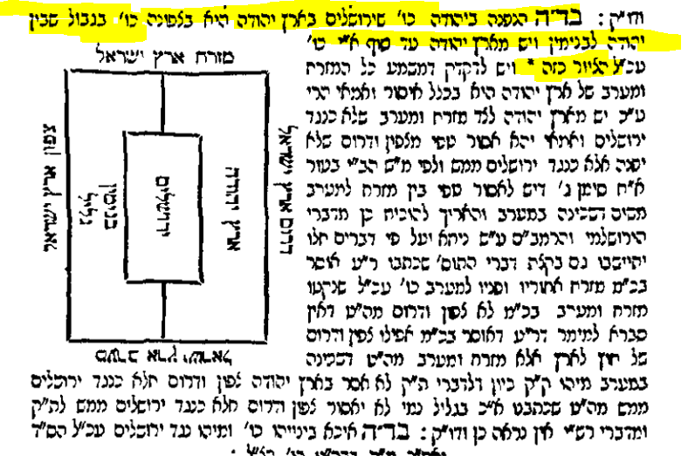
The first thing to consider is does the Maharsha mean that there was a ציור in Rashi?
It does not say “כזה” in Rashi
There was no space left open for a picture in the Bomberg edition of 1520 or the Soncino edition of 1484. This indicates there was no picture on the manuscript that served as the basis for the printed edition. Often חכמת שלמה (Prague 1582) will add a picture or diagram if it was missing from the Bomberg Shas. Here there is no indication of a missing picture in חכמת שלמה.
There are only two complete manuscripts of Rashi on Berachot , British Library Or.5975 and Parma 1309. Parma 1309 was copied from the other one. There are six other fragments but they do not contain Rashi’s Peirush of 61b. Neither manuscript contains a diagram or picture here.
The British Library, London, England Or. 5975
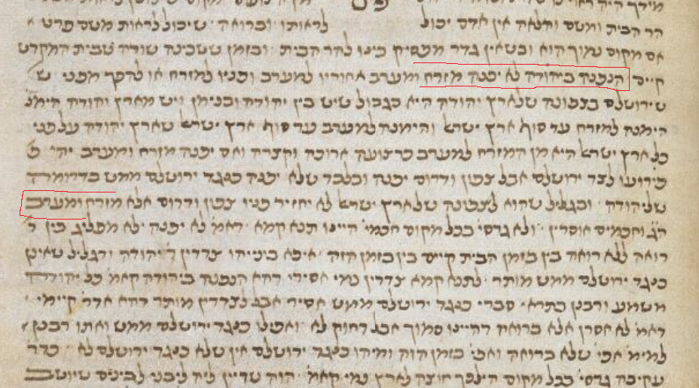
Conclusion: Maharsha is drawing a diagram of what he understands Rashi to be saying
We do not have the Ktav Yad of the Maharsha on Berachot so our best knowledge of what he actually drew comes from the Defus Rishon. How was the map represented in that edition?
There were multiple first editions of Chidushei Halachot of Maharsha. The first few Masechtot were printed anonymously. The main one was printed in 1612. Berachot was printed in Lublin in 1621
First edition of Berachot 1621- The picture is the same as the Vilna Shas
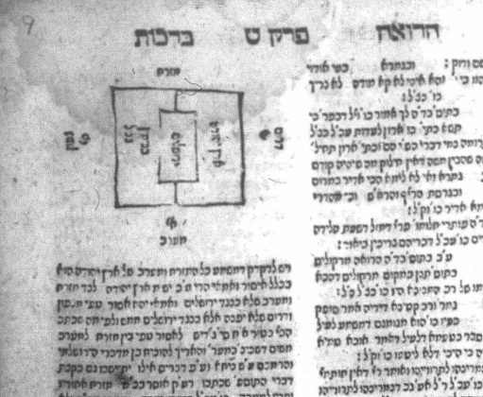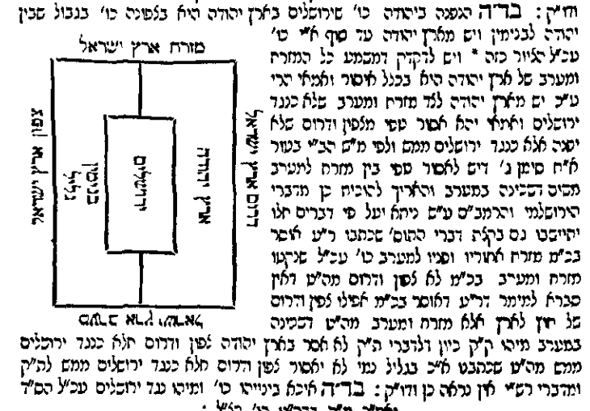
Is the map correct? Does it represent the words of Rashi?
Yerushalayim is represented as being half in Yehuda and half in an area described as Binyamin and Galil. 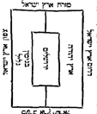
The words of Rashi say “Yerushalyim is in Eretz Yehuda in the north of Eretz Yehuda, on the border between Yehuda and Binyamin”. (שירושלים בארץ יהודה היא בצפונה של ארץ יהודה בגבול שבין יהודה לבנימין ) This seems to mean that Yerushalyim is contained within Yehuda and does not extend into Binyamin/Galil.
Ginzei Yosef (Bilgoraj 1932 by יוסף אלטר בן מרדכי אפשטיין) calls the map in the Vilna Shas a Taut Sofrim and corrects the map to show Yerushalayim completely contained in Yehuda.
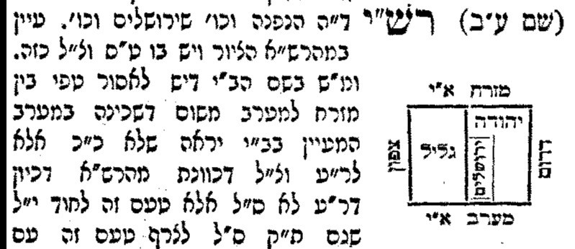

There is some space on the east and west sides of Yerushalayim, meaning that Yerushalayim is between the eastern and western borders but does not extend to either border. (see the extra line drawn in on the west side of Yerushalayim). This is in line with the words of Rashi ויש מארץ יהודה הימנה [למזרח] עד סוף ארץ ישראל והימנה למערב עד סוף ארץ ישראל
This is also the opinion of Rav Tziyon Kohen Yehonatan (Djerba 1872-1931) in his Sefer Sha’arei Tziyon ( Dejerba 1932)
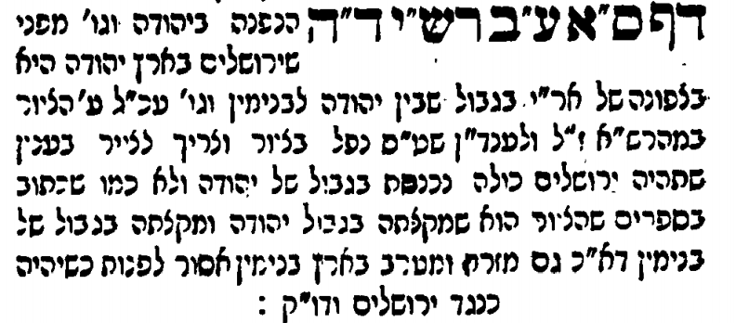

The Sefer D’vash Tamar (Warsaw 1897) by Rabbi Dovid Teitelbaum of Mezeritch draws the map in a similar manner. In this map you can clearly see space between Yerushalayim and the western and eastern borders of Yehuda
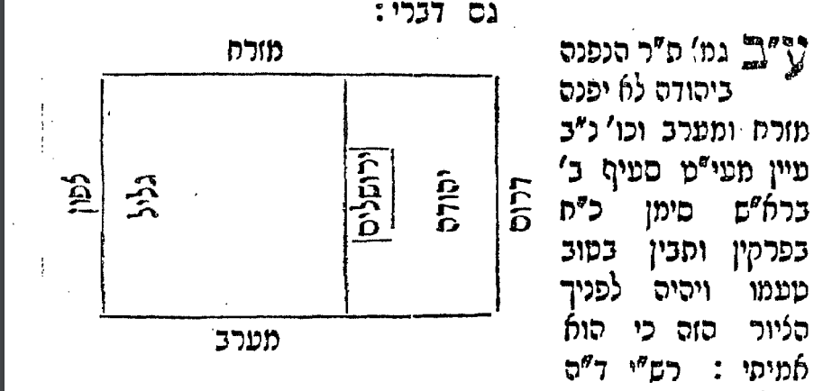
Oz Vehadar copies the map of Ginzei Yosef but does not have a line on the western side of Yerushalayim. It seems to indicate that Yerushalayim extends to the western border of Yehuda which is incorrect.
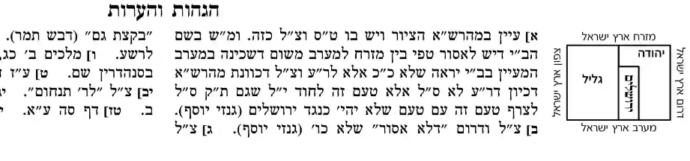
Vilna HaChadash redraws the map of the Vilna Shas but still has Yerushalayim extending into Binyamin
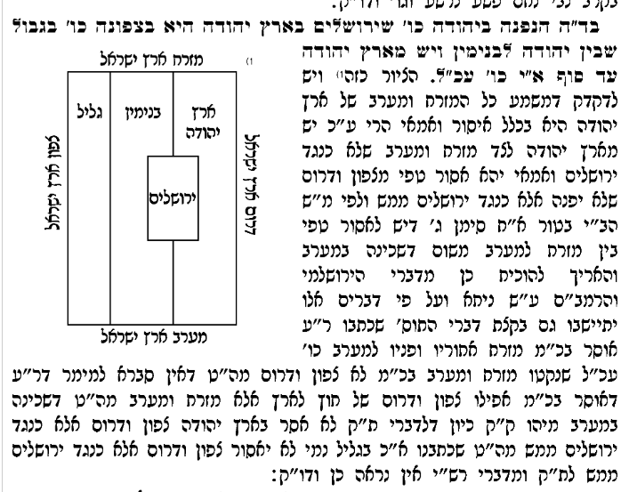

Vagshal 2008 is similar to Vilna HaChadash
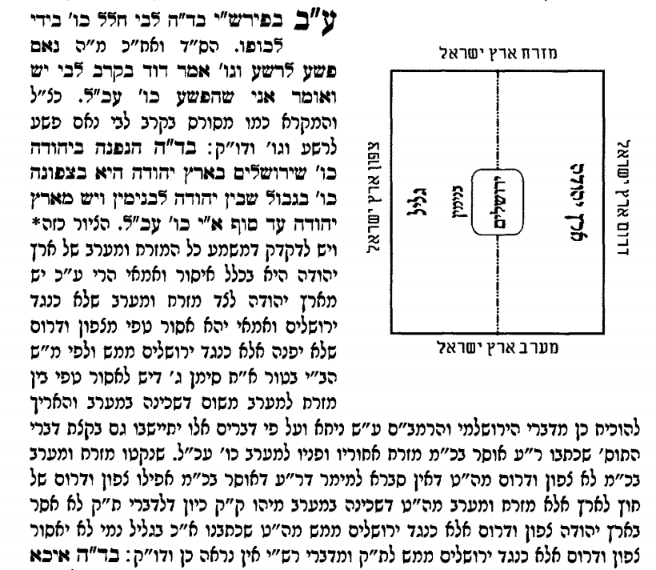
Conclusion: I believe that Maharsha drew the map correctly but the printer was not able to copy it in its true form .Because of that, it remained mistakenly represented in the Vilna Shas. Some of the newer editions of the Talmud are trying to correct the original mistake but are not always successful.

