איורים חסרים ברש״י בענין "פיתחי שימאי"
Eiruvin 11a
The Gemara Eruvin 11a provides us with an example in Peirush Rashi where the both the text and the inclusion of diagrams differ substantially from that of Rashi manuscripts. In one instance, the word “כזה” and the diagram that goes with it is completely missing. In another instance, the word “כזה’ was always included in the text but the diagram we have today is not the same as in the manuscripts and only originated in with Amsterdam edition of Eruvin of 1716. Its addition within the text of Rashi fits with the editor’s statement that all the “ציורים” were included "לפי הבנת הפשט", and none were left out.
"עוד נעשׂו כל הציורים בדקדוק כפי הראוי לפי הבנת הפשט באר היטיב ואחד מהם לא נעדר"
The Gemara on Eruvin 11a discusses a particular type of “צורת הפתח” called "פיתחי שימאי", “broken entrances”. The Gemara then asks:
מאי פיתחי שימאי? פליגי בה רב רחומי ורב יוסף, חד אמר דלית להו שקפי, וחד אמר דלית להו תיקרה
What are broken entrances? Rav Rechumei and Rav Yosef argued on the matter. One said that they do not have proper doorposts, and the other one said that they do not have a lintel (a horizontal board across the top) above the openings.
Rashi first explains the opinion that “broken entrances” are ones דלית להו שקפי
שיקפי - מזוזות שנחלצו אבניהם מכאן ומכאן אבן יוצאת ואבן נכנסת ואין זו צורת פתח:
Doorposts where bricks are broken on either side, one brick going out and one brick going in, and such an opening does not constitute a “Tzurat HaPesach”
There is no “כזה” in the Rashi or a diagram, but the Peirush Chai renders it as follows (page 23)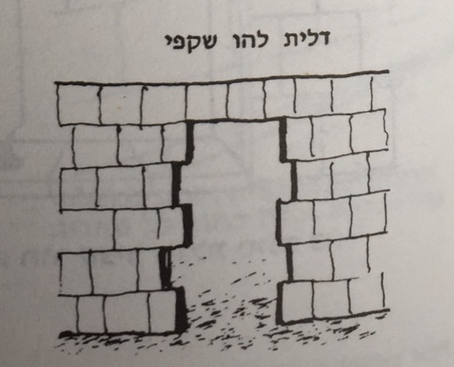

Rashi then explains the word “תיקרה”
תיקרה - שאין כלום בנין למעלה מן הפתח אלא כל הכותל חלוק כפתח עד ראשו כזה וצורת פתח שאמרו קנה מכאן וקנה מכאן וקנה על גביהן:
The opening to the alleyway does not have any structure (“תיקרה”) on top of it, rather the walls are open all the way up to the top “like this” (“כזה”), whereas a normal צורת הפתח has to have a “קנה” ( wall) on either side and a “קנה”(board) on top of them. (Note that at the end of the Rashi, there is no “כזה” or picture of what the normative צורת הפתח looks like with the “קנה” on top of walls)
Peirush Chai renders it like this
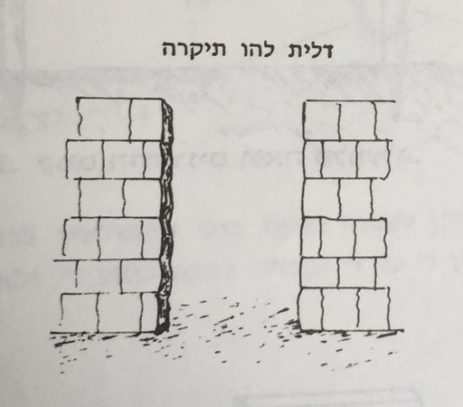
This is the way it looks in the Vilna Shas of 1881
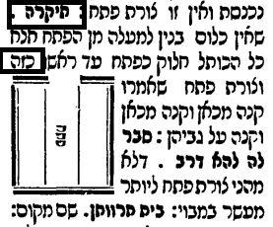
What was the source for the picture in the Vilna Shas? The first time it showed up in a printed edition of the Talmud was in Amsterdam 1716. As you can see, the picture in the Vilna Shas is quite similar.
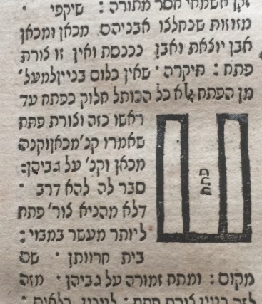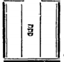
As mentioned, this picture was not included in previous printed editions
The Soncino/Pesaro edition of Eruvin 1515 contains many diagrams, but, despite the inclusion of the word “כזה” in the text of the Rashi, we do not find a diagram.
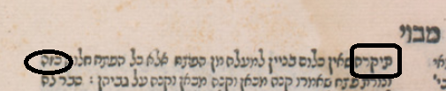
It also does not contain a “כזה” or a picture for the previous Rashi of שיקפי
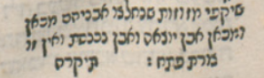
It appears in a similar manner in the Bomberg edition of Eiruvin 1521.Here too it does not contain a “כזה” or a picture for the previous Rashi of שיקפי
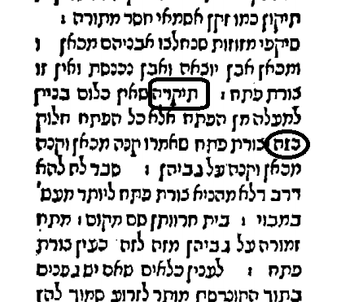
Continuing on in time, it appears this way in the Basel edition of 1580. As you can see, while there is no diagram included, some space is left indicating that a diagram goes there.
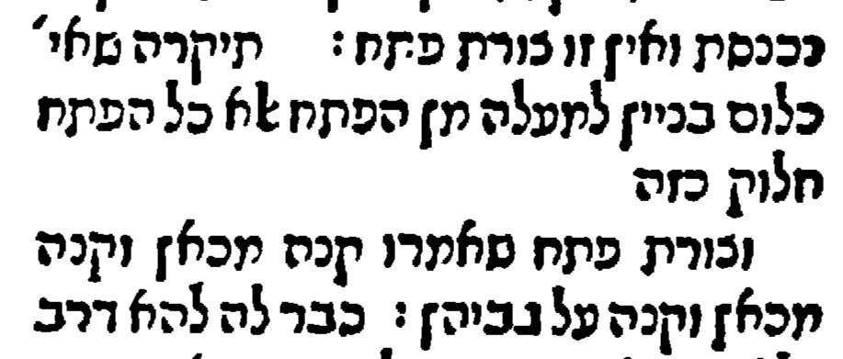
The Benveniste edition of 1646 follows the Bomberg form and does not leave a space after “כזה”, but the Frankfurt on the Oder edition of 1697 does leave a space. As expected, both editions do not contain a “כזה” or a picture for the previous Rashi of שיקפי
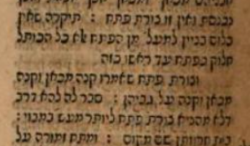
This particular edition is very important in the history of printed editions because it was the first one to include diagrams since the time of the first edition of the Talmud of Daniel Bomberg in the early 1520’s. Here is an example on Eruvin 9a. It is an exact copy of the one included in Chochmat Shlomo.
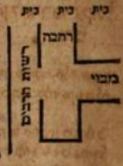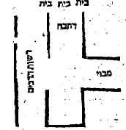
This follows the statement by the editors of this edition that they used the diagrams included in the books Chochmat Shlomo and Chidushei Halachot.
There was no diagram included in any of those books on 11a so they had to leave out a diagram despite the inclusion in the text of the word כזה.
This is Chochmat Shlomo on 11a
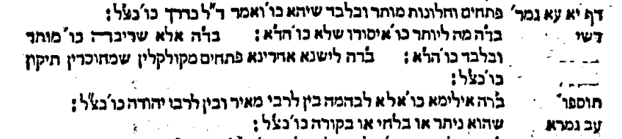
The editor of the Amsterdam adds Maharam Lublin and Chochmat Manoach to the list of books he consulted in making Hagahot to this edition but there is no diagram either in those two books.
Chochmat Manoach even comments in this Rashi of “תיקרה”, but does not include a diagram
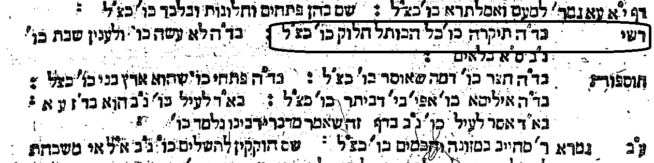
It seems clear then that the editor of this edition of Talmud created his own diagram to fit into the words of Rashi.
We know that the word “כזה” made it into the printed text in both the Soncino/Pesaro edition and the Bomberg edition and we assume it was therefore in the manuscripts they used. But was there an actual picture in any manuscript that we can access today?
It turns out that there was the word “כזה” and a picture in the Rashi of “תיקרה” in all six Rashi manuscripts I examined. In two manuscripts, there was an additional “כזה” and a picture at the end of that Rashi. There was also a “כזה” and a picture at the end of the previous Rashi of “שקפי” in all six of the manuscripts.
BN 324 (13th to 14th century). In the Rashi of “Tikrah” it has the word “Kazeh” and a picture of two vertical lines representing walls and an opening on top. It also has a diagram in the previous Rashi of “שקפי” preceded by the word “כזה”.
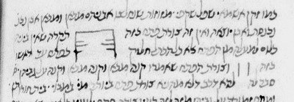

Munich 216 (13th century) has “כזה” in our Rashi of “תיקרה” followed by a very rudimentary diagram, two horizontal lines. It is likely that the lines were drawn horizontally rather than vertically to fit into the line of text. It also has a diagram in the previous Rashi of “שקפי” preceded by the word “כזה”.
In JTS Ms 6499, (14th century) the word Kazeh is in the Rashi of “Tikrah” and the picture is very clear. It also has a diagram in the previous Rashi of “שקפי” preceded by the word “כזה”.
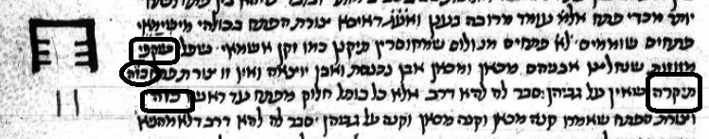
Vatican 127 is similar to JTS 6499 with word Kazeh and a diagram in both “Shikfi” and “Tikrah”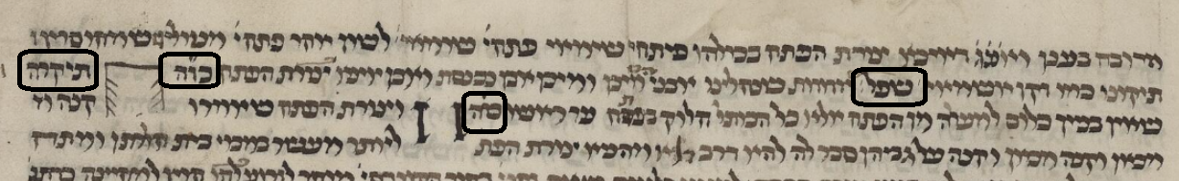
Note The Dibbur HaMatchil should be “שקפי”

Bodleian Library MS. Oppenheim Add. 4° 23 (15th century) in the Rashi of “Tikrah” has a configuration of two walls which are open on top, and at the end, has the word “כזה” and a picture of the normal צורת הפתח which has a “קנה” going across the top. Our edition of the Talmud does not include that “כזה” or a picture. It also has a diagram in the previous Rashi of “שקפי” preceded by the word “כזה”.
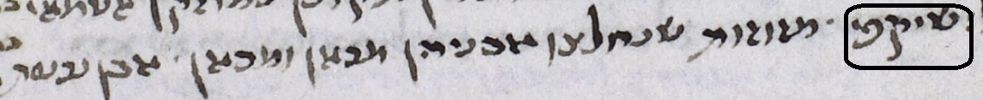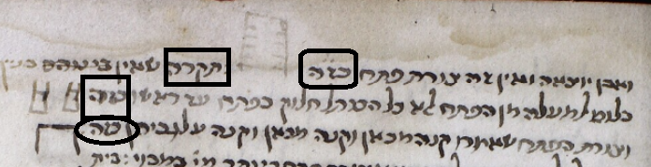

Finally, there is The National Library of Russia,Ms. EVR II A 266/1(unknown date) which has in the Rashi of “Tikrah” a picture of two walls without a board on top and at the end, also has the word “כזה” followed by a picture of a normal צורת הפתח. . It also has a diagram in the previous Rashi of “שקפי” preceded by the word “כזה”.
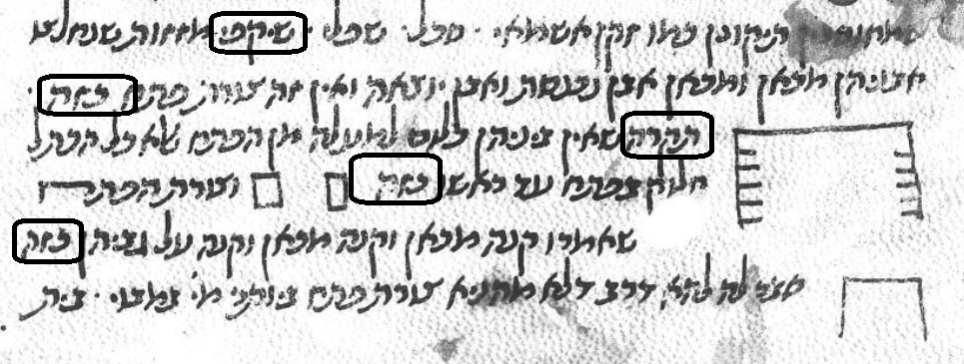

Conclusion:
Based on the fact that all six manuscripts contained the word “כזה” and contained diagrams for both Diburei HaMatchil (תיקרה and שקפי ) makes it likely that Rashi himself drew a diagram to illustrate those words. We are completely missing the diagram for שקפי which seems to have been included by Rashi himself. The diagram we have for תיקרה represents the Amsterdam editor’s understanding of Rashi and is not from any Rashi manuscript, nor from any of the Gedolim who commented on it. It was added to the צורת הדף in 1716 and has remained there until today.

From the introduction to Masechet Shabbat.
This is the Shaar Blatt from the Frankfurt on der Oder edition. It lists two sources which were used to edit this edition, Chochmat Shlomo of Maharshal and Chidushei Halachot of Maharsha. It also says that another advantage of this edition is that “ציורים” were included in Eruvin and Sukkah. An examination of the diagrams included in the 1697 Eruvin shows that in all cases, the diagrams came from Chochmat Shlomo Here is an additional example from Eruvin 26a Frankfurt on der Oder 1697 Chochmat Shlomo (Cracow 1583)
This is the list of sources consulted by the Amsterdam edition as stated in the introduction. MaHaram is Maharam Lublin in Meier Eini Chachamim.

