Eruvin 17b– עוֹשִׂין פַּסִּין לְבֵירָאוֹת.

The Picture of פסי ביראות in the Rambam’s Peirush HaMishnayos

Eli Genauer

Summary of an analysis of a diagram in the Peirush HaMishnayos of the Rambam, Eruvin 2:1

The original diagram of the case of “פסי ביראות” which the Rambam drew is reflected in the manuscript Bodleian Library Ms. Pockocke 236, and it was transmitted accurately through time in various manuscripts in the original Judeo-Arabic.[1] It seems though that when the Peirush HaMishnayos was translated into Hebrew, the diagram was reduced in detail to a great degree. It was reproduced accurately (as in Pockocke 236) in the first printed edition, Napoli 1492. It was not included in any printed edition of Peirush HaMishnayos until Amsterdam 1715 where it appeared in its reduced form. With few exceptions, it remains that way until today. Eyal Berkowitz HY"D drew his own diagrams and did a wonderful job of illustrating the two opinions in the Mishneh by drawing two diagrams. It raises the issue of whether drawings made by Rambam, or any other Rishon, should be treated with the same respect as their words

The following is a look at the diagram presented in the Peirush HaMishnayos of the Rambam in Eruvin 2:1, the famous Sugya of "פסי ביראות". We will focus on the first part of the Mishneh which describes two opinions on what is needed for an artificial fence around the well.

תלמוד בבלי מסכת עירובין פרק ב׳ משנה א׳

**Introduction:** A well ten Tefachim deep which is found in the Reshus HaRabim is considered to be a Reshus HaYachid, and hence one is not allowed to draw water from the well on Shabbos. Our Mishnah teaches that the Chachamim allowed people to make a special arrangement around the well so that they could draw water from it on Shabbos.

עוֹשִׂין פַּסִּין לַבֵּירָאוֹת אַרְבָּעָה דְיוּמְדִין, נִרְאִין כִּשְׁמֹנָה, דִּבְרֵי רַבִּי יְהוּדָה. רַבִּי מֵאִיר אוֹמֵר, שְׁמֹנָה, נִרְאִין כִּשְׁנֵים עָשָׂר, אַרְבָּעָה דְיוּמְדִין וְאַרְבָּעָה פְשׁוּטִין. גָּבְהָן עֲשָׂרָה טְפָחִים, וְרָחְבָּן שִׁשָּׁה, וְעָבְיָן כָּל שֶׁהוּא, וּבֵינֵיהֶן כִּמְלֹא שְׁתֵּי רְבָקוֹת שֶׁל שָׁלֹשׁ שָׁלֹשׁ בָּקָר, דִּבְרֵי רַבִּי מֵאִיר. רַבִּי יְהוּדָה אוֹמֵר, שֶׁל אַרְבַּע אַרְבַּע, קְשׁוּרוֹת וְלֹא מֻתָּרוֹת, אַחַת נִכְנֶסֶת וְאַחַת יוֹצֵאת:

**One may arrange** upright **boards [*passin*] around a well** in Reshus HaRabim in order to permit drawing water from the well on Shabbat. (A well is usually at least four Tefachim wide and ten Tefachim deep, therefore, it is considered a Reshus HaYachid, and it is prohibited to draw water from it on Shabbat as that would constitute a violation of the prohibition to carry from a Reshus HaYachid into a Reshus HaRabim.) For עולי רגל, the Chachamim therefore instituted that a virtual partition may be built in the area surrounding the well, so that the enclosed area could be considered a Reshus HaYachid, thus permitting use of the well and carrying of the water within the partitioned area. In this specific instance, the Chachamim demonstrated special leniency and did not require a proper partition to enclose the entire area. For this purpose, it suffices if there are **four double posts [*deyomadin*] that look like eight** single posts, i.e., four corner pieces, each comprised of two posts joined together at right angles; this is **the statement of Rav Yehuda. Rav Meir says:** There must be **eight** posts that **look like twelve.** How so? There must be **four double posts,** one in each corner, with **four plain** posts, one between each pair of double posts. **The height** of the double posts must be at least **ten Tefachim, their width** must be **six** tefachim, **and their thickness** may be even **a minimal amount.**

To review: The Chachamim said that if a well (which by nature is a Reshus HaYachid) is located in the Reshus HaRabim, a pseudo-fence could be set up, one which would prevent the area from being a Reshus HaRabim but still allow easy access. According to Rav Yehuda, this is done by setting up corner-posts at each of four corners. Each corner post would have two pieces of wood set at a right angle so that it would look as if there were four walls. Rav Meir says that it is not sufficient for there to be four corner-posts. There must also be four single pieces around each side. These form pseudo-walls which give the structure more of an appearance of a fenced in area.

The height of the posts must be ten tefachim in order for them to constitute a separate Reshus. Their width must be six tefachim, which makes an Amah. Their thickness is not important.

In studying this Mishneh, one feels that a picture of the proposed “structure” would be helpful. Remember, that there are two cases here, one according to Rav Yehuda and one according to Rav Meier.

In setting up the scenario of “עוֹשִׂין פַּסִּין לַבֵּירָאוֹת”, the Rambam in his Peirush HaMishnayos includes the following picture. The source for the picture shown here is the highly regarded manuscript identified as Bodleian Library Ms. Pockocke 236 copied over by the scribe Solomom ben Samuel Halevi in 1233. 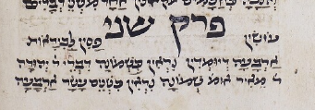

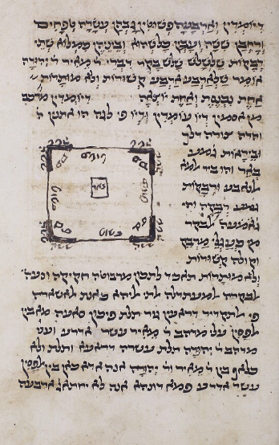

The narrative part of the Rambam’s commentary (translated into Hebrew) which deals with the two opinions of the Halachic requirements for making this “imaginary” fence, is as follows:

עוֹשִׂין פַּסִּין לַבֵּירָאוֹת:  
דיומדין מלה מורכבת מב' מלות דיו עמודין ודיו בלשון יוני שנים ע"כ פי' המלה שנים עמודין. וביראות קבוץ באר והוא באר מים הנובע. **וזו היא צורתה**

The word “דיומדין” is a compound word consisting of two words “דיו עמודין” The word “דיו” in Greek means “two”, therefore the explanation of the word is “two posts”. And the word “ביראות” means “well spring” and it is a well of flowing water. **And this is how it looks.**

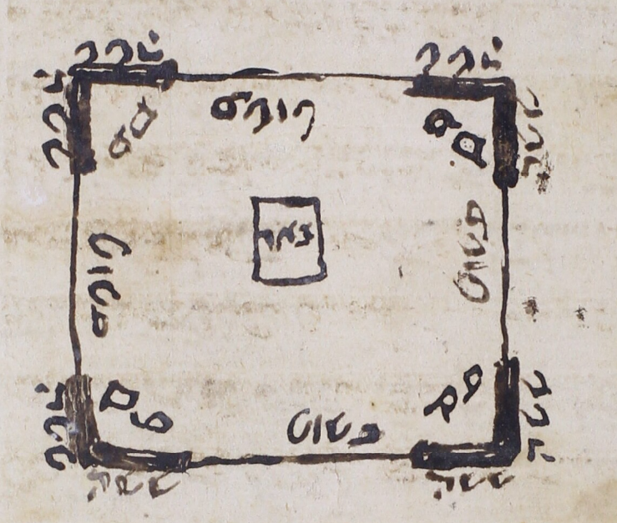

The Rambam illustrated the view of Rav Meir that not only do you need the double posts in each corner, you also need a single post (“פשׁוּט”) in the area between the double posts. The picture also informs us that each corner double post (“פס”) has to be six (“ששה”) Tefachim wide. You also see the well (“באר”) in the middle. The view of Rav Yehuda is included in this picture by just subtracting the single posts (“פְשׁוּטִין”)

You can readily see that Rav Yehuda only requires the corner double posts, and Rav Meir requires additional posts in the middle.

Vagshall Mishnayos Zichron Chanoch 1999 does not reproduce the picture of the Rambam in the manuscript as it does not include the single posts (פְשׁוּטִין) in the middle which is the view of Rav Meier

<https://hebrewbooks.org/pdfpager.aspx?req=37941&st=&pgnum=265>

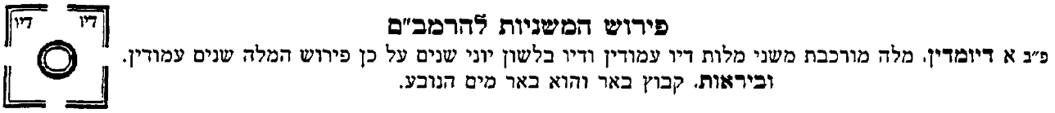

Nor does the Mishnayos Vilna HaChadash Jerusalem 2009

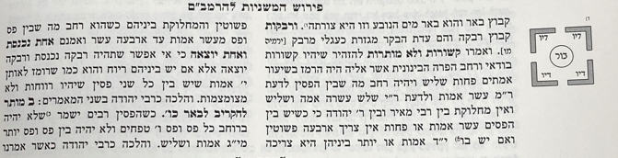

Nor does Oz VeHadar 2016 - Back of Gemara

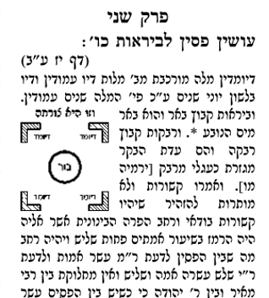

But the Mishnayos Oz VeHadar 2021 does reflect the picture in the manuscript

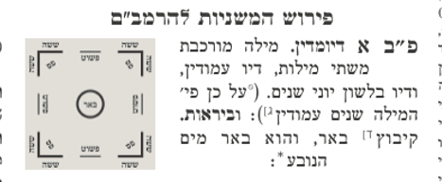

The website Al HaTorah also reflects the accurate picture

<https://mishna.alhatorah.org/Full/Eiruvin/2.1#e0n6>

פירוש המשנה לרמב"ם ערובין ב':א'

דיומדין – מורכבת משתים, דיו עומדין, ודיו בלשון הוא שנים, וזו צורתן:

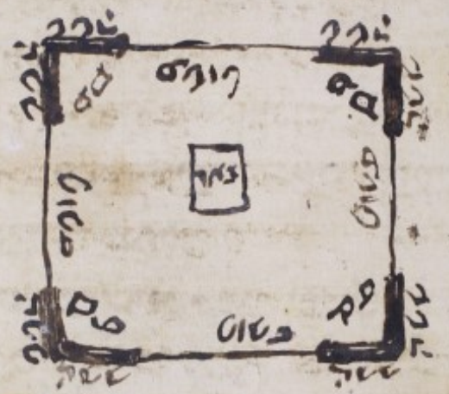

The first printed Mishnayos with the Peirush of the Rambam was printed in Napoli, Italy in 1492. It faithfully reproduced the picture of the Rambam which included the פְשׁוּטִין

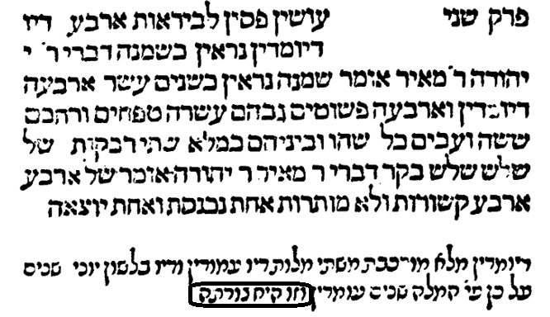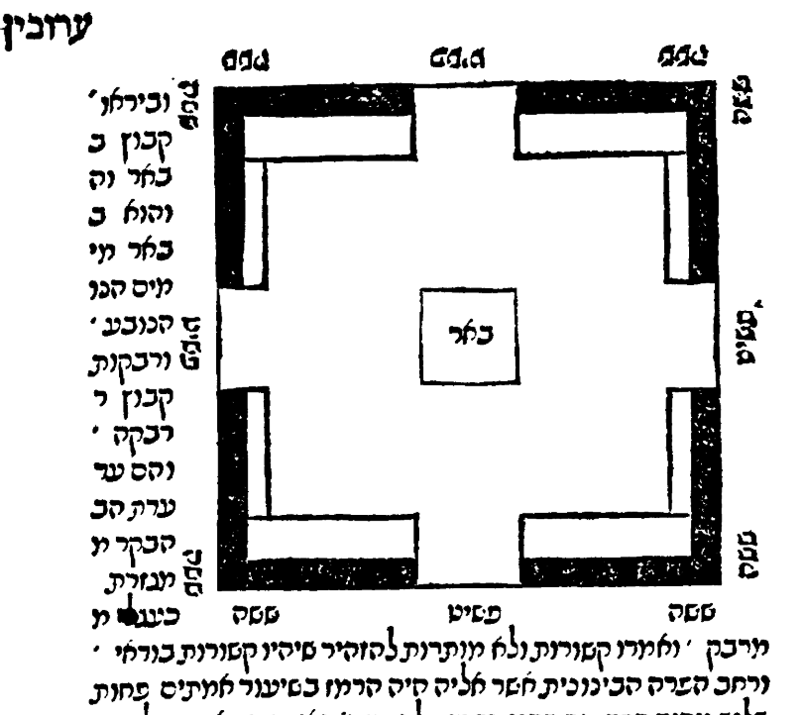

An edition of Gemara printed in Venice 1546 by Giustiani left a space blank indicating that a diagram was supposed to go there.

<https://www.nli.org.il/en/books/NNL_ALEPH990013513060205171/NLI>

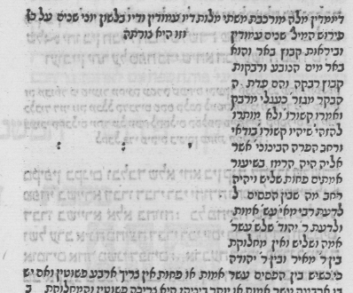

There is a copy of this edition on Otzar HaChochmah and you can see someone drew it in, most likely copying from the Napoli edition.

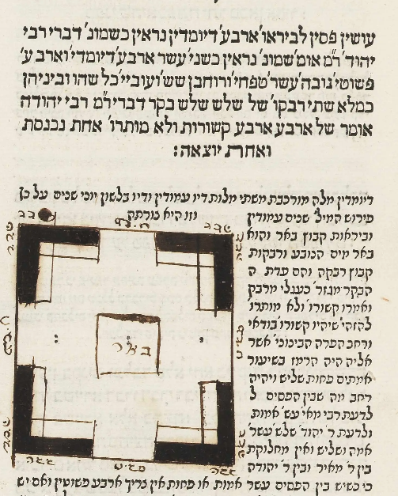

The Bomberg edition of Eruvin of 1522 also left a blank space for “זו היא צורתה”

<https://www.hebrewbooks.org/pdfpager.aspx?req=21819&st=&pgnum=215>

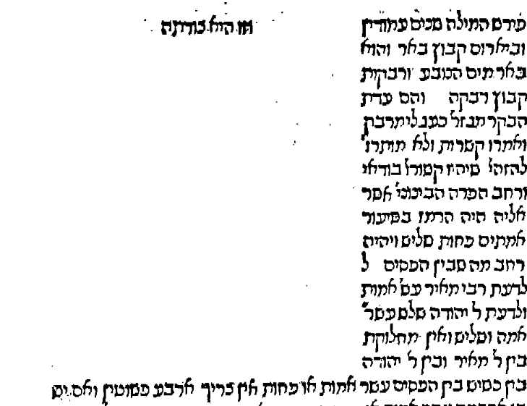

The first printed Gemara with the Peirush HaMishnayos of the Rambam in the back which included the picture was Amsterdam 1715. It left out the פְשׁוּטִין and most Gemaros printed afterwards followed suit.

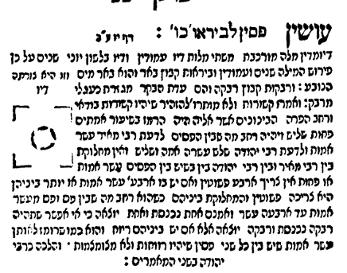

As an example, this is a Gemara printed in Slavuta 1817 by Rav Moshe Shapira, son of Rav Pinchas of Koretz

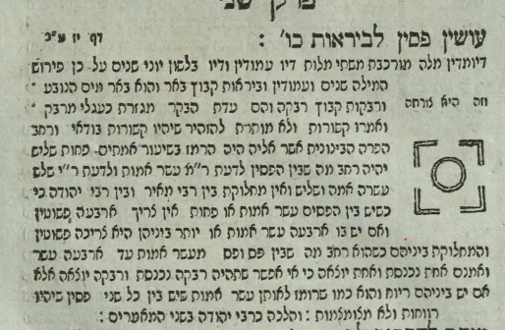

These are Mishnayos which belonged to Eyal Berkowitz HY”D

<https://www.nli.org.il/en/manuscripts/NNL_ALEPH997012720575605171/NLI#$FL216477698>

הערות סביב ששה סדרי משנה בהוצאת "משנה סדורה" תשס"ז.

המאייר, איל ברקוביץ׳, בוגר הישיבה הגבוהה "בני דוד" ביישוב עלי שבבנימין, שירת ביחידת מגלן ונפל בדרכו למשימת חילוץ גופות חטופים ברצועת עזה ביום כ"ד כסלו תשפ"ד, 7.12.23. הכרך נמסר לצילום בידי אשתו

Eyal Berkowitz HY’D was a Talmid in the Yeshiva Bnai Dovid and was also a member of the Hesder program. He fell in Gaza while trying to retrieve the body of a hostage for Kevuras Yisroel. His copy of Mishnayos in which he left comments and drew pictures was digitized by the National Library of Israel.

As you can see, he drew two pictures, the first to reflect the view of Rav Yehuda and the other to reflect the view of Rav Meir who required פְשׁוּטִין

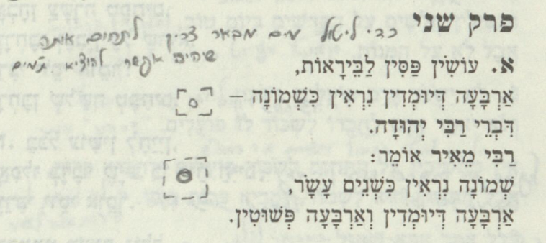

Here are more examples of some very old manuscripts of the Peirush HaMishnayos of the Rambam both in Judeo Arabic which accurately reflect the intended picture of the Rambam including the פְשׁוּטִין.

Huntington 368

<https://digital.bodleian.ox.ac.uk/objects/cda275fb-4dd6-4ffe-813d-3077c11eb37e/surfaces/d0cf813d-41e2-4bba-8878-d25a70eacc54/>

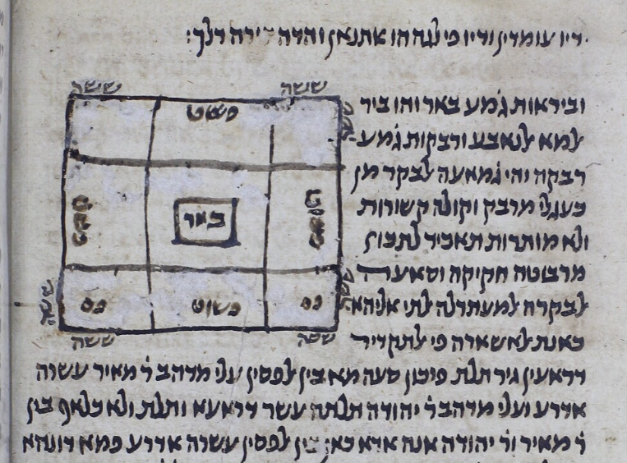

ספריית המדינה בברלין, ברלין, גרמניה Ms. Or. Qu. 567a -14th century? -Yemenite script

<https://www.nli.org.il/en/discover/manuscripts/hebrew-manuscripts/viewerpage?vid=MANUSCRIPTS#d=[[PNX_MANUSCRIPTS990001751810205171-1,FL55161736>]]

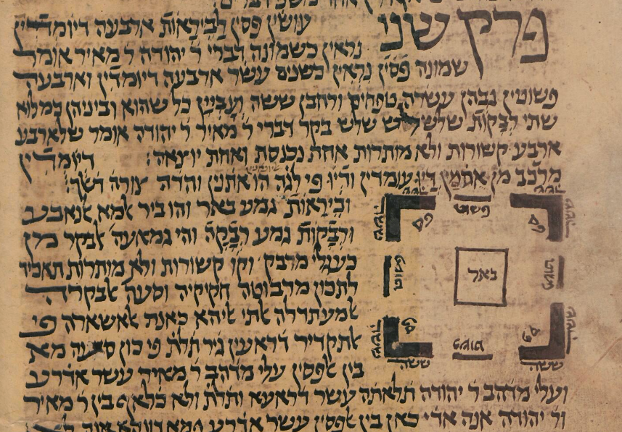

However, this manuscript in the Hebrew translation known as Vatican ebr. 465, does not include the פְשׁוּטִין

<https://digi.vatlib.it/view/MSS_Vat.ebr.465>

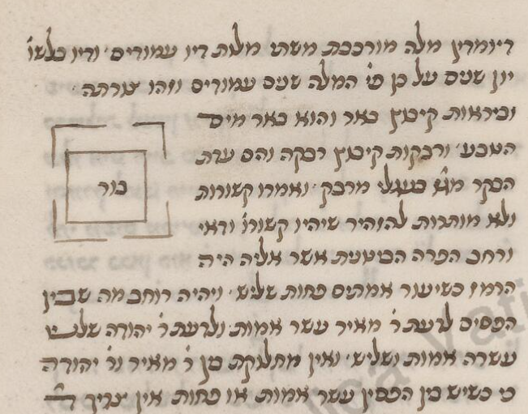

Nor does this manuscript

הספרייה הלאומית של צרפת, פריס, צרפת Ms. hebr. 328

<https://www.nli.org.il/he/discover/manuscripts/hebrew-manuscripts/viewerpage?vid=MANUSCRIPTS#d=[[PNX_MANUSCRIPTS990001292390205171-1,FL48124702>]]

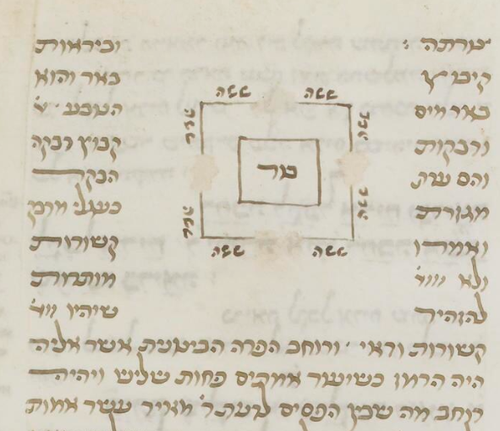

Nor does this one, known as Cod. hebr. 18 ספריית המדינה והאוניברסיטה של המבורג, המבורג, גרמניה

<https://www.nli.org.il/he/discover/manuscripts/hebrew-manuscripts/viewerpage?vid=MANUSCRIPTS#d=[[PNX_MANUSCRIPTS990001675280205171-1,FL49629154>]]

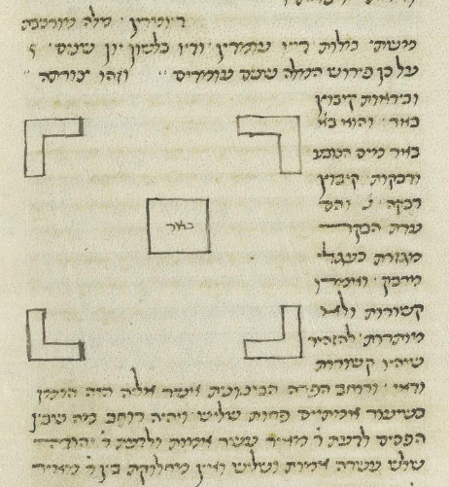

Conclusion:

The original diagram of the case of “פסי ביראות” which the Rambam drew is reflected in the manuscript Bodleian Library Ms. Pockocke 236, and it was transmitted accurately through time in various manuscripts in the original Judeo-Arabic. It seems though that when the Peirush HaMishnayos was translated into Hebrew, the diagram was reduced in detail to a great degree. It was reproduced accurately (as in Pockocke 236) in the first printed edition, Napoli 1492. It was not included in any printed edition of Peirush HaMishnayos until Amsterdam 1715 where it appeared in its reduced form. With few exceptions, it remains that way until today. Eyal Berkowitz HY"D drew his own diagrams and did a wonderful job of illustrating the two opinions in the Mishneh by drawing two diagrams. It raises the issue of whether drawings made by Rambam, or another Rishon, should be treated with the same respect as their words

1. i.

   For background and analysis of the scribe of Bodleian Libraries, University of Oxford Ms. Poc. 236”, please see the article by Dr Ezra Chwat entitled

   “Solomon b. Samuel Halevy, A Genizah Scribe in the Court of Maimonides”. <https://www.academia.edu/119241094/Solomon_b_Samuel_Halevy_A_Genizah_Scribe_in_the_Court_of_Maimonides>

   Dr Chwat concludes that “These elements combined, qualify Solomon’s copy as a prime text witness of Maimonides’ library.”

   Unfortunately, the Ksav Yad of the Rambam himself which is housed at the National Library of Israel only begins later on in Eruvin

   כולל: סדר מועד ממסכת ערובין סוף פרק שביעי (ס' 9978, 155 עמודים) וסדר נשים