עירובין כ׃ -ציור פרה בהגהות הב״ח
Eli Genauer
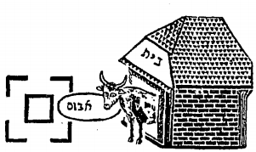
Summary
The diagram in the first edition of the Bach (1824) is much more accurate than how it is depicted in later editions, especially the Vilna Shas. The Bach’s picture features a long feeding trough, (an אבוס), whereas Vilna and others show it looking more like something attached to the animal. The Zhitomir Shas compounds the error by leaving out an essential characteristic of the situation under discussion. The new editions of the Talmud get it much better. The one diagram I found in a manuscript and the diagram in the Soncino Pesaro edition of 1515 (which was based on a manuscript) are very close to the drawing in the Bach (1824).
The picture in the Bach focuses on the relationship between an animal, its feeding trough and a well. One of the key words here is אבוס which is the feeding trough.
מסכת עירובין :משנה י״ז׃
משנה: עושין פסין לביראות …… From Sefaria
MISHNA: One may arrange upright boards [פסין] around a well (in the Reshut Harabim in order to permit drawing water from the well on Shabbat.) [A well is usually at least four Tefachim wide and ten Tefachim deep. Therefore, it is considered a Reshut HaYachid, and it is Asur to draw water from it on Shabbat, as that would constitute a violation of the prohibition to carry from a Reshut HaYachid into a Reshut HaRabim. The Chachamim therefore sometimes made a Kulah that a virtual partition may be built in the area surrounding the well, so that the enclosed area could be considered a Reshut HaYachid.]
Perush Chai http://hebrewbooks.org/pdfpager.aspx?req=47535&st=&pgnum=46
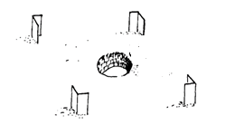
Gemara on 20b
The Gemara discusses a case where the owner fills a bucket and gives water to an animal or fills a bucket and then pours water into a trough from which the animal then drinks
לא ימלא אדם מים ויתן בשבת לפני בהמתו, אבל ממלא הוא ושופך והיא שותה מאיליה
A person may not fill a bucket with water and hold it before his animal on Shabbat; but he may fill it and pour it out (into a trough.) The animal then drinks of its own accord.
הא אתמר עלה אמר אביי הכא באבוס העומד ברשות הרבים גבוה עשרה טפחים ורוחב ארבעה וראשו אחד נכנס לבין הפסין
The Gemara qualifies the case of pouring water into a trough by saying that the above Baraita is dealing with a cow standing inside a house with windows open to the Reshut HaRabim, eating from a trough that stands in the Reshut HaRabim that is ten tefachim high and four tefachim wide, ( meaning it is a Reshut HaYachid), and one end of this trough extends into the area between the upright boards surrounding a well. Here is what it looks like.
Source: Chavruta English
http://files.daf-yomi.com/klali/lilmod/chavruta-english-eruvin1.pdf page 14
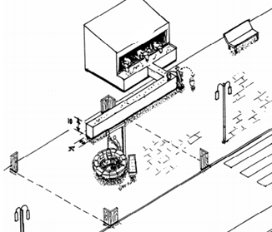

רש״י -הא איתמר עלה כו'
הא איתמר עלה כו' - כלומר כי בעינן ראשה ורובה בדלא נקיט לה וכי הוי ראשה ורובה שרי וברייתא דקתני לא ימלא ויתן הוא עצמו לבהמתו הא תרצה אביי לקמן דלאו בבהמה העומדת ברה"ר וראשה ורובה בין הפסין עסקינן אלא בבהמה העומדת בבית וחלונות פתוחות לה לרה"ר ואיבוס מתוקן לה )ב”ח( לפניה ברה"ר גבוה י' ורחב ד' דהוי רה"י ונותן לה שם תבן ומספוא מרה"י וראש האיבוס נכנס לבין הפסין ואשמעינן דלא ימלא מן הבור ויגביה הדלי על ראש האיבוס וילך דרך רה"ר ויטלטל הדלי על האיבוס לפני בהמה ואע"ג דקיי"ל עומד אדם ברה"ר ומטלטל ברה"י בהמוצא תפילין (לקמן עירובין ד' צח:). הכא אסור:
The portion of Rashi relevant to the diagram in the Bach is in bold
בבהמה העומדת בבית – It is a case where the animal is standing in the house which has windows open to the Reshut HaRabim and a trough is positioned in front of it in the Reshut HaRabim and it is 10 tefachim high and 4 tefachim wide which makes it a Reshut HaYachid, and the owner puts animal feed(תבן ומספוא) into the trough in the Reshut HaYachid and the front portion of the trough enters into the area between the upright boards (בין הפסין)
In the Vilna Shas (Eruvin,1881) in the middle of this description in Rashi, there is an indication to look at the Hagahot HaBach.
The Hagahot HaBach are suggestions for textual emendations in the Talmud and Rashi, copied from the notes that the author added to his copy of the Talmud. The Bach died in 1640 but these suggested emendations were not printed until 1824
The picture is in the bottom right corner of the Daf and looks like this
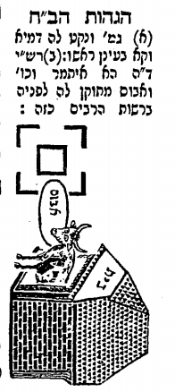Here it is straightened out
It has all the elements mentioned in Rashi…an animal standing in a house (with a window) connected in some way to an אבוס which extends through the Reshut HaRabim and into the area between the upright posts surrounding the well. Nevertheless, I had two issues with this depiction
- Did the Bach really draw a picture of an animal in his Gemara?
- The אבוס does not look like a trough positioned on the ground that has substantial dimensions. (10 tefachim high and 4 tefachim wide).
In the first edition of the Hagahot HaBach ( Warsaw 1824), the picture looks like this:
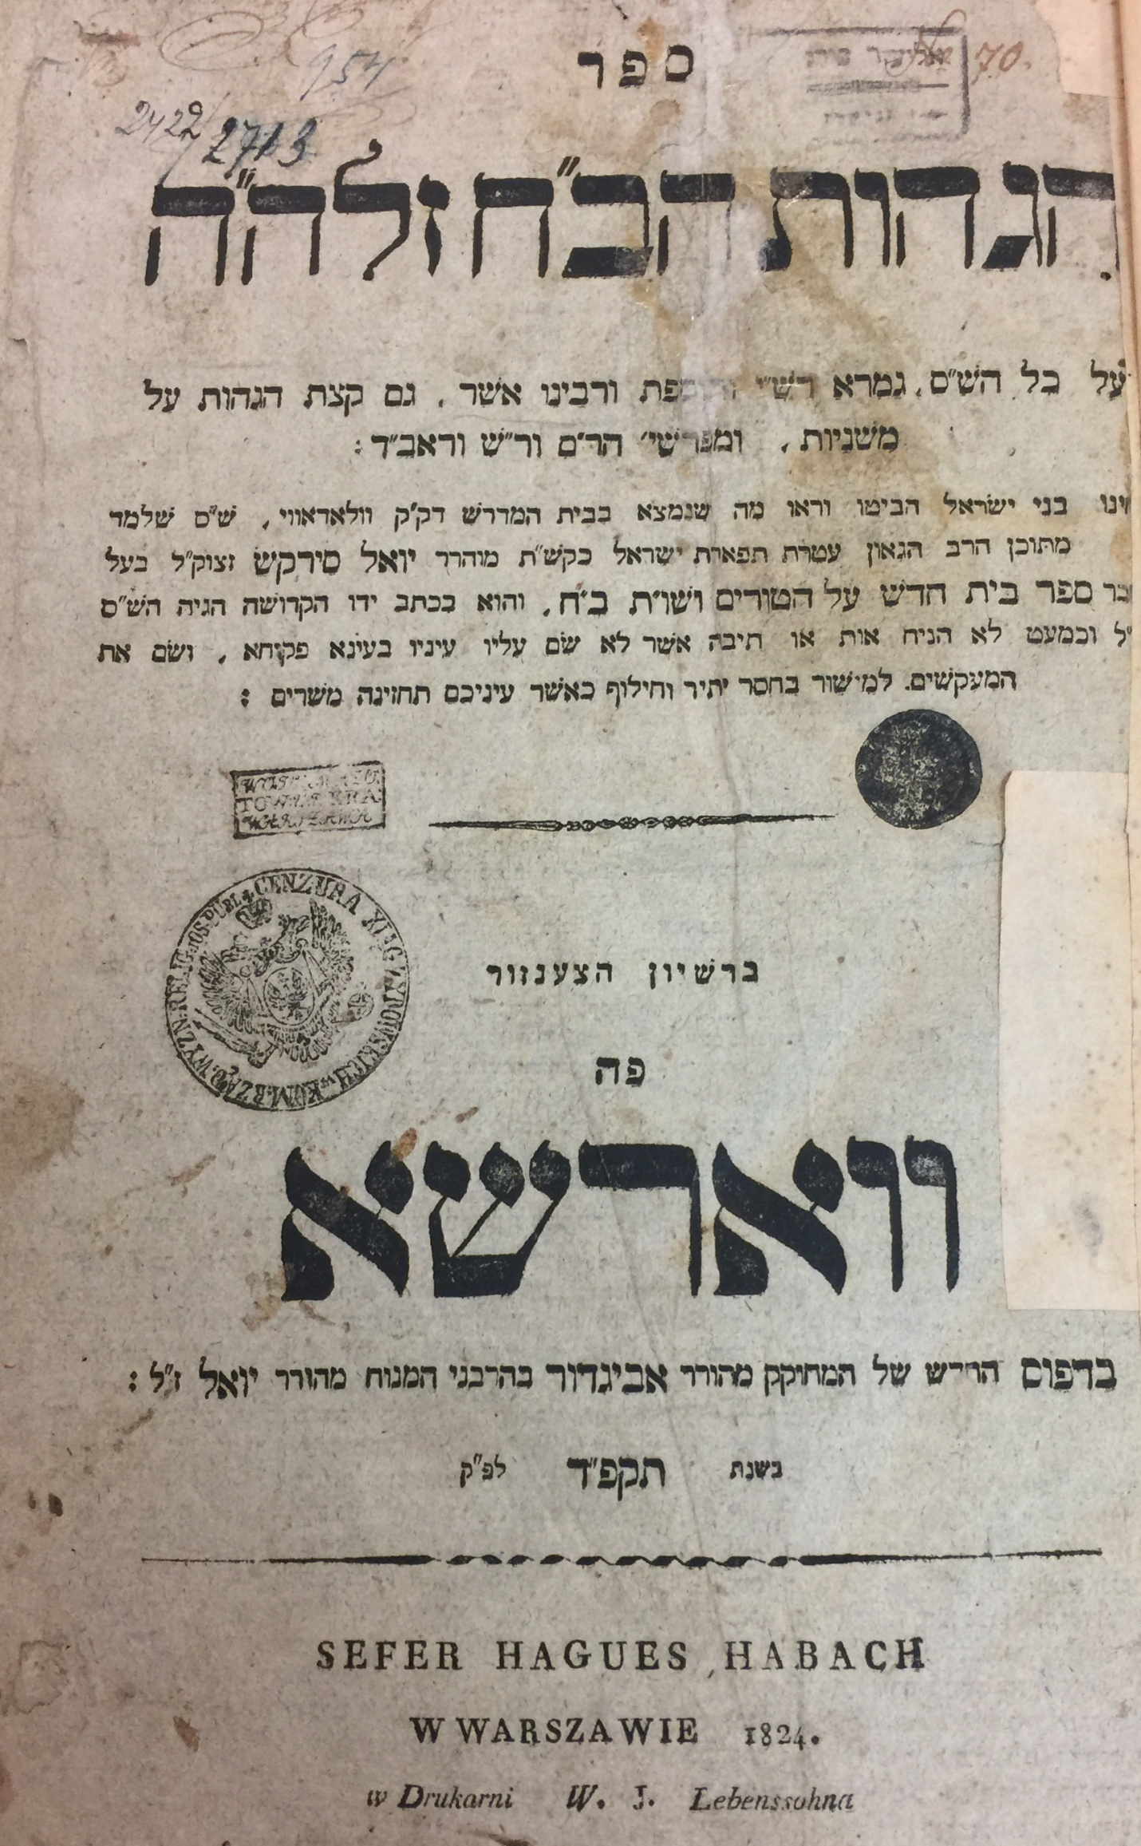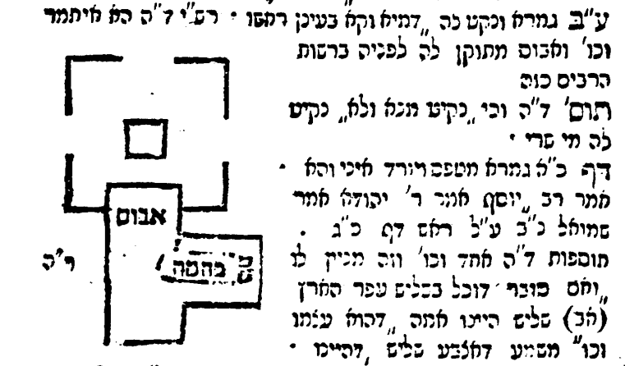
We have all the elements described in Rashi, but the house and animal are depicted by words rather than pictures. The crucial אבוס could easily be a feeding trough which stands on the ground and has significant enough dimensions to make it a Reshut HaYachid. I find this depiction a more accurate one than what appeared in the Vilna Shas.
What was the origin of the depiction in the Bach? We know that the Bach emended the text based on manuscripts he had, or by using his logic to arrive at the proper text. It would be nice if we could find a manuscript with a similar depiction, as this might give us a clue to the source of the Bach. Fortunately, there are two such sources.
Source #1- Rashi-Commentary on Talmud Bavli (Eruvin and Betsah)
The Bodleian Libraries, University of Oxford, Oxford, England Ms. Opp. Add. Qu. 23 –15th century (1426-1475)
https://web.nli.org.il/sites/NLI/English/digitallibrary/pages/viewer.aspx?&presentorid=MANUSCRIPTS&docid=PNX_MANUSCRIPTS990000891680205171#|4486a0cb-1620-4a3c-b02a-7fc46bf03be1.json
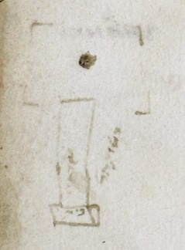 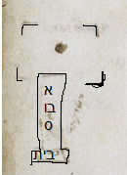 compared to Bach 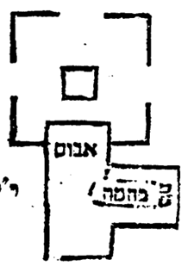
There is no indication of where the animal is standing, but otherwise it is quite similar, especially its depiction of the אבוס.

Source #2
Soncino Pesaro 1511(?) – First printed edition of Eruvin. Its source was from manuscripts.
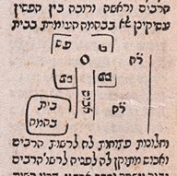 compared to Bach
There are some differences with the depiction of the Bach, mainly in the positioning of the animal, but this depiction also shows the אבוס being a long substantial structure.
After the printed edition of the Hagahot HaBach appeared in 1824, those Hagahot began to be included in printed Gemarot. I was able to find a number of editions containing this diagram which were printed between 1824 and 1881 when the Vilna edition was published.
The first I examined was Vilna/Horodna 1836 which included the Hagahot Ha’Bach after the Peirush Mishnayot of the Rambam. It was the first printed edition to include these Hagahot on Eruvin after 1824. We already see major changes from the first edition, including the picture of the animal and the change to the depiction of the אבוס.
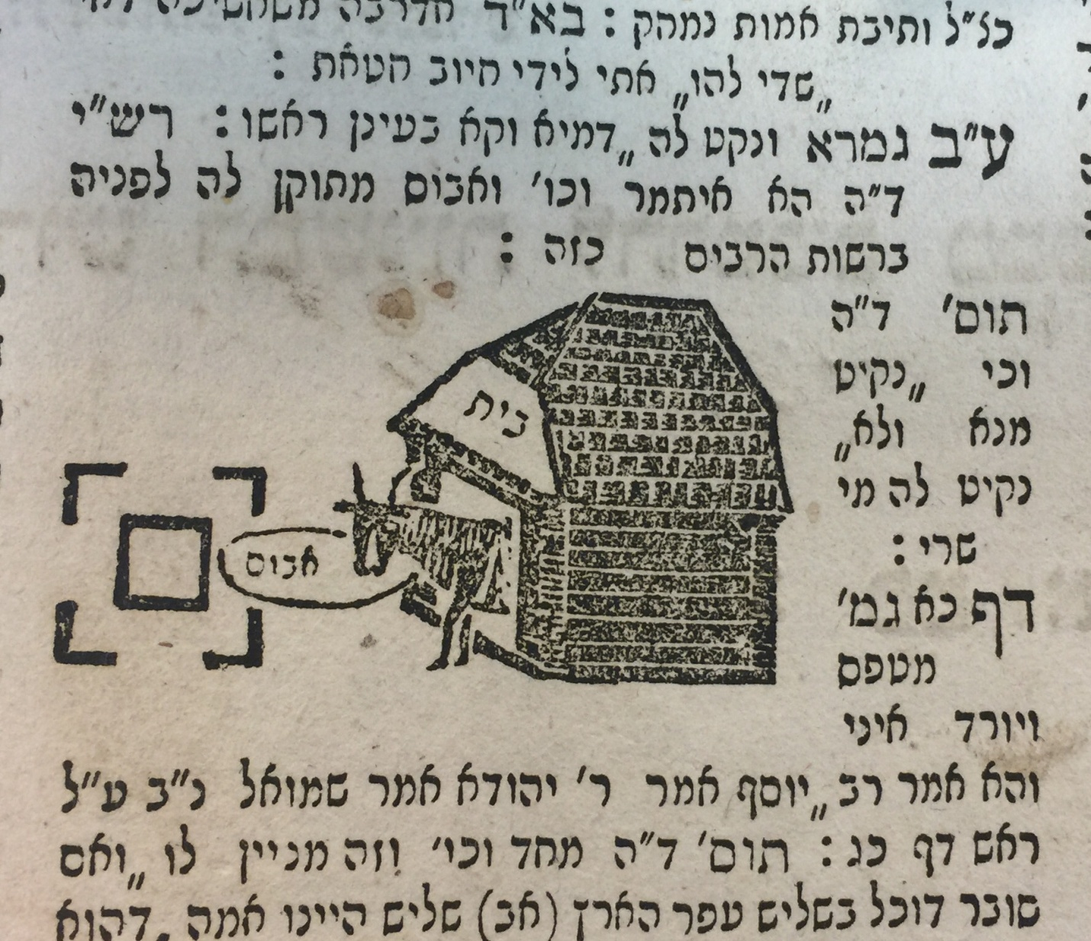

The second printing I examined was Chernowitz 1847. This printing retained the exact diagram of the 1824 edition
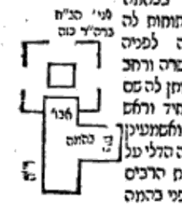

The third is in the normally reliable Zhitomir edition of 1862. It completely misplaces the אבוס by not having it extend into the area surrounding the well.
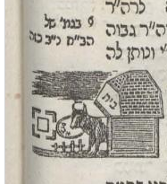

It turns out that the depiction attributed to the Bach appearing in the first printed edition of Hagahot HaBach is more in line with the words of Rashi than the “improvements” to that depiction made in subsequent editions.

Manger is defined as a “long open box or trough for horses or cattle to eat from”. I use “trough” as a definition for אבוס. Jastrow ( 1926 edition, page 4)defines it as either a feeding receptacle, bowl for working men, manger, stall or stable. Manger/trough seems to be what is meant here because the dimensions are given as at least ten Tefachim high and four Tefachim wide and it is stated that it is standing on the ground Steinsaltz English translation renders our case (available on Sefaria) “….eating from a manger or trough that stands in the public domain that is ten handbreadths high and four handbreadths wide”
All translations are based on Sefaria.org, the William Davidson Talmud based on the Steinsaltz English Talmud
While there are a few Gemarot at the NLI which were hand copied from the actual Gemara of the Bach, there is not one for Eruvin. Therefore, the first edition of the Bach is our only source for what the Bach’s diagram actually looked like.
Amudim B’Toldot Sefer HaIvri, Hagahot U’Magihim , Spiegel p. 366 , (Ramat Gan, 2005) the paragraph beginning with the words “Sof Davar…”
I examined four other Rashi manuscripts on this Daf and none had a diagram. Also, none of them, nor any other Rashi text I saw include the word “Kazeh”. That would indicate there most likely was no diagram in the original Rashi work. However, we do have one manuscript with a diagram, and more importantly the Soncino Pesaro edition which contains quite a complex diagram. The editors of this edition worked from multiple manuscripts and often decided the text based on a majority. They did not add diagrams on their own and therefore they included this depiction based on the manuscript(s) they had.
After Soncino, until much later, empty spaces were left where Soncino had included a diagram. This Soncino diagram was the reason why an empty space existed in this Rashi in subsequent editions of the Talmud until Amsterdam 1717 which eliminated the empty space. It has stayed that way until today. Here is Bomberg 1522 Amsterdam 1646 Amsterdam 1717
One possible source for diagrams was the Chochmat Shlomo of the Maharshal which was printed in 1580 in Prague. It included many diagrams left out of the Bomberg Shas. It, however, has no diagram of this case.
The first time it was included in a printed edition of a Gemara was Fuerth 1829 (Maamar al Hadpasat ha-Talmud with Additions, ed. A.M. Habermann. Jerusalem, 1952 [Hebrew] p.132). However, it was only included for Masechet Berachot and Seder Zeraim. In 1832, Masechet Shabbat was printed without the Hagahot Ha’Bach. The rest of the Talmud was not printed there.
See footnote above on the Fuerth edition which did not include Eruvin. There was an edition printed in Vienna from 1830-1833 but according to Maamar al Hadpasat ha-Talmud, it did not include the Hagahot Ha’Bach. There was also an edition of the Talmud printed in Prague between 1830-1835, but it also did not contain the Hagahot Ha’Bach. This makes the Vilna/Horodna edition of 1836 the first to include the Hagahot Ha’Bach on Eruvin. (See pages 133-134 of Maamar al Hadpasat ha-Talmud)
Warsaw 1860 is exactly the same as Vilna/Horodna 1836
Maamar al Hadpasat ha-Talmud….p.142 writes"תבניתו פוליו גדול ויפה מאד"
I examined three of the newer editions of Shas; Vilna HaChadash, Oz Vehdar and Vagshal Nehardea. They all had improved substantially on the picture depicted in the Vilna Shas. Here is Vagshal https://hebrewbooks.org/pdfpager.aspx?req=37954&st=&pgnum=51

