ערובין כ״ו עמוד א׳ - "פירא דבי תורי”
By: Eli Genauer
... והאמר רב הונא מחיצה העשויה לנחת לא שמה מחיצה, דהא רבה בר אבוה מערב לה לכולה מחוזא ערסייתא ערסייתא משום פירא דבי תורי, והא פירא דבי תורי כמחיצה העשויה לנחת דמיא
But Rav Huna has said, a Mechitza built for storage ( meaning to protect something that is stored) is not considered a Mechitza ( for residential purposes), because Rabbah bar Avuha made Eiruvei Chatzeirot for the entire city of Mechoza, neighborhood by neighborhood, because of the ditches that held food for the oxen, and Mechitzot built to protect ditches used to store food for oxen are like Mechitzot built for storage (and therefore not valid for residential purposes)
רש״י
משום פירא דבי תורי - שוחה עמוקה היתה בין שכונה לשכונה ושם היו מניחין גרעיני תמרים לאכול השוורים והעיר אין לה חומה ומבואות של (בין) [בתי] השכונות מפולשים ועשו מחיצות לראשי המבואות לכל צד שחוץ לעיר להשתמר הגרעינין ולא חשיב ליה מחיצה לצרף את המבואות ולעשות העיר אחת ואע"פ שמחיצה של קיימא היתה:
There was a deep ditch between each neighborhood, in which they would put date pits as feed for the oxen. The city did not have a wall around it and the alleyways of the houses were open (to the outside). And they made partitions at the end of each alleyway on each side facing the outside of the city to guard/protect the (date) pits..nevertheless this type of partition was not considered valid to join together the alleyways and make the city as one unit, even though these were permanent partitions.
It looks like this: ( Courtesy of “Peirush Chai”) You see houses on the perimeter of the city which almost close off the city with a wall. But you also see a few areas where there are alleyways that extend towards the outside of the city. These alleyways have been closed off with Mechitzot.
Mechoza was almost completely enclosed as it had houses surrounding it on each side. But it also had areas where the alleyways between the houses led to the outside of the city and these were open. That would mean that the city was not completely enclosed. But because of the fact that there were storage ditches inside the city, the people put up partitions where the alleyways opened to the outside of the city to protect/guard the stored animal feed. It turns out that the city was then completely enclosed….but the partitions put up at the end of each alleyway, because they were installed for protective and not residential purposes, did not function to unite and enclose the city.
In the classic Vilna Shas, there is a diagram/picture in Rashi which supposedly illustrates the words of Rashi.
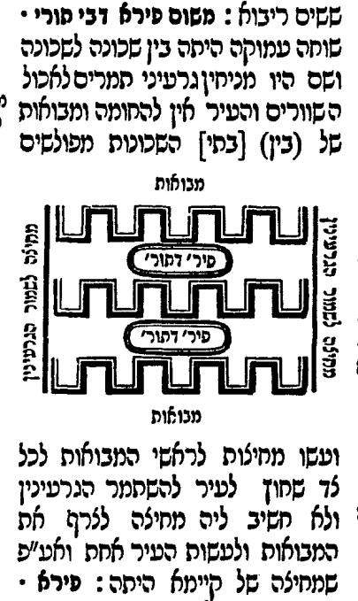
There a number of issues with this picture
- The Mevo’ot are outside of the perimeter of the city
- Rashi seems to say that the Mevo’ot lead to the outside of the city on all sides לכל צד and this diagram shows them only extending on two sides. It does show correctly that a Mechitza is built where the Mavoy extends towards the outside of the city
- You do not get the feeling of the city being enclosed on the top and bottom side
- There is nothing that looks like houses on the perimeter of the city
Let us now look at the history of this diagram. One thing we notice is that Rashi does not contain the word “Kazeh” which makes us wonder if this diagram was originally included in Rashi’s own text.
Looking at some of the early manuscripts of Rashi confirms that there may not have been a diagram in the original Rashi. Manuscripts and first printed editions (because they are based on manuscripts) are generally known as “Eidi Nusach”.
This is the earliest manuscript we have. As you can see, there is no “Kazeh” and no diagram. Start with "פירא דבי תורי” in the middle of the third line.
Bavarian State Library Munich Germany Cod.hebr. 216
From the 1200’s
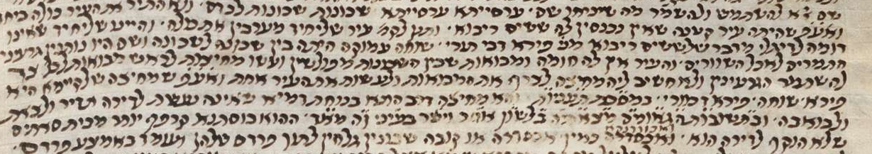
The following are some other manuscripts which also do not have the word Kazeh or a diagram. ( Start with first line, second word. ) All of these manuscripts contain diagrams in other Rashis in Eruvin.
Shelfmark: Bodleian Library MS. Oppenheim Add. 4° 23
1426-1475
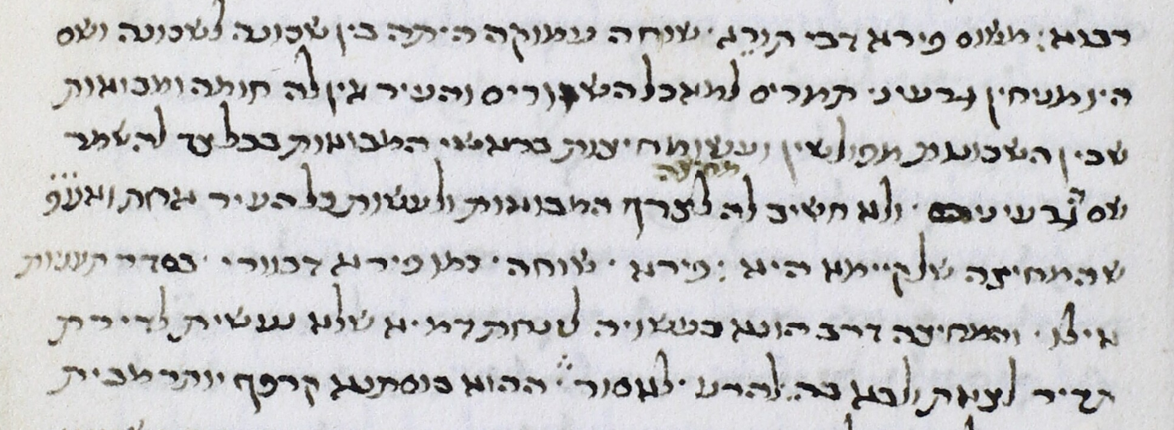
The National Library of Russia, St. Petersburg, Russia Ms. EVR II A 223/3
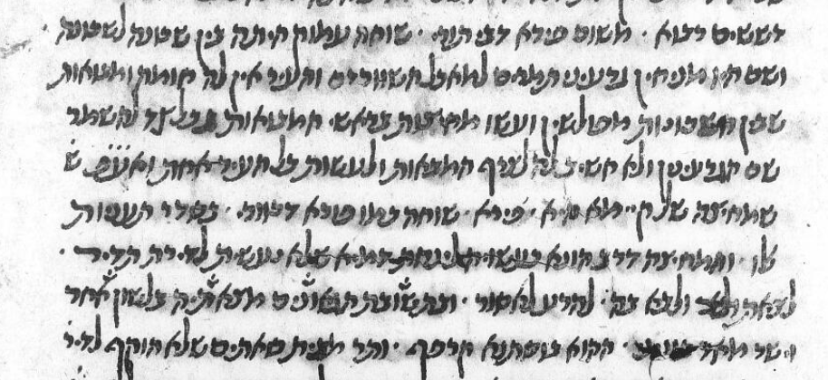
Paris BN 324
13th-14th century
Starts with last three words on second line
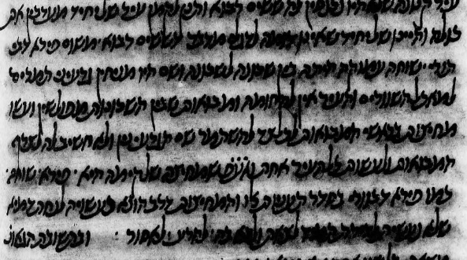
The first printed editions of Eruvin do not have the word Kazeh, a diagram, or even space for a diagram.
This is despite the fact that it contains diagrams throughout the Masechet.
Soncino family, Pesaro, Italy – 1511
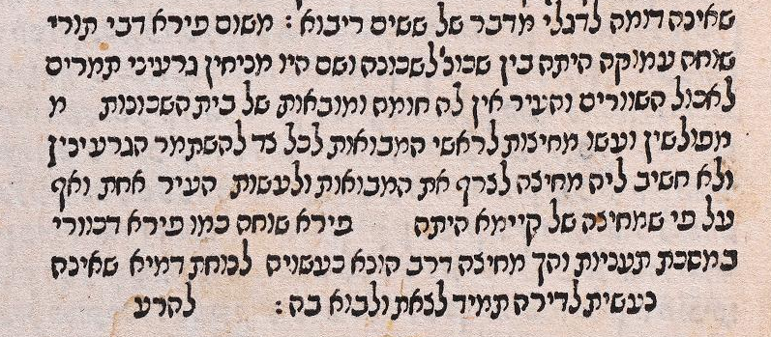
The Bomberg edition, Venice 1522, did not contain any diagrams, but it did leave space for them many times. Here there is no empty space left.
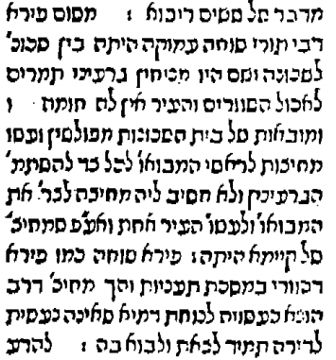

At this point it does not look very promising for the existence of this diagram before later printed editions. (The first time this diagram appeared in a printed edition was in the Frankurt on Oder edition of 1697)
But there are two manuscripts which not only have a diagram, but also have the diagram fitting into Rashi’s words.
Here is the first one
The Jewish Theological Seminary of America, New York, NY, USA Ms. 6499 (Rab.718)
14th Century
Second line starting with last four words
http://aleph.nli.org.il:80/F/?func=direct&doc_number=000054530&local_base=NNL01

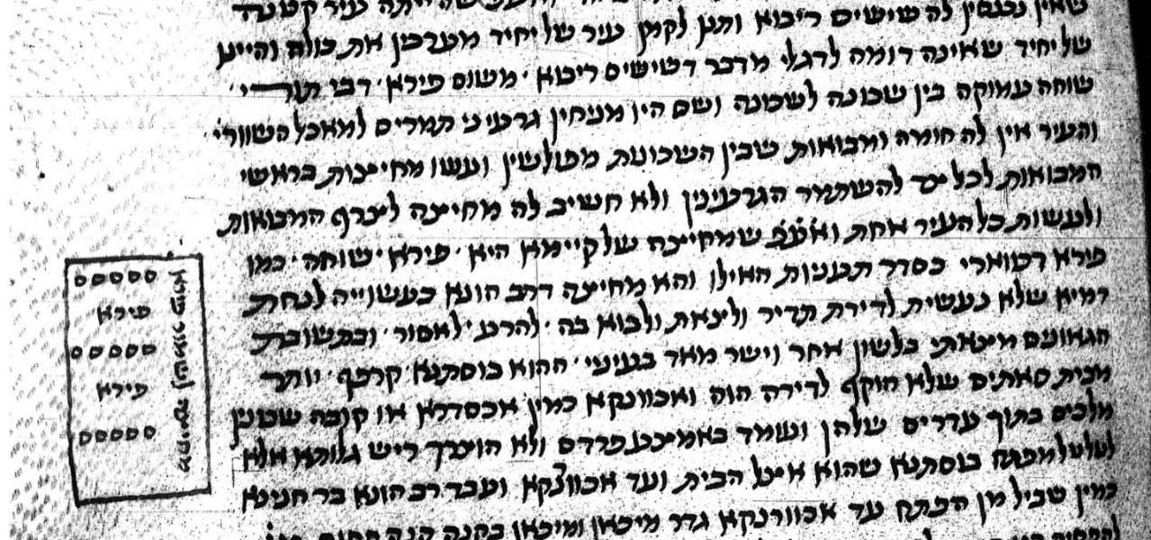
A close up shows houses on the perimeter and Mechitzot surrounding the city with the notation “Mechitzot Lishmor Peiri”
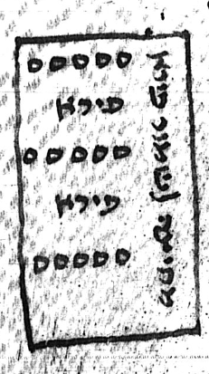
The second manuscript looks like this.
Vatican ebr.127 – second line of the Rashi on top, about midline.
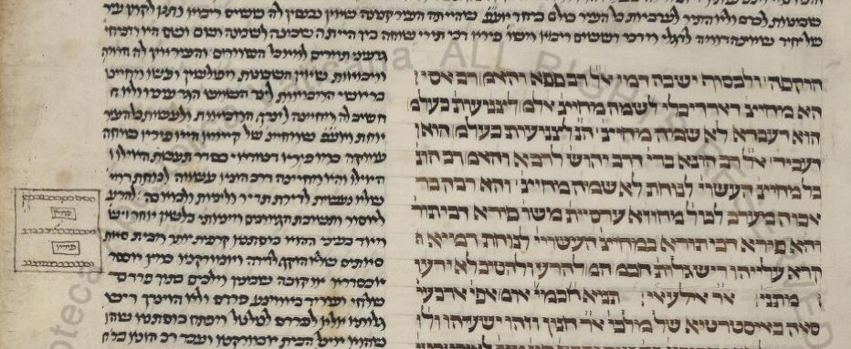
A close up shows “houses” on the perimeter and “Mechitzos” surrounding the city on all sides.
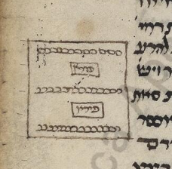
As I mentioned, the first time this type of diagram appears in a printed Gemara was the Frankfurt on Oder edition of 1697. It is fairly accurate in that it depicts houses on the perimeter and also all four sides somehow being enclosed even if it doesn’t identify those closures as Mechitzot
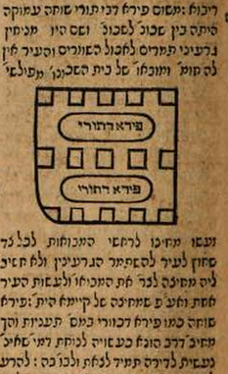
What was the source for this diagram? It is obvious that it came from the Chochmat Shlomo ( Prague 1582) as you can see the same curvature of the wall on the bottom left hand corner. The Maharshal’s diagram even includes the words “Mechitza Lishmor Peiri D’Toari” on all four sides to really illustrate the words of Rashi. These words were cut out of the Frankfurt on Oder edition most likely because of space limitations.
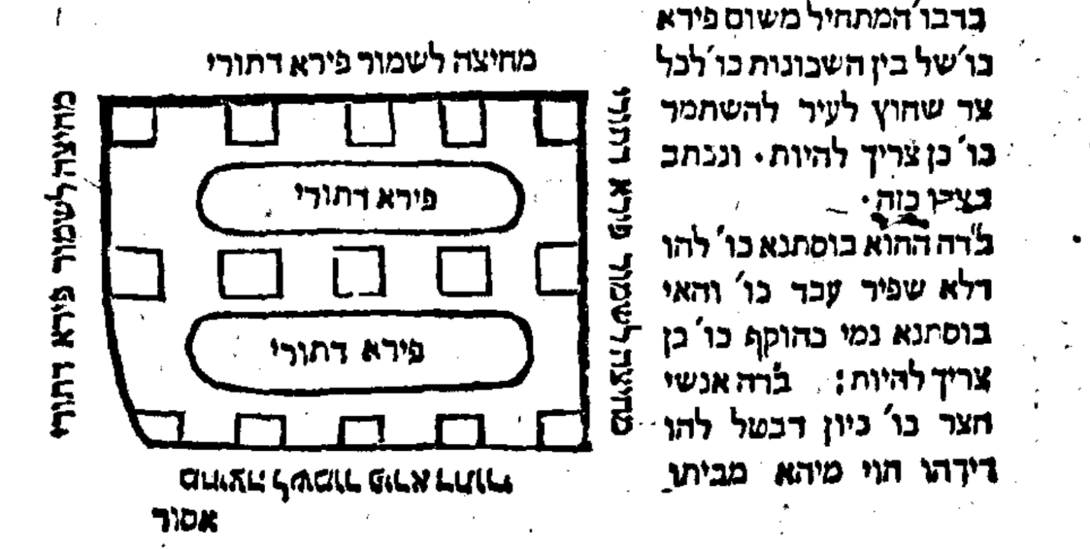
It is important to note that the Maharshal (1510-1573) lived at a time that the transition between manuscripts and print took place and the diagrams he drew in his Gemara (which were later published as the Chochmat Shlomo, Prague 1582) either reflected manuscripts he had, or his understanding of the text. Either way, they have outstanding Yichus. We sometimes find diagrams included in two other contemporary Seforim, Chochmat Manoach and Omek Halacha but they do not have a diagram for this.
How did the diagram end up the way it did in the Vilna Shas?
It seems to be based on the next printed edition of the Talmud after the one in Frankfurt on Oder, and that would be the Eruvin printed in Amsterdam in 1716.
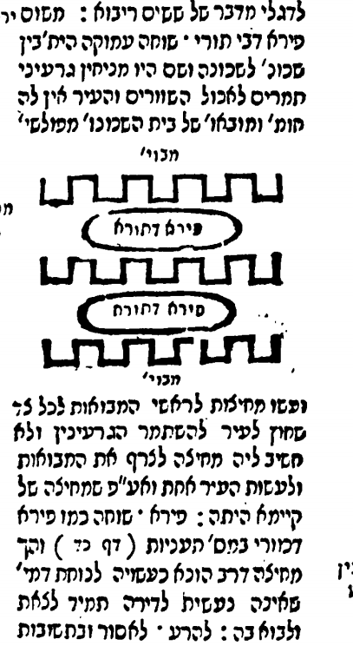

Amsterdam 1716 Vilna 1882 adds the idea of Mechitzot on two sides
.

What has happened to the diagram since the Vilna Shas?
There are three new editions I checked, Vilna HaChadash, Nehardea ( Vagshal) and Oz Vehadar
You can see that two out of the three were very aware of the issues facing the Vilna Shas diagram and made extensive changes to it.

Nehardea – Substantially changed from Vilna 1882
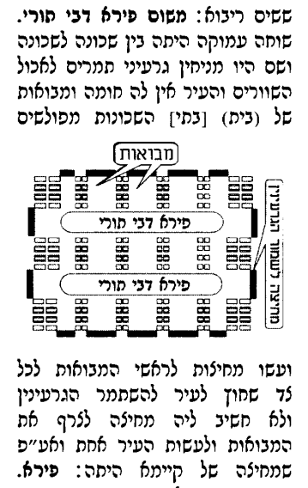
Oz Vehadar HaMurchav – Very similar to Vilna 1882
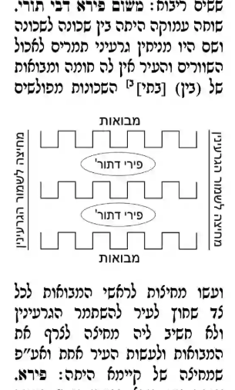

Vilna HaChadash -Substantially changed from Vilna 1882
