“מפני שהוא מפסיד את הזויות “
EIRUVIN 56B
Eli Genauer

The Gemara in Eruvin 56b deals with measuring the limits of travel outside of a city on Shabbat. While one can leave the city on Shabbat, one cannot travel more than 2000 amot (cubits) beyond city limits. Specifically, calculating 2,000 amot is fairly simple when the city limits form a square or at least bisect at 90 degrees. When, however, a city is not square shaped but instead the city limits present as a circle, the calculation of 2,000 amot is complicated.
תנו רבנן המרבע את העיר עושה אותה כמין טבלא מרובעת וחוזר ומרבע את התחומין ועושה אותן כמין טבלא מרובעת וכשהוא מודד לא ימדוד מאמצע הקרן אלפים אמה מפני שהוא מפסיד את הזויות אלא מביא טבלא מרובעת שהיא אלפים אמה על אלפים אמה ומניחה בקרן באלכסונה, נמצאת העיר משתכרת ארבע מאות אמות לכאן וארבע מאות אמות לכאן נמצאו תחומין משתכרין שמונה מאות אמות לכאן ושמונה מאות לכאן נמצאו העיר ותחומין משתכרין אלף ומאתים לכאן ואלף ומאתים לכאן .אמר אביי ומשכחת לה במתא דהויא תרי אלפי אתרי אלפי
The Gemara is concerned with measuring that 2000 amot distance when the city is not square but is circular and whose circumference is 2,000 amot. The Gemara explains that first one must “square the city,” which adds 400 amot to the normal limit of 2,000 amot in each “corner” of the circle. That is, encompass the circle with a square. Second, add another 800 amot from the newly squared corner’s 2,000 amot limit and draw a diagonal line outwards in all directions. Third, and finally, draw a straight line across and up from these new diagonal endpoints and we will have the actual limits of travel outside of the city wall in all directions. It turns out that you are allowed to travel 2,000 amot from one point in the city wall, but 3,200 amot from another point of that wall. Confused? A diagram or a series of them would certainly be most helpful.
The idea of squaring a circle is not that difficult to picture and that this adds area to the circle is also easily imagined.
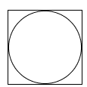

The difficulty with this passage lies in picturing what it means when it says that by measuring diagonally from the middle of the corner, we would then lose the corners. Thankfully, there is Rashi to explain this idea to us but he needs approximately 275 words in which to do it.
In this extraordinarily long explanation, in essence, Rashi explains that the issue is that merely squaring the circle is insufficient to determine the techum distance because that results in the only point from which one can walk a full 2000 amot is from the corners of the square. If one were to walk from the midpoint of the curvature of the circle, they would only be able to walk 1428 amot outside the city from that point and not the full 2000. Rashi explains the concept by creating 8 square boards measuring 2,000 by 2,000 amot surrounding the city like this: (Diagram from Daf Yomi Advancement Forum website)
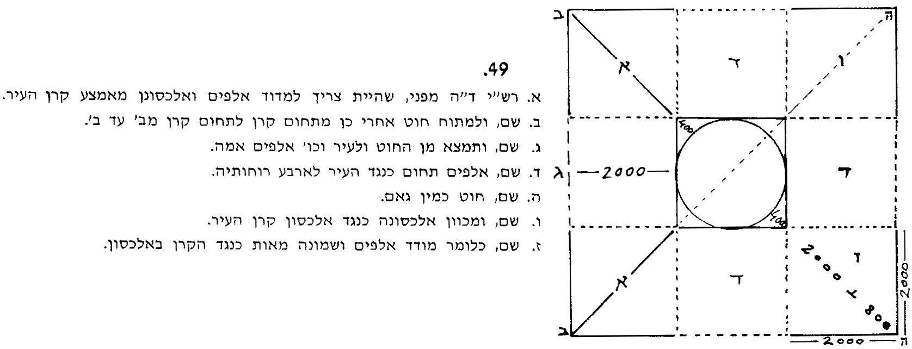
In this manner, from the midpoint of the city outwards will be a Techum of 2,000 amot, and at the corners the Techum will be 2,800 amot. When you add that to the 400 amot you gained already in the corners by squaring the city, you end up with the Techum being 3,200 amot at its longest.
In the standard version of the Talmud Bavli, the Vilna edition (Eruvin,1881), the illustration as drawn is unhelpful, and likely creates more confusion than it aids. The diagram appears as such:
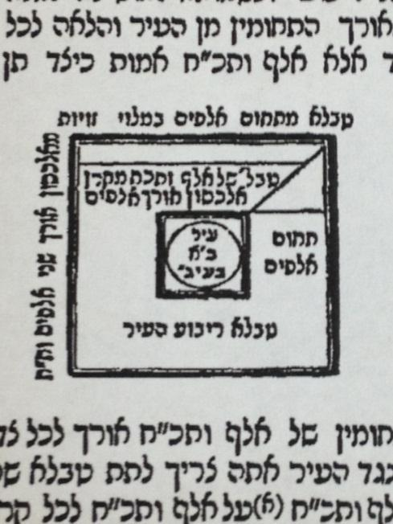
What this diagram intends to illustrate is the different steps it takes to reach the end point of Rashi’s explanation of the text. In the middle of the diagram is the circular city that is 2,000 amot “b’igul” (“encompassed by a circle”). A square surrounds the city. Then it gets a bit unclear. The bottom of the outside square, reads “tabla rivuah ha’ir” meaning a board or rectilinear element which squares the city. In reality, there are two boards or elements that act to square this city that are then shown. The inside square board is what occurs if you only go out 2,000 amot from the right-hand corner of the board squaring the city. There is only one line going from right to left at that point and it says “tabla shel 1428 amot mi’keren alachson shel 2,000.” Meaning, drawing a diagonal line of 2,000 amot from the right-hand corner of the squared city outwards, will result in the square boards being only 1428 amot by 1428 amot and in the techum being only 1428 amot outwards from any of the midpoints of the squared city.
In this diagram, however, the diagonal line going outwards from the right-hand corner of the squared city then continues and ends up meeting up with a line that then extends as a square around the entire city. That is the result of what occurs when you extend the diagonal line 2,800 amot resulting with 8 squares of 2,000 amot each (which are not shown) and the techum of 2,000 amot from any midpoint of the squared city. To be clear, the diagram is not incorrect per se, and it really tries to illustrate in one picture what should probably take two or three steps, but one wonders if this is the way Rashi originally drew this diagram. Unlike in other instance where the text includes the word “kazeh” “like this” indicating an illustration, here there is no such indication, as the text does not include “kazeh.”
What type of diagram appeared in the “original” Rashi? The first edition of the complete printed Talmud, Bomberg circa 1520, contains only a blank space where the diagram should be.
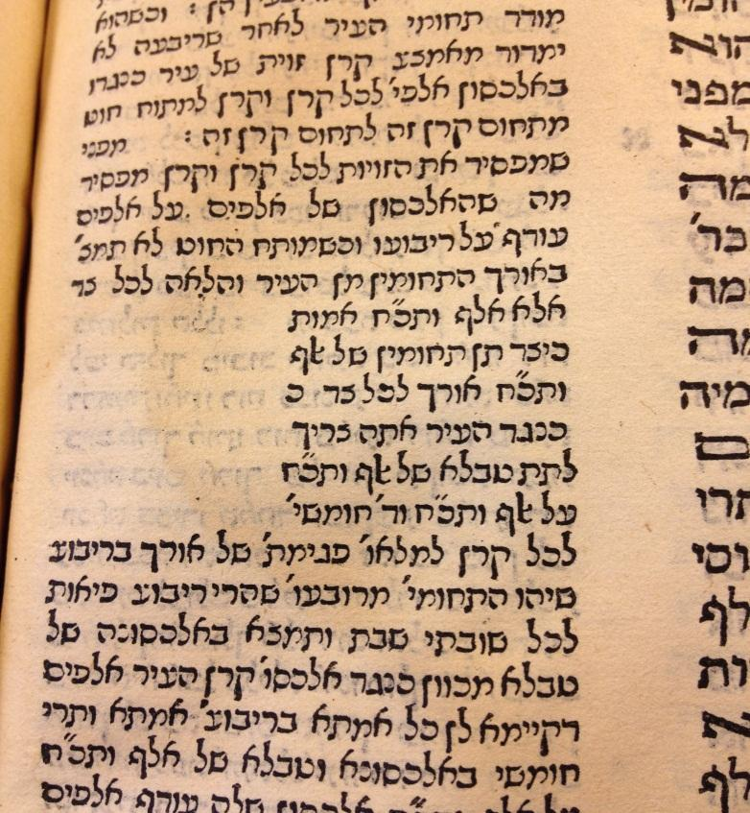
However, a previous edition printed by the Soncino family in Pesaro, Italy in 1511 contains an actual set of diagrams. The equivalent page to our 56B is very different from ours and looks like this.
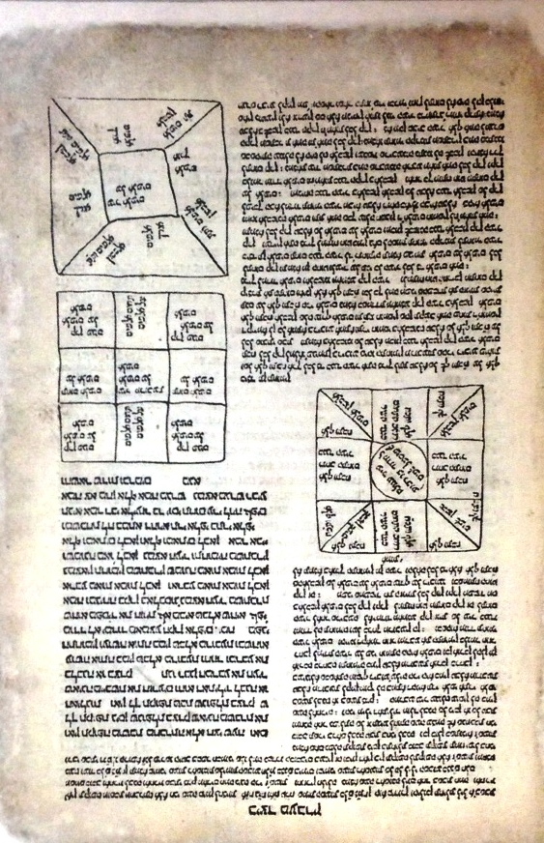
As you can see, this page contains three diagrams. They are all diagrams relevant to our 275-word Rashi. The first diagram illustrates what happens if you draw a diagonal line of 2,000 amot from the corner of the squared city. The result is a techum of only 1428 amot from the midpoint of the squared city. The second diagram illustrates how to construct 8 boxes each of which are 2,000 amot square all around the city. The third diagram illustrates that the result of doing that is having the diagonal line go out 2,800 amot from the corner of the squared city with the result being that there is a techum of at least 2,000 amot from any point in the city. These perfectly illustrate the complex passage.
The question now is, what was Gershon Soncino’s source for these diagrams? Were they missing or different in the Rashi manuscript that he copied from and he just made up his own diagrams? Or more likely, did he copy them from a Rashi manuscript that he had?
To begin to answer those questions, we have to look at a manuscript copy of our Rashi. The one we will now study is referred to as NY JTS RAB 718 and is being used with the permission of the JTS Library. This Rashi manuscript was written in the 14th century in Italy and it would make sense that it might have been available to Gershon Soncino in Italy a little over 100 years later.
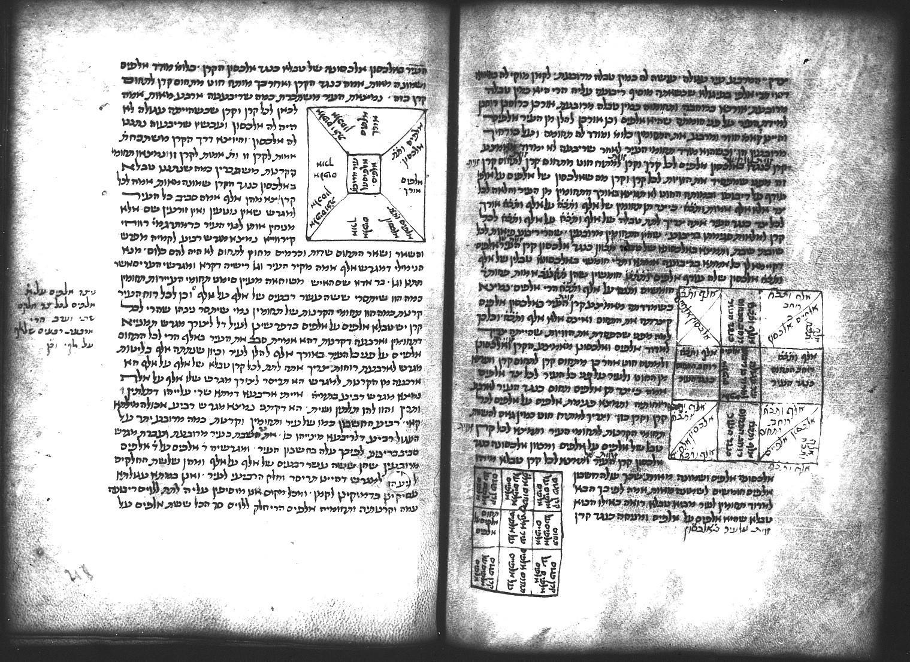
Does that look familiar? These three diagrams are nearly exactly reproduced by Soncino, in his Pesaro edition. Not just the diagrams, but all the words in the diagrams are exactly the same. It seems clear to me that this manuscript (or a copy of it) is the source for Soncino’s diagrams.

We find a very similar set of drawings in an earlier manuscript identified as National Library of France, Paris, France Ms. hebr. 324 (13th-14th century)
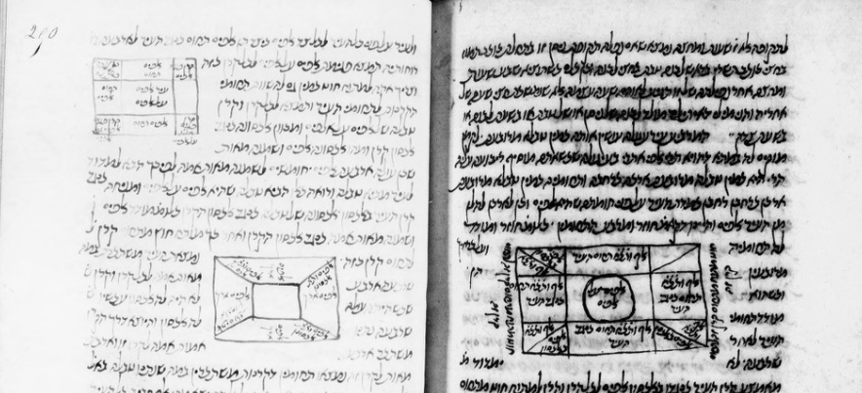
There is a similar set of drawings in Bodleian Library MS. Oppenheim Add. 4° 23 (1426-1475) with the first one appearing as follows
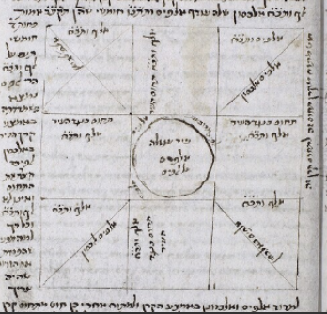
It seems fairly clear that these types of diagrams appeared in the “original” Rashi.
Let us now return to the Bomberg 1520 edition and see whether the editors had access to Soncino’s 1511 edition or to a manuscript similar to the ones shown above.
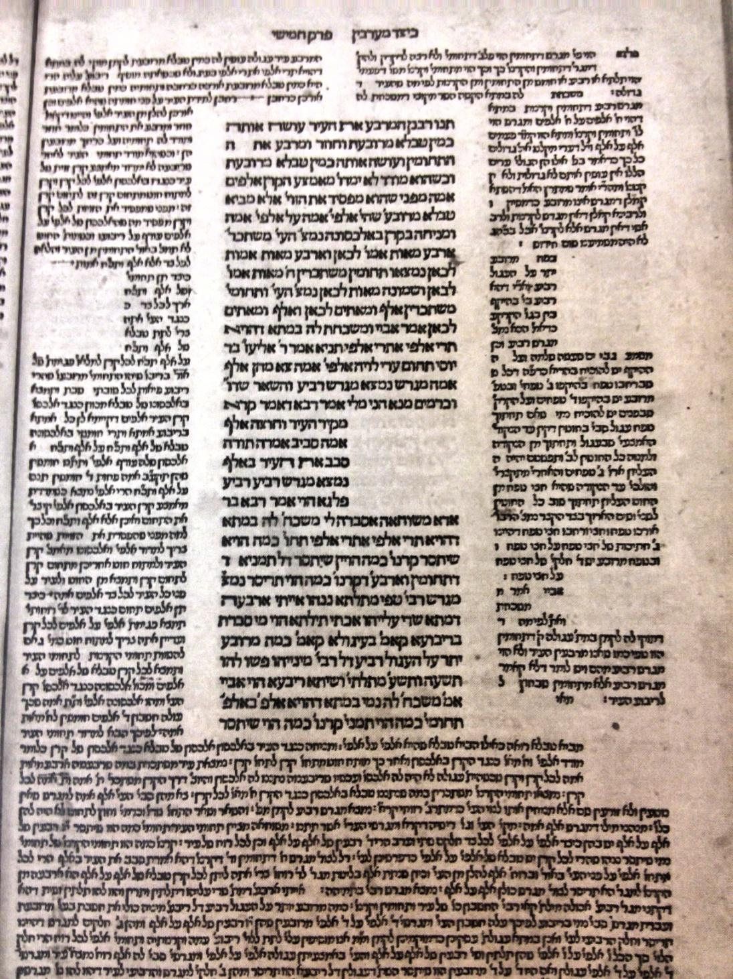
You can see that Bomberg left five blank spaces on 56B. One is squarely in the middle of our Rashi as we have it today, another seems to be in the text of the Gemara, and there are three more on the right side of the page. The top two are in the commentary of Tosfot, but the bottom one seems to be more in the text of Rashi. It is clear to me that Bomberg left room for the second Rashi diagram in the text of the Gemara, and the third one on the right side of the page on the bottom. That is the same method employed in Soncino’s edition and also in the manuscript edition. Bomberg knew there were three diagrams with this Rashi and he left room for all of them. Subsequent printed editions retained these two extra spaces for diagrams notably 1580, Basel, 1584 Constantinople, and 1644 Amsterdam.
In our case, it is possible that the original Rashi included three diagrams, those diagrams were included in the first printed edition, that of Soncino in Pesaro, they were not reproduced in any printed edition for almost 200 years, and reappeared as one completely different diagram in the early 1700’s.

