"דקיימי כחצובה"
Eruvin 85b- Does the Diagram Belong in The Text of the Gemara?
Eli Genauer
On Eruvin 85b we find one of the few times that a diagram appears in the text of the Gemara
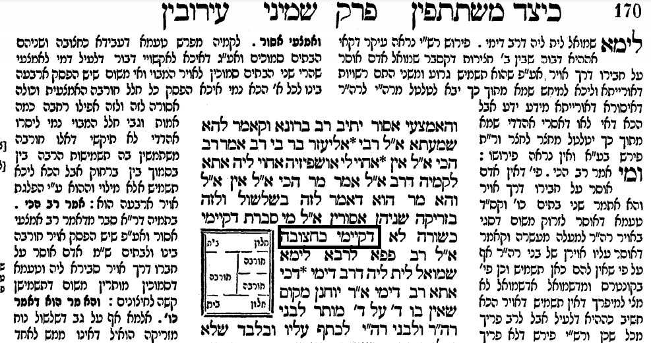
The picture is illustrating the words “דקיימי כחצובה” - “They are arranged in the form of a חצובה”
(Note: even though the Gemara text of all modern printed editions of the Talmud have the Girsa as “דקיימי כחצובה” all Gemara manuscripts, early printed editions, and the Dibur HaMatchil of Rashi in printed editions have it as כחצובה דעבידא)

The main issue here is with the placement of this diagram in the text of the Gemara. It makes it seem as if this diagram is as integral to the Gemara as the words. However, there were no diagrams in the original text. The text of the Gemara consisted of many hundreds of years of discussion which were handed down orally and, and while words can be transmitted orally, it would have been impossible to transmit a diagram in that manner. In the words of Hillel Gershuni of the Friedberg Jewish Manuscript Society and its Hachi Garsinan section “I find it quite obvious that no one ever thought of attributing diagrams to the Talmud itself, which was transmitted orally for centuries”. Not surprisingly, we do not find this diagram in any manuscript of Eiruvin. We do not find it in the earliest printed editions of Eiruvin ( Soncino Pesaro c.1511 and Bomberg Venice 1522) which were based on manuscripts. As we will see, the first time it appeared in print was in the Berman Shas of 1697, it was modified in the Amsterdam Shas in 1716, and has remained there since that time.

Some background on the Sugya
Eiruvin 85a on the bottom, continuing on to 85b – Courtesy of Sefaria and the William Davidson Talmud
…ְאָמַר רַב נַחְמָן אָמַר רַבָּה בַּר אֲבוּהּ אָמַר רַב: שני בתים ושלש חורבות ביניהם זה משתמש בסמוך שלו על ידי זריקה וזה משתמש בסמוך שלו על ידי זריקה והאמצעי אסור... אמר ליה, והא מר הוא דאמר, לזה בשלשול ולזה בזריקה שניהן אסורין? אמר ליה מי סברת דקיימי כשורה, לא דקיימי כחצובה.
Rav Nacḥman said that Rabba bar Avuh said that Rav said , if there are two houses with three ruins between them, the resident of this house may use the ruin adjacent to him by means of throwing into it, and the resident of the other house may use the ruin adjacent to him by means of throwing into it, and the middle ruin is prohibited to both of them. He (Rav Elazar) said to him…. But wasn’t it you (Rav) who said: With regard to a place that can be used by the residents of the one courtyard only by lowering an object down to it and by the residents of another courtyard only by throwing an object on top of it, both sets of residents are prohibited from using it? He said to him, do you think that we are dealing with a case of three ruins positioned alongside each other in a straight line? No. They are arranged like a חצובה.
It was originally thought that when Rav said a Halacha, it was a case where there are two houses and three חורבות(ruins) positioned alongside each other in a straight line. (From Peirush Chai Eruvin p.177)
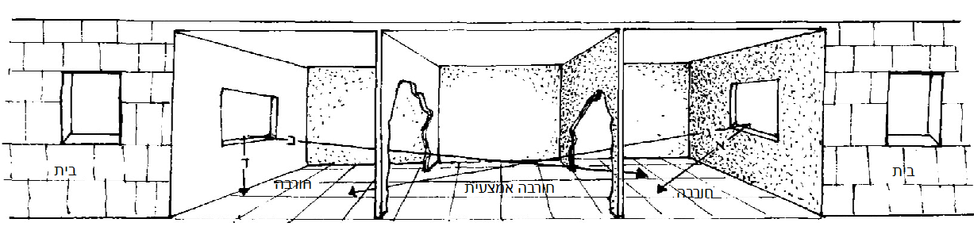
But this caused a difficulty with another statement of Rav.
The problem was solved by saying that the חורבות are not positioned in the manner shown above (like a שורה), but rather they are positioned like a חצובה.
As mentioned, the text of our Gemara has a picture of what it means when it says that the חורבות are positioned like a חצובה.
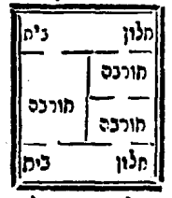
The Daf Yomi Advancement Forum makes the following comment on our Gemara, noting that the form of “דקיימי כחצובה is represented by the picture found in the text of the Gemara.
“Rav: You assume that the ruins are in a line. Really, they are in a triangle [like the picture in the Gemara]. Each is adjacent to the middle ruin”.
This drawing happens to reflect the opinion of Rashi, Ritva and also of Rav Shlomo Luria (as we will see later). However, there are many other opinions as to what it means “דקיימי כחצובה “
The מתיבתא Yalkut Biurim on Eruvin published by Oz Vehadar (2014) and available on Otzar HaChochmah lists many other opinions as to what it means. Its introduction to our Sugya begins like this.
“In the explanation of the form of דקיימי כחצובה we found various opinions among the Rishonim”
The first one they list is Rabbeinu Chananel and HaAruch which looks like this.
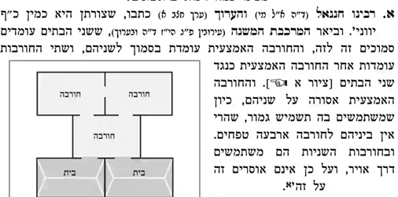
As you can see, the representation of the case is quite different from the picture in the Vilna Shas. It also proves that neither Rabbeinu Chananel or the Aruch were working from a text which had that picture.

It then lists the opinion of Rashi and Ritva. As you can see, it is like the picture in our Gemara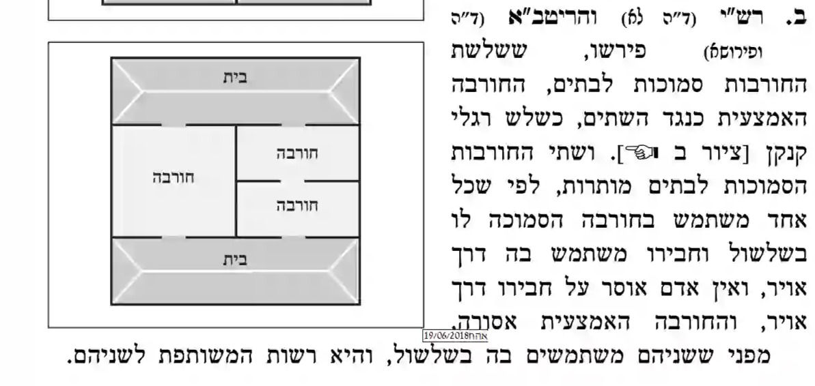
In addition to Rabbeinu Chananel and Rashi, "מתיבתא" lists many other Shitot, each with lengthy explanations.
Each one is represented by a different configuration. 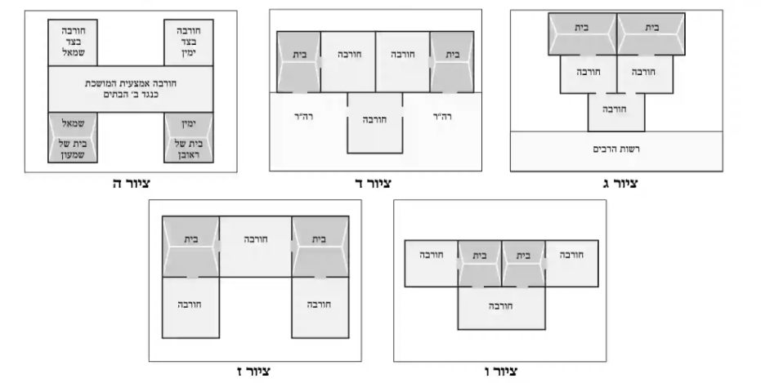
Diagrams 3 and 4 are the opinion of Baal Hamaor according to various Achronim. Diagram number 5 is Rashba and diagrams 6 and 7 are the opinion of the Rabbeinu Yerucham according to two different diagrams in the Bach. Again it is clear that none of these Rishonim were working with a Gemara text which had the Vilna Shas diagram embedded within it.
There are two manuscripts of this Gemara on the Hachi Garsinan website (Munich 95 and Vatican 109a) Neither manuscript has this diagram embedded in the text. The diagram is also not included in any early printed edition. Here is Soncino Pesaro circa 1511
.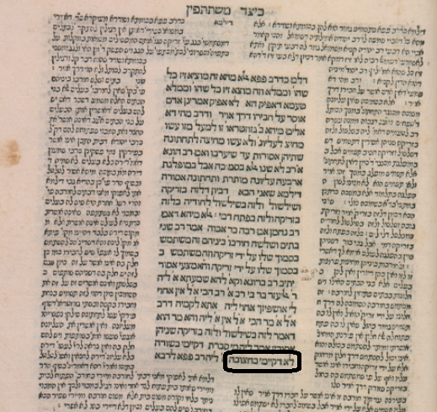
It did not appear in any printed edition until the Berman edition of Masechet Eruvin printed in Frankfurt an der Oder in 1697. Here is how it appears
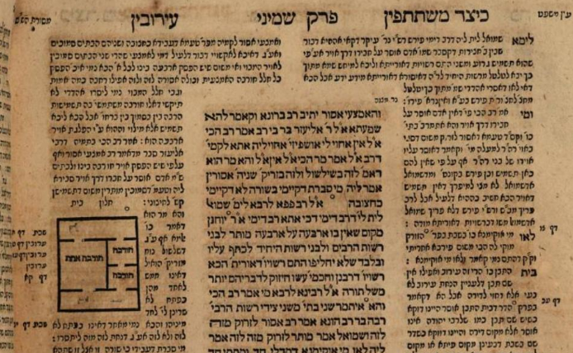
Note than even though the diagram is inserted inside the text of the Rashi, the small circle there which corresponds to the circle inside the Gemara text indicate that it belongs in the Gemara immediately after the word “ כחצובה “
It was first inserted into the text of the Gemara in the Amsterdam edition of 1716 and has remained there ever since
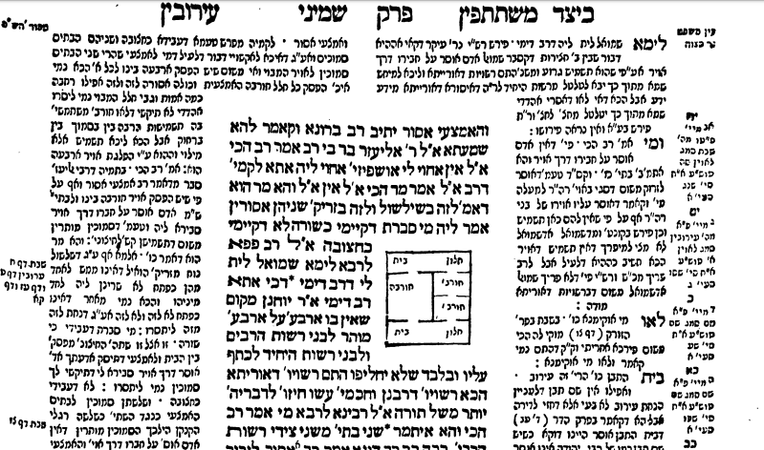
What was the source for this addition? Rav Refael Natan Nata Rabinowicz write in the Ma’amar al Hadfasat HaTalmud that the Hagahot and Tziyurim of the Frankfurt an der Oder edition came from Maharshal ( Rav Shlomo Luria, Chochmat Shlomo) Maharsha and Maharam Lublin. There are no diagrams found in the latter two sources, but we find an exact match in the Chochmat Shlomo ( Cracow 1582)
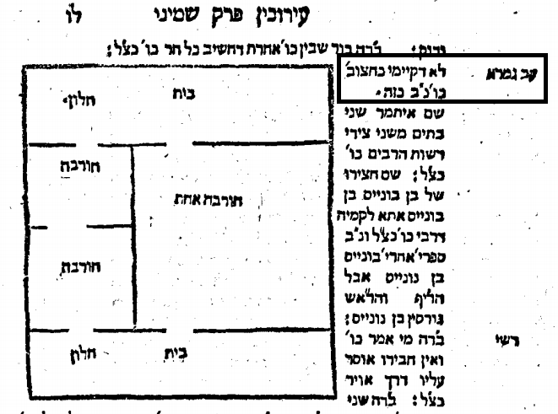
Chochmat Shlomo was printed after the death of Maharshal based on the notations he made in his Gemara.
We do not have a copy of the actual Gemara in which Maharshal drew his diagrams so we cannot be absolutely sure where he placed this picture and what notation he made. It seems more than likely though that he intended it just to show his opinion, and possibly that of Rashi, as to what was meant by the word “ כחצובה “.
It is interesting to note that it might be appropriate to insert a diagram in Periush Rashi. Four out of the five Rashi manuscripts I consulted (all available on KTIV) have a diagram inserted in the Rashi of "לא דעבידי כחצובה". Here is Oxford 420 Ms. Opp. Add. Qu. 23 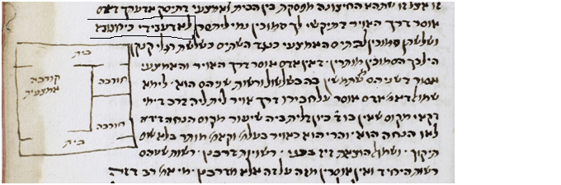
It looks remarkably like the diagram of Maharshal.

This manuscript, which even contains the word “כזה”, is known as Munich 216. It also contains a diagram quite similar to the one of Maharshal.
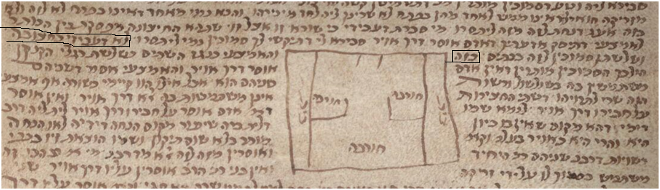
Conclusion:
I am reticent to advocate changing the Tzurat HaDaf especially since it is possible that Maharshal wanted his diagram to be inserted into the text of the Gemara and to become part it. But I don’t think it would be improper to recommend to publishers going forward to make a notation on top of the diagram that simply states "רש״ל".

It is noted with sadness the recent Petirah of Rav Chaim Porush ZT”L, the author of Peirush Chai.
Such as Bomberg 1522, Giustiani 1548, Basel 1580 and Amsterdam 1646. Bomberg 1522
R.N.N. Rabinowicz, Maamar al Hadfasat haTalmud with additions by AM Haberman, Mosad HaRav Kook, 2006 page 98
Ibid, P.63 – Bottom of the page, R.N.N. Rabinowicz writes as follows "כי חכמת שלמה לא כתבו הרב ז״ל בספר מיוחד ורק אחר פטירתו לגן עדן העתיקו בניו ותלמידיו מגליון התלמוד שלו מה שרשם על הגליונות מדי למדו בהם, כמבואר בהקדמת חכמת שלמה דפוס קראקא" Professor Yaakov Spiegel on page 312, footnote 84 of “Amudim B’Toldot HaSefer HaIvri, Hagahot U’Magihim, Ramat Gan 2005 also writes as follows "שהרי רש״ל לא התכוון להדפיס את הספר"

