Eiruvin 94b - בַּיִת שֶׁנִּפְרַץ מִשְׁתֵּי רוּחוֹתָיו
Eli Genauer
The Mishna on 94a discusses a case of a house, where when Shabbos began, it was permissible to carry (as all its walls were intact) but then two of its walls were breached on Shabbos. Is it permissible to carry within that house the rest of that Shabbos or not? Rabbi Yehuda says it is Mutar (הואיל והותר למקצתה: רש״י) and Rav Yosi says it is Assur.
מַתְנִי׳ - חָצֵר שֶׁנִּפְרְצָה לִרְשׁוּת הָרַבִּים מִשְׁתֵּי רוּחוֹתֶיהָ, וְכֵן בַּיִת שֶׁנִּפְרַץ מִשְׁתֵּי רוּחוֹתָיו, וְכֵן מָבוֹי שֶׁנִּטְּלוּ קוֹרוֹתוֹ אוֹ לְחָיָה — מוּתָּרִים בְּאוֹתוֹ שַׁבָּת, וַאֲסוּרִים לֶעָתִיד לָבֹא, דִּבְרֵי רַבִּי יְהוּדָה. רַבִּי יוֹסֵי אוֹמֵר: אִם מוּתָּרִין לְאוֹתוֹ שַׁבָּת — מוּתָּרִין לֶעָתִיד לָבֹא, וְאִם אֲסוּרִין לֶעָתִיד לָבֹא — אֲסוּרִין לְאוֹתוֹ שַׁבָּת.
I would like to focus on the Machlokes of Rav and Shmuel regarding the case ofבַּיִת שֶׁנִּפְרַץ מִשְׁתֵּי רוּחוֹתָיו. I will then focus on the Rashi which explains Shmuel’s opinion and whether the picture that is contained within the Rashi in the Vilna Shas is accurate. Finally, I will discuss the origin and evolution of that illustration and show how it changed even within three editions of Artscroll.
After establishing that the case in the Mishna is dealing with a breach which is less than 10 Amos, the Gemara on 94b analyzes the case of the house in which two of its walls were breached on Shabbos
“וְכֵן בַּיִת שֶׁנִּפְרַץ מִשְׁתֵּי רוּחוֹתָיו”. מַאי שְׁנָא מֵרוּחַ אַחַת, דְּאָמְרִינַן: פִּי תִקְרָה יוֹרֵד וְסוֹתֵם. מִשְׁתֵּי רוּחוֹת נָמֵי לֵימָא: פִּי תִקְרָה יוֹרֵד וְסוֹתֵם!
With regard to a house that was breached on Shabbat from two of its sides into a Reshus HaRabim, (the residents are permitted to carry in the house on that Shabbat, but not a future Shabbat). The Gemara asks: In what way is a breach on one side different? The difference is due to the fact that we say: The edge of the roof descends and seals the house, as if there were a full-fledged partition there. So too, when it is breached on two sides, let us say: The edge of the roof descends and seals.
פִּי תִקְרָה יוֹרֵד וְסוֹתֵם- “The edge of the roof extends downwards and seals”. The edge of a flat roof is considered to extend downward to the ground to form a legal partition. It thus renders the area beneath the roof a Reshus HaYachid.
אָמְרִי דְּבֵי רַב מִשְּׁמֵיהּ דְּרַב: כְּגוֹן שֶׁנִּפְרַץ בְּקֶרֶן זָוִית וְקֵירוּיוֹ בַּאֲלַכְסוֹן, דְּלֵיכָּא לְמֵימַר פִּי תִקְרָה יוֹרֵד וְסוֹתֵם.
The Gemara answers: The school of Rav said in the name of Rav: The Mishna is referring to a case where the house was breached in a corner, (which is not a normal place for an opening) and its roofing was inclined, as in that case, one cannot say: The edge of the roof descends and seals, (as the edge of an inclined roof does not appear to be the beginning of a partition.)
According to Rav , the house spoken about in the Mishnah which is breached on two sides (שֶׁנִּפְרַץ מִשְׁתֵּי רוּחוֹתָיו) has the following characteristics
- The breaches on two sides are actually on either side of one of the corners. (This despite the normal understanding of “breached on two sides” meaning that it was breached on two separate sides
- The roof of the house is sloped (despite most houses having flat roofs)
This is the way the house looks after it was breached in one corner and had a slanted roof.

Peirush Chai (p, 207 #73)
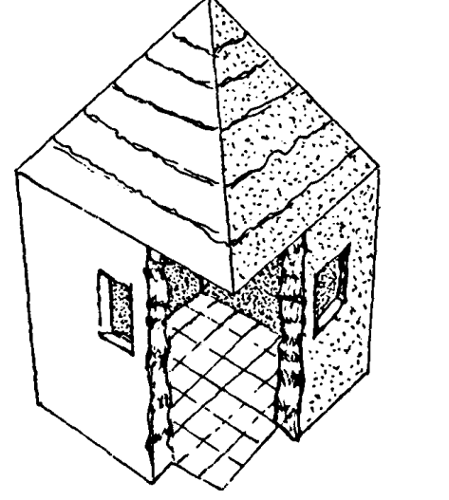
וּשְׁמוּאֵל אָמַר: אֲפִילּוּ בְּיָתֵר מֵעֶשֶׂר.
And Shmuel said: The Mishna is referring to a breach that is even wider than ten Amos.
אִי הָכִי, מֵרוּחַ אַחַת נָמֵי!.........
If so, why did the Mishna cite a case where it is breached from two sides? It should be prohibited to carry there even if it were breached from one side?……..

כִּדְאָמְרִי בֵּי רַב מִשְּׁמֵיהּ דְּרַב: כְּגוֹן שֶׁנִּפְרַץ בְּקֶרֶן זָוִית וְקֵירוּיוֹ בַּאֲלַכְסוֹן, הָכָא נָמֵי, כְּגוֹן שֶׁנִּפְרַץ בְּקֶרֶן זָוִית וְקֵירוּיוֹ בְּאַרְבַּע.
The Gemara answers: The reason is as the school of Rav said in the name of Rav: The Mishna is referring to a case where the house was breached in a corner, and its roofing was inclined, as in that case, one cannot say: The roof of the house descends and seals. Here too, Shmuel’s opinion can be explained in a similar manner: The Mishna is dealing with a case where the house was breached in a corner, and its roof is at a distance of at least four Tefachim from the breach, and is uneven. In that case, the principle of “the edge of a roof descends and seals”, would have to be applied to four corners, and Shmuel is of the opinion that it may not be applied in that case.
Rashi first explains what Shmuel means when he says that the case involves a house similar to the way Rav explained it, where the house was breached in a corner (despite the normative understanding of “breached on two sides”)
כדאמרי בי רב - דהאי שתי רוחות קרן זוית קאמר:
Rashi then explains that just like Rav rendered the case involving one Dochek (that two sides mean one corner), and then adds another Dochek of the roof being slanted, so too Shmuel understands the case to be where the breach is in the corner, but the second Dochek is not that the roof was sloped, but that when the walls fell away, part of the roof fell away with them
וקירויו - נמי אף עף על גב דלא איירי ביה מתניתין מבעי ליה לאוקומי שאינו כשאר תקרות אלא משופע לדידי נמי האי שתי רוחות חדא קרן זוית הוא וכגון שנפרץ זה הכותל מן הקירוי על פני כל הפרצה
Rashi then explains what it means when Shmuel says that a section of the roof collapsed with the walls in an uneven manner. (See diagram from Peirush Chai below)
סמוך לה במזרח ובצפון חמש אמות לכאן ברוחב ד׳ (טפחים) וחמש אמות ועוד לכאן ברוחב ד’ (טפחים)נמצאו כאן ארבע פיות שצריך לסתום פי תקרה בחמש אמות למזרח וחמש ועוד לצפון הרי שתי סתימות ועכשיו נמצאו סתימות הללו נמשכות לפנים בחלל הבית מרוחקות ממקום המחיצה ד׳(טפחים) לכאן וד׳(טפחים) לכאן וצריך לסתום פי תקרה ד’ (טפחים)בשפת מקצוע פרצת הקירוי המזרחי בדרומה משפת המזרחי ולכותל וכן ד’(טפחים) בשפת מקצוע פרצת הצפונית לשון קצר שנפרץ בקרן זוית וקירויו נפרץ בד’(טפחים) ברוחב לפנים למזרח וכן לצפון ואורך פרצת הקירוי חמש אמות לכאן וחמש אמות ועוד לכאן כמדת פרצת הכותל שיש כאן ארבע פיות תקרה אחת למזרח חמש אמות ארכה ואחת אורך ארבע סמוך לה בדרום ועוד אחת לנגד פרצת כותל הצפוני חמש אמות ארכה ואחת סמוך לה ארכה (ארבע) במקצוע מזרחית
Finally, Rashi explains that Shmuel maintains that you can never apply פי תקרה יורד וסותם four times to the same building
ובארבע לית לשמואל פי תקרה יורד וסותם:
There is a picture in Rashi in the Vilna Shas which tries to illustrate this complex case, but before we look at that, let us first look at the picture in Peirush Chai Eruvin which portrays the situation accurately. (page 209 #81)

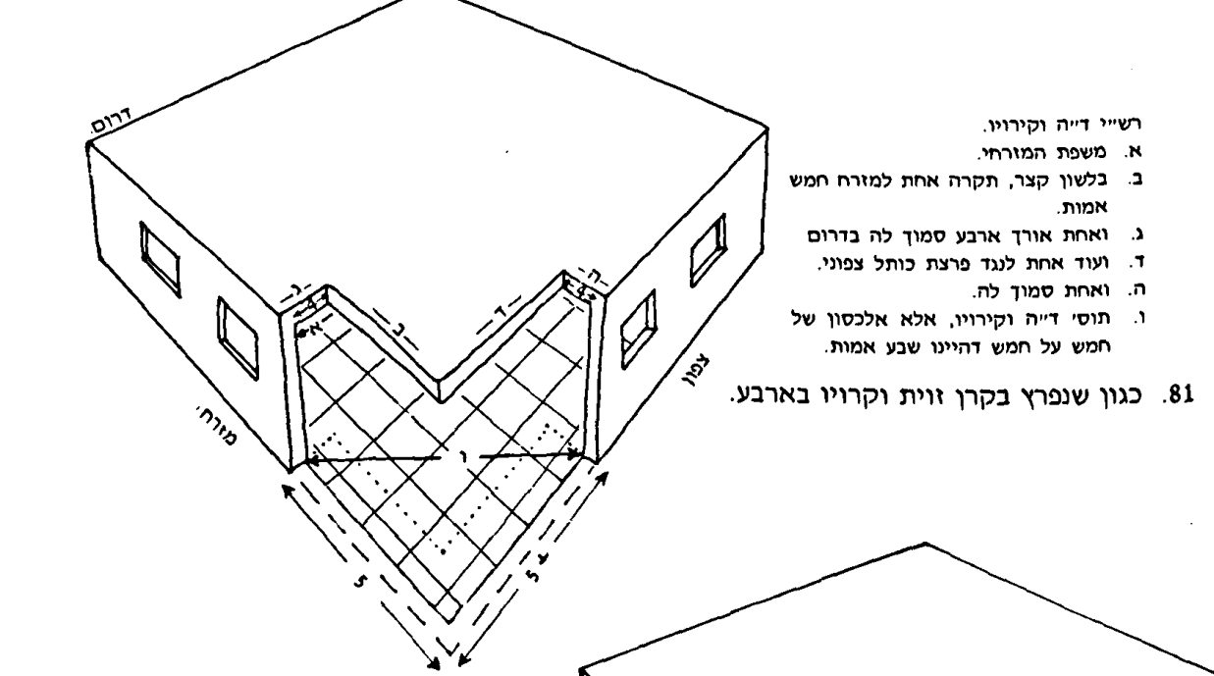

A five Amah piece of wall attached to a four Tefach piece of roof fell away, and another five+ Amah piece of wall attached to a four Tefach piece of roof fell away. (The breach is then more than 10 Amos)
One thing to note is that the measurements are drawn to scale in that 5 Amos looks much bigger than four Tefachim. You can also see that there are now four areas, indicated on the floor by the dotted lines, where to close them off we would need to apply the concept of “פִּי תִקְרָה יוֹרֵד וְסוֹתֵם “, and Shmuel’s opinion is that this cannot be done. (ובארבע לית לשמואל פי תקרה יורד וסותם )
Certainly, it would be helpful if Rashi drew a diagram to illustrate this complex case.
Here is the diagram in the Vilna Shas which attempts to illustrate this case (קירוי means roof). We assume that in some similar shape and form, it was included in the original Rashi, just as we assume the words of Rashi included in the Vilna Shas are from Rashi’s pen.
e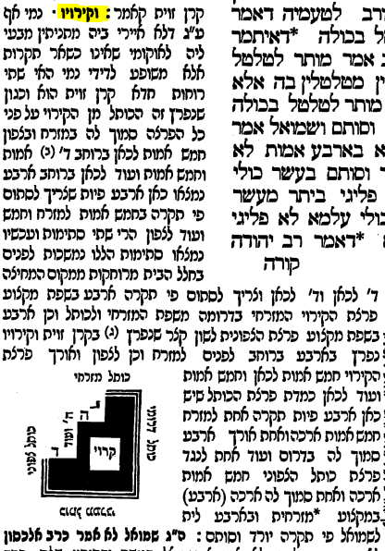 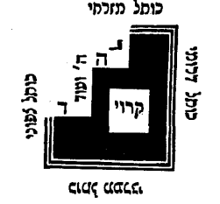
Note that Rashi does not indicate that there is a picture included, because we do not find the word “Kazeh” as we do so often when pictures are included. Although not as detailed as the illustration in Peirush Chai, it does give an idea that a four Tefach section which was attached to a five Amah section of wall collapsed, and that another four Tefach section of wall which was attached to a 5+ section of wall also fell away. This led to an uneven breach which created four places where פִּי תִקְרָה יוֹרֵד וְסוֹתֵם was needed. It is also clear from this picture that you are looking at the house from a vantage point above it because it labels the dark area “roof”. What is clearly not correct is the relative size of five Amos to four Tefachim.
Where did this illustration in the Vilna Shas come from?
To me it is clear that its origin was the Chochmas Shlomo (Cracow 1582) attributed to Rav Shlomo Luria ( MaHarShal). Rav Shlomo Luria often instructed that certain pictures be inserted in the Gemara, Rashi or Tosfos. Because his directions to include an illustration came from a manuscript (in this case a Rashi manuscript), or Mi’Sevara, they have very good Yichus. As you can see, in our Rashi he writes “נכתב בצדו כזה”.
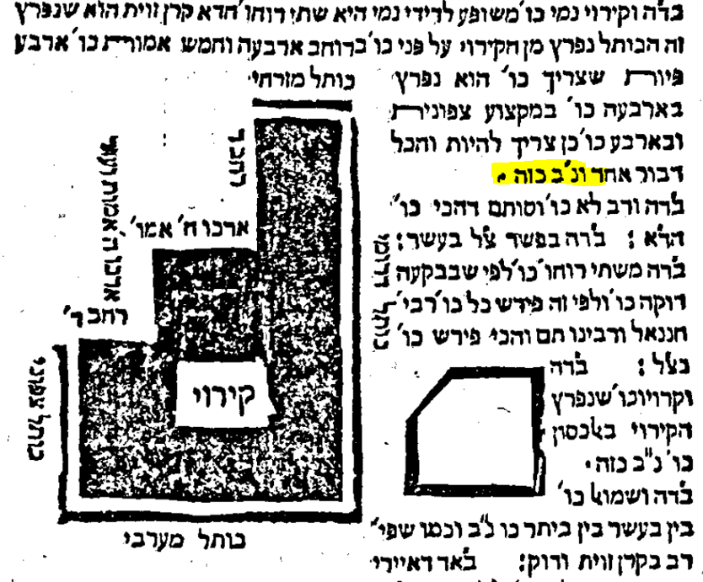
Here are the two drawings side by side
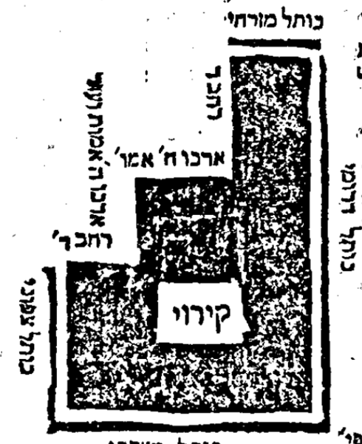
Chochmas Shlomo Vilna Shas
This drawing did not appear in the first complete printed edition of Shas, that of Daniel Bomberg (1519-1522) nor in any printed edition after that until Frankfurt/Oder 1697.
After that, the picture was portrayed in different ways, but all in all, fairly close to what appears in the Vilna Shas.

Are there any manuscripts which have a similar picture?
There are three ״עדי נוסח״ which testify to the existence of a similar picture in Rashi and affirm that the “original Rashi” had such a drawing
Bavarian State Library, Munich, Germany Cod. hebr. 216, Date: מאה י"ג, Style Script: Italian
https://web.nli.org.il/sites/NLI/English/digitallibrary/pages/viewer.aspx?&presentorid=MANUSCRIPTS&docid=PNX_MANUSCRIPTS990001278630205171-1#|FL47272669
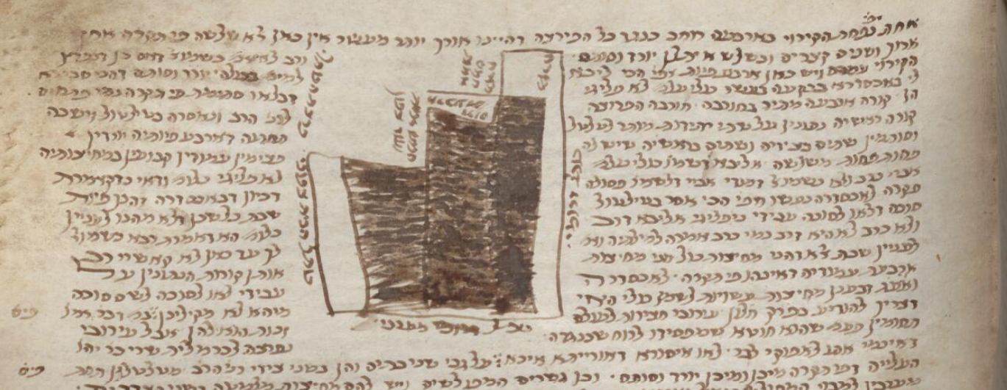
The basic structure of the diagram is remarkably similar to what we have today. It is highly unlikely that a Sofer or a student would insert such a detailed diagram into the Rashi text if they had not been copying from one that preceded it all the way back to Rashi’s time.
Here is a comparison of the manuscript drawing to that of MaHarShal. The main thing it is trying to show is that there are four corners which require closing by the concept of פִּי תִקְרָה יוֹרֵד וְסוֹתֵם
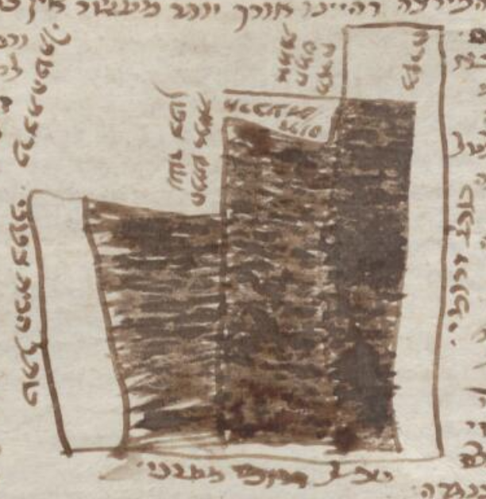
13th century manuscript MaHarShal mid to late 16th century
Here is another manuscript dated approximately 200 years later than the first and 100 years before MaHarShal
Bodleian Library MS. Oppenheim Add. 4° 23 – Date 1426-1475
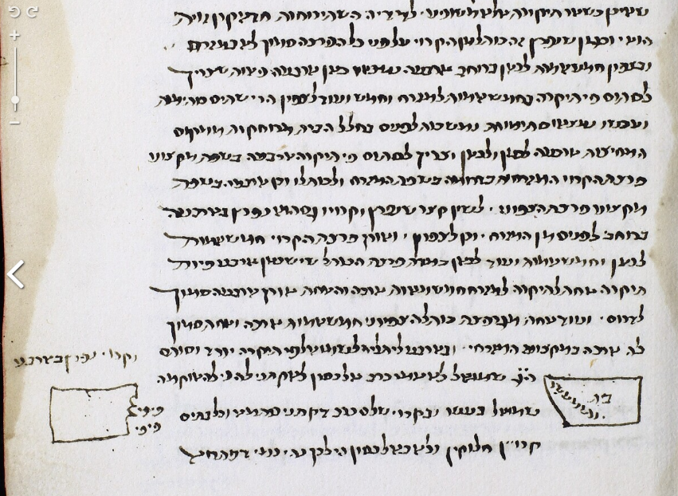
It is not as detailed as the first one but it tries to emphasize the four corners. נמצאו כאן ארבע פיות שצריך לסתום

Our last witness is a Gemara printed before Bomberg, and that is one printed by Gershom Soncino. These Gemaros were known for their accuracy. While not a manuscript, it’s source had to be a manuscript.

Pesaro, Soncino 1511
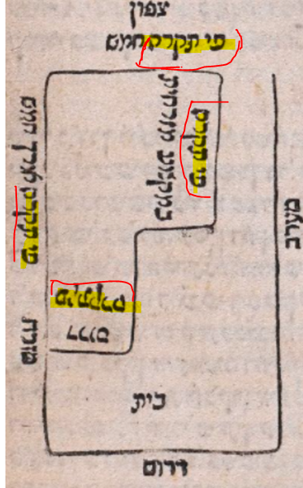
You can see it specifically defines four areas where one would say פִּי תִקְרָה יוֹרֵד וְסוֹתֵם
Finally, let us look at the evolution of the picture in the “notes” section of the Schottenstein ArtScroll edition of this Gemara
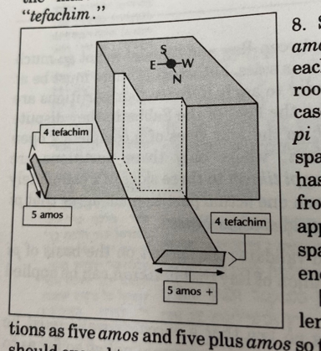
First edition, 1991. It does a good job of showing the four corners and also that the roof fell away along with the sides. It also portrays the relationship between Amos and Tefachim correctly.
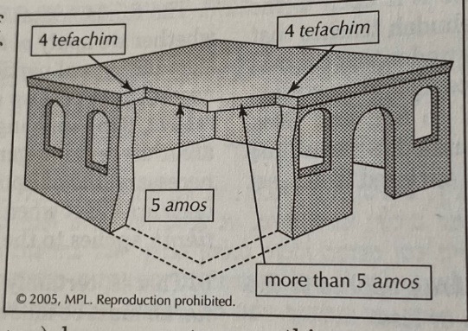
This is from 2005. For some reason ArtScroll decided to eliminate the representation of the roof falling with the walls. There is also a lack of portraying the four breaches as above.
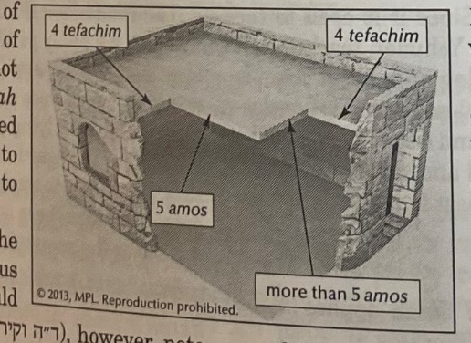ma
This is from 2013. The only improvement in this is that ArtScroll tried to make the building look more like a building.
It seems clear in this case that Rashi drew a diagram to accompany his words. It is true that we have come a long way from to 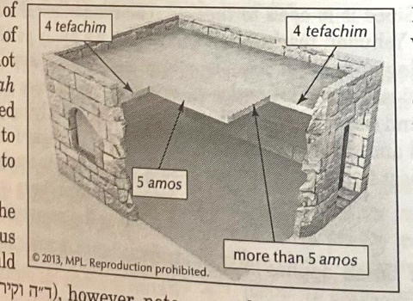.
But maybe more than anything, Rashi was telling us that sometimes images are needed to help illustrate his words.

I am explaining these two lines of Rashi as they are explained in the Sefer Piryo B’Ito by Yakov Yisroel HaLevi (Bnei Brak 1975)
Here is another illustration from Portal HaDaf Yomi “There are four openings which need to be closed”
Tosfos point out that the diagonal breach is only 7 Amos and concludes that Rashi was not precise in his statement of the measurements. וקירויו בארבע - רש"י פירש שנפרץ הכותל חמש מכאן וחמש לכאן ולא דק דאם כן לא הויא פרצה יתר מעשר אלא אלכסון של חמש על חמש דהיינו שבע אמות ולא חש לדקדק בזה:
A description of the book in the Bibliography of the Hebrew Book contains the following הגהות וחידושים על מסכתות התלמוד, הועתקו מגליונות הש"ס של רּ שלמה לוריא. ‬‬‬‬‬‬‬ בראש הספר הקדמת המגיה, רּ שמואל בן הקדוש רּ יצחק פיהם זלה"ה הי"ד מארץ לועז, והקדמת בני המחבר, רּ וואלף ורּ יחיאל. ‬ כותב המגיה: "וארא... שלשה אנשים... רּ אורי ליפמן חפץ יצ"ו ומהר"ר מרדכי אשכנזי יצ"ו והר"ר יחיאל יצ"ו מק"ק פוזנן ובידם העתק מעשה ידי... רּ שלמה לוריא ז"ל... וזה... אשר עשה לא הניח מלהשיג גמרות רש"י ותוספות של קלף ישנים ועל פיהם ועל פי הפוסקים... ובעל הערוך ושאלות ותשובות... דרך והגיה וכל מעוות התקין... הכל פירש היטב... וידוע תדעו שהגמרוּ של הגאון הנ"ל... היו רובן דפוס בומברגי ראשון [ויניציאה ר"פ-רפ"ג]. ויוכל להיות שהגמרוּ שנדפסו אחר כך נתקן איזה דבריּ, אבל... לא נתקן כאשר תקן הוא". ‬
Bomberg, Venice 1522, Giustiani, Venice 1550, Basel 1580, and Benveniste, Amsterdam 1646, all do not have a picture, nor do they leave space indicating there was originally one present. This is a bit unusual, as when Soncino (as will see) included a picture in Eruvin, Bomberg usually left an empty space in its place, which was then followed by Giustiani, Basel and Benveniste.
Amsterdam 1716 Prague 1844

