Gittin 7b – [רצועה נפקא [מעכו צפונה –
Did Rashi Include a Map In His Commentary?
Eli Genauer
גמרא גיטין ב'.
משנה :רַבִּי יְהוּדָה אוֹמֵר, מֵרֶקֶם לַמִּזְרָח, וְרֶקֶם כַּמִּזְרָח. מֵאַשְׁקְלוֹן לַדָּרוֹם, וְאַשְׁקְלוֹן כַּדָּרוֹם. מֵעַכּוֹ לַצָּפוֹן, וְעַכּוֹ כַּצָּפוֹן.
Rabbi Yehuda says: With regard to the borders of Eretz Yisrael, from Rekem eastward is considered to be part of “Medinas Hayam”( meaning outside Eretz Yisroel) , and Rekem itself is outside of Eretz Yisrael. From Ashkelon southward is outside of Eretz Yisrael, and Ashkelon itself is outside of Eretz Yisrael. Likewise, from Akko northward is outside of Eretz Yisrael, and Akko itself is like north of Eretz Yisrael.
This indicated that Akko is the northernmost border of Israel
גמרא גיטין ז':
לְמֵימְרָא דְּעַכּוֹ לִצְפוֹנָהּ דְּאֶרֶץ יִשְׂרָאֵל קָיְימָא, וּרְמִינְהוּ הָיָה מְהַלֵּךְ מֵעַכּוֹ לִכְזִיב מִימִינוֹ לְמִזְרַח הַדֶּרֶךְ טְמֵאָה מִשּׁוּם אֶרֶץ הָעַמִּים וּפְטוּרָה מִן הַמַּעֲשֵׂר וּמִן הַשְּׁבִיעִית עַד שֶׁיִּוָּדַע לָךְ שֶׁהִיא חַיֶּיבֶת,מִשְּׂמֹאלוֹ לְמַעֲרַב הַדֶּרֶךְ טְהוֹרָה מִשּׁוּם אֶרֶץ הָעַמִּים וְחַיֶּיבֶת בְּמַעֲשֵׂר וּבִשְׁבִיעִית עַד שֶׁיִּוָּדַע לָךְ שֶׁהִיא פְּטוּרָה עַד הֵיכָן עַד כְּזִיב רַבִּי יִשְׁמָעֵאל בְּרַבִּי יוֹסֵי אוֹמֵר מִשּׁוּם אָבִיו עַד לַבְלָבוֹ.אָמַר אַבָּיֵי רְצוּעָה נָפְקָא
Explanation of Rabbi Steinsaltz
The Mishna teaches that Rabbi Yehuda says:….from Akko and north is outside of Eretz Yisrael, and Akko itself is outside of Eretz Yisrael. The Gemara asks: Is this to say that Akko is located to the north of Eretz Yisrael? The Gemara raises a contradiction from a Baraisa (Tosefta, Oholot 18:14) that indicates that Akko is not on the northern border of Eretz Yisrael: If one was traveling from Akko to Cheziv, the area on his right, to the east of the road, is Tamai due to “Eretz Ha’Amim”, and that area is Patur from the Chiyuv to separate Ma’aser and from the Mitzvot of the Shemitah, (as it is assumed to be outside of Eretz Yisrael), until he arrives at a place where it is known to you that it is obligated. The Baraisa continues: Conversely, the territory on his left, to the west of the road, is Tahor with regard to “Eretz Ha’Amim”, as it is assumed to be within Eretz Yisrael, and Chayav in the Mitzva to separate Ma’aser and in the mitzvos of Shemita, until he arrives at a place where it is known to you that it is Patur. Until where does this Halakha apply? Until Cheziv. Rabbi Yishmael, son of Rabbi Yosi, said in the name of his father: Until the place known as Lavlevu. In any case, this indicates that Akko is not considered the northern border of Eretz Yisrael, as the description in the Baraita indicates that Keziv is further north than Akko.
Abaye answered: A strip extends northward from Akko, which is still considered part of Eretz Yisrael, but the general border is at the latitude of Akko
רש"י גיטין ז'::ב'
למימרא דעכו לצפונה דארץ ישראל קיימא – בסוף הצפון.
מימינו למזרח הדרך – השתא משמע לן דעכו קיימא בגבול מזרחה של ארץ ישראל משוך ממקצוע צפונית יום או יומים לצד הדרום וכזיב במקצוע מזרחית צפונית ודרך המהלכת מעכו לכזיב היה גבול מזרח לא"י הילכך כשמהלך מעכו לכזיב דהיינו מדרום לצפון הוי ימינו למזרחית הדרך.
טמאה – הארץ שהיא לימין המסילה.
משום ארץ העמים – דגזרו טומאה על ארץ העמים.
ופטורה כו' – כדין חוצה לארץ.
עד שיודע לך כו' – כלומר לעולם חזקת ימין הדרך מעכו ועד כזיב ארץ העמים אלא א"כ תבא למקום שיאמר לך בקי כאן הדרך מתעקם ונכנס לתוך א"י קצת וימין הדרך הוי ארץ ישראל.
למערב – הדרך.
לבלבו – שם מקום אלמא עכו משוכה לצד דרום וכזיב במקצוע.
רצועה נפקא – לעולם עכו בצפון ריבועא דא"י היא אלא שרצועה קצרה יוצאת עוד מעכו לצד צפון והיא מא"י:
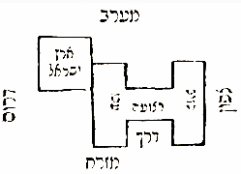
It looks like this when rotated so that north is on top
It appears like this in the Vilna Shas (1882) A picture appears as part of Rashi which illustrates the words:
רצועה נפקא – לעולם עכו בצפון ריבועא דא"י היא אלא שרצועה קצרה יוצאת עוד מעכו לצד צפון והיא מא"י:
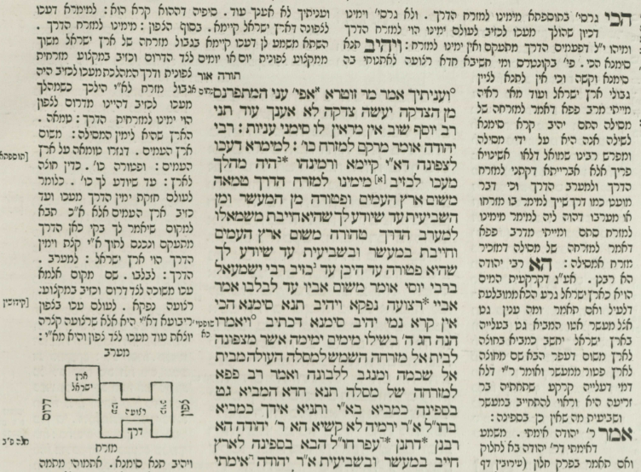
The Bomberg Shas of 1521 did not leave an empty space in Rashi to indicate a missing diagram (in this case a map) as it did in situations where there was a diagram in the Soncino edition.
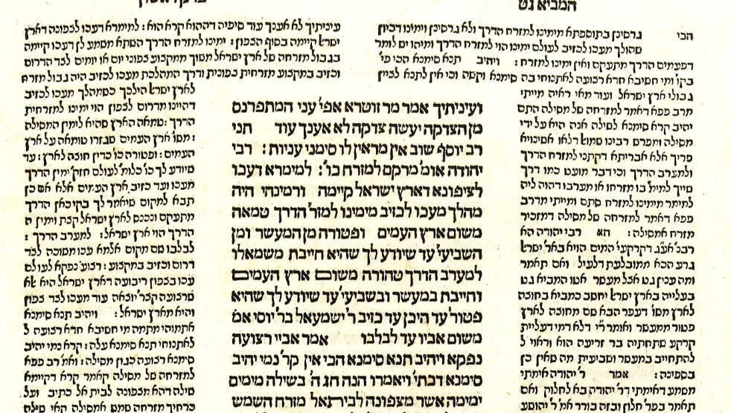
As you can see, there was no map in the Soncino edition of Gittin of 1488, which means that most likely the manuscript on which that edition was based did not have the map.
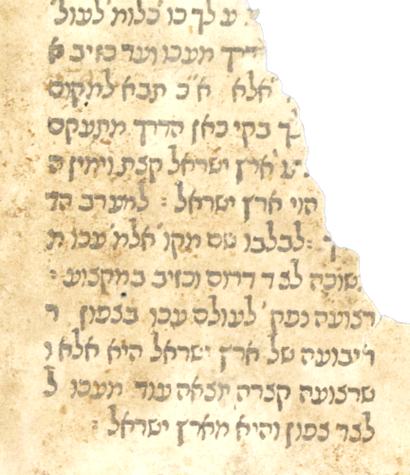
However, we do find manuscripts copied over from Rashi which indicate the presence of a map incorporated into Rashi’s commentary. In this example there is a map of Eretz Yisroel showing Akko and Cheziv.
Note that the map is included in the text of Rashi and not drawn in later
JTS : MS 6648- MS R832 -SHF 1632:1
Title: Perush Rashi ʻal masekhtot Megilah, Sukkah, Gittin. Copiest: Elkanah ben Mosheh, Jewish Theological Seminary Library. 1400’s
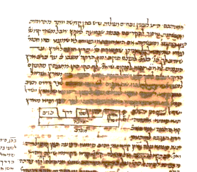
Map showing Akko and Cheziv with the narrow road between them
Here is a manuscript of Maseches Gittin which includes Rashi’s commentary. It is from the 14th century and is known as Vatican 127. As you can see, it contains a map drawn in later.
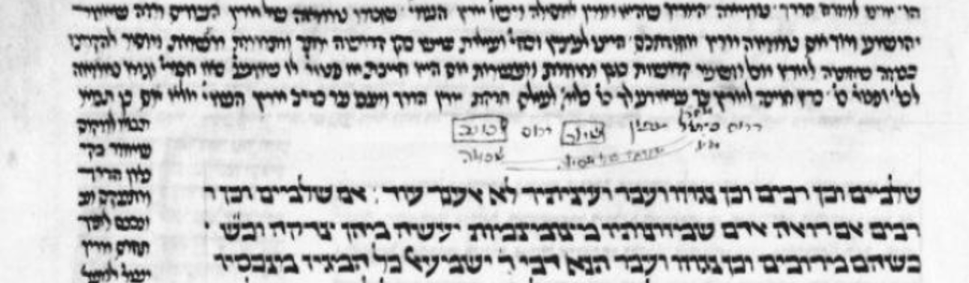

However, we also find Rashi manuscripts with no map, such as Vatican 140 (14th century) and Vatican 135
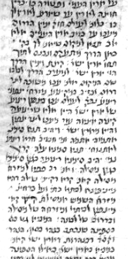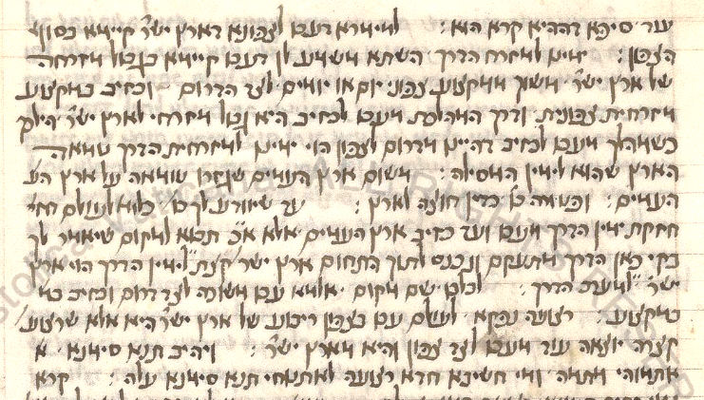
There seems to have been some tradition of the appearance in Rashi of a map, as evidenced from this Gemara, printed in Basel in 1581, in which someone hand drew a map in the margin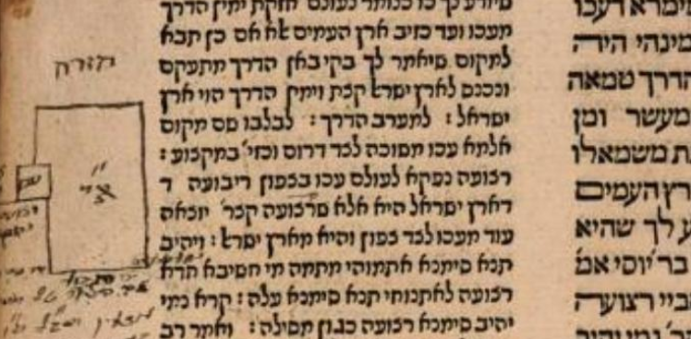
The Chochmas Shlomo of Rav Shlomo Luria, (Cracow 1582) which often includes diagrams which were left out of the Bomberg edition, does not include a map here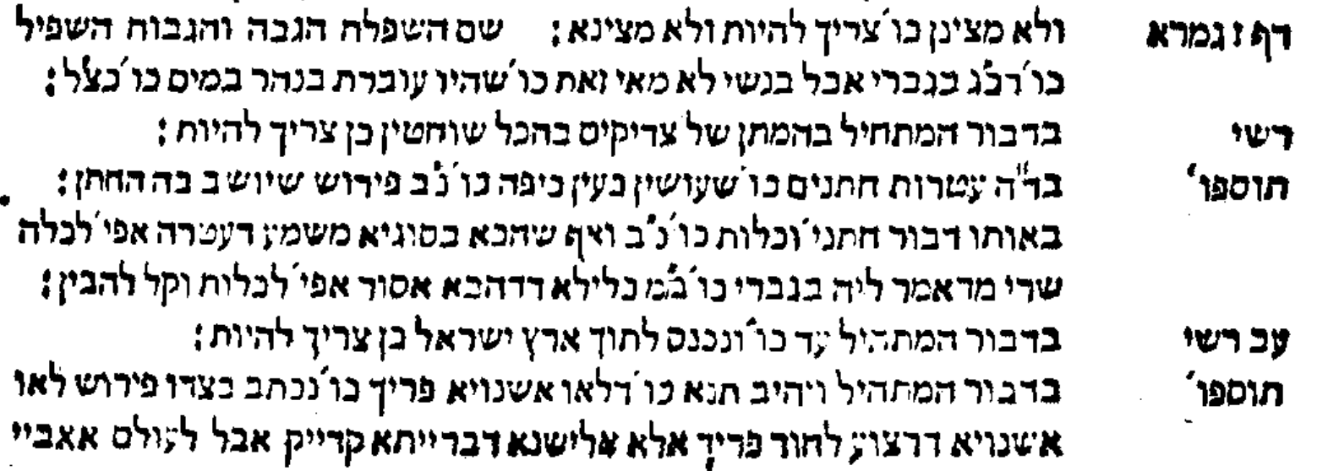
We often find diagrams added in the Sefer Chochmas Manoach (Prague 1612) but not in this case
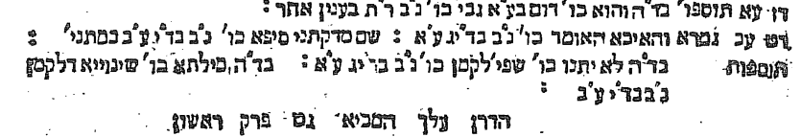

But in the Sefer Omek Halacha (First printed in Cracow. 1593, this from Amsterdam 1710) we do find the word “כזה” included in Rashi and two maps. Note that these maps do not correspond to what we have in our present-day Rashi
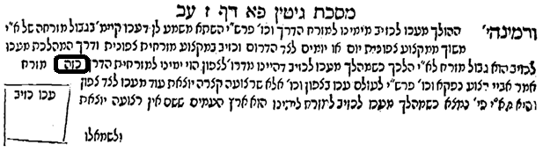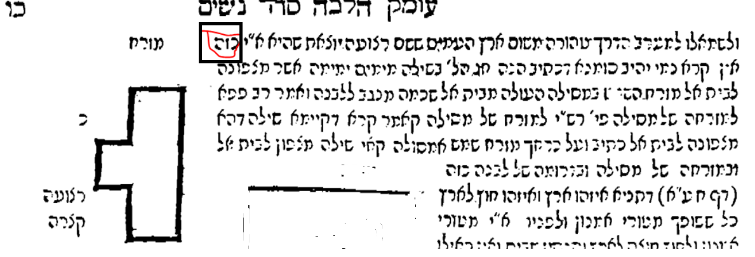
As mentioned, the map was not included in the 1521 Venice Bomberg edition of Maseches Gittin (nor an empty space for it) nor in any printed edition for the next 200 years. This includes the following editions which I checked: Giustiani 1550, Cracow 1604, Amsterdam 1647, Frankfurt an der Oder 1698, and Frankfurt am Main 1708,
What was the origin of the map we find included in the Vilna Shas, and which now has become part of Rashi’s commentary?
The earliest printed edition in which the map appears is Frankfurt am Main 1720
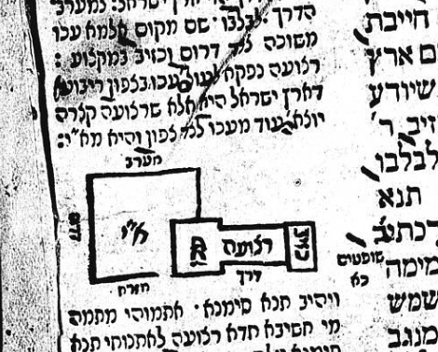
After that it appeared in many printed editions such Amsterdam 1756, Sulzbach 1760 and 1768, Vienna 1794, Dhyenfurth 1803, Prague 1835, Zhitomir 1863 and finally in the iconic Vilna Shas. No one would print a Shas today without this map included in the Rashi text. The depiction of the map from Frankfurt am Main 1720 to Vilna 1882 changed a bit as can been seen here.
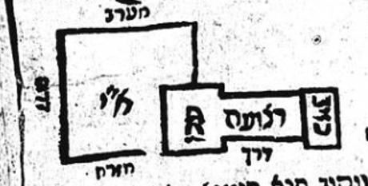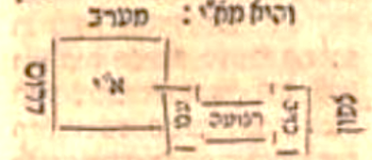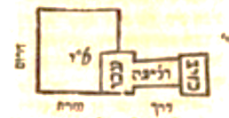
Frankfurt aM 1720 Amsterdam 1756 Sulzbach 1760,1768
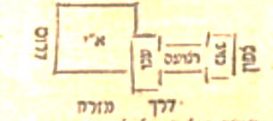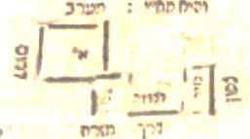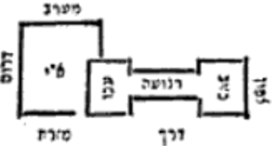
Vienna 1794 Dhyenfurth 1803 Prague 1835
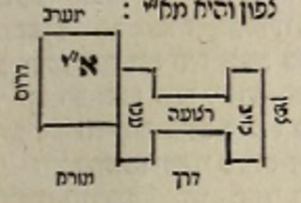
Zhitomir 1863
One important difference in the maps is as follows:
The initial Frankfurt a/M 1720 map depicts Akko as being partly in Eretz Yisroel and partly outside whereas for example, the Zhitomir 1863 map depicts Akko as being completely outside Eretz Yisroel
Frankfurt 1720 Zhitomir 1863
We will see how important this is shortly

What was the source for the map which appeared in the Frankfurt Gemara?
The editors of this Shas tell us that they used Chochmas Shlomo, Chochmas Manoach, Chidushei Halachos of MaHarsha, and MaHaram Lublin in editing their edition
They also state clearly that they used their own understanding of Pshat in deciding how the pictures should look
We have already seen that neither Chochmas Shlomo nor Chochmas Manoach include a map for this Rashi
However, the MaHarsha in Chidushei Halachos (Lublin 1630) does include a map, and it is very similar to the one in the Frankfurt Shas. It is important to note that although MaHarsha includes an opinion of Tosfos in his map, the Dibur HaMaschil he deals with is the Rashi of רצועה נפקא – לעולם עכו בצפון ריבועא דא"י היא
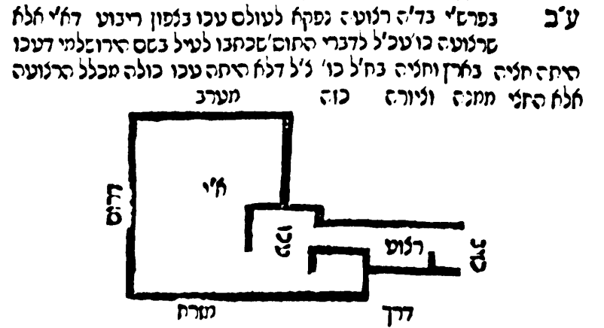
בפרש"י בד"ה רצועה נפקא לעולם עכו בצפון ריבוע דא"י אלא שרצועה כו' עכ"ל :לדברי התוס' שכתבו לעיל בשם הירושלמי דעכו היתה חציה בארץ וחציה בחוצה לארץ כו' צ"ל דלא היתה עכו כולה מכלל הרצועה אלא החצי ממנה וציורה כזה*:
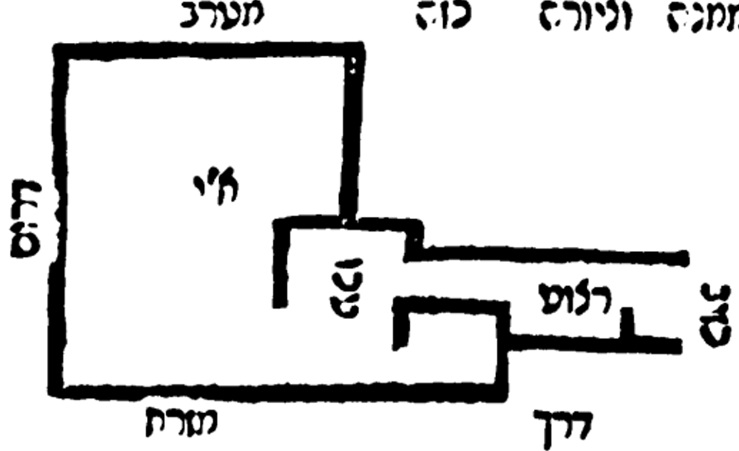
MaHarsha Frankfurt a/M Shas
Notice at all the similarities in word usage.
MaHaram Lublin in Meier Eini Chachamim (Venice 1619) includes a similar map. Please note that he has north on the left side as opposed to MaHarsha and Frankfurt which have north on the right side. It is important to note that MaHaram Lublin tells us that he drew this map incorporating into it the information from Tosfos on 2a. He does not say that he had a manuscript which had a map like this.
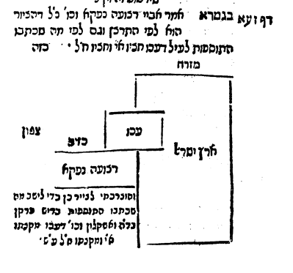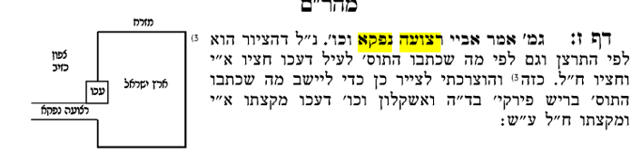
The map in Frankfurt which is standard in Rashi now, was not adopted by many subsequent editions, such Amsterdam 1725, Fuerth 1726, Constantinople 1757, all the way up to Zolkiew 1826
Zolkiew 1826
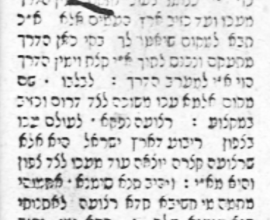

Conclusion:
The map which is included in Rashi in the Vilna Shas most likely did not originate with Rashi. It seems to have been added after Rashi by a scholar and it made its way into some manuscripts but not to others. It was not included in the first printed Gemara Gittin, that of Soncino 1489, and was therefore not included the first edition of the entire of the Talmud, that of Bomberg in Venice 1520-22. It was not added to any printed edition of Gittin for 200 years, until an edition printed in Frankfurt am Main in 1720. It seems to have been taken from a map drawn for this Rashi by MaHarsha in 1630. After that, it was adopted by some printed editions, but not others. It was not always reproduced the same as in the Frankfurt edition when it was included in printed editions from 1720 to Vilna in 1882. Its inclusion in the Vilna Shas made it an integral part of Rashi to this day.
Postscript
In terms of newer editions, Nehardea/Vagshal (2008) has the most detailed
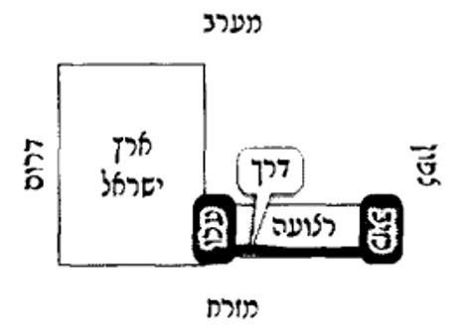
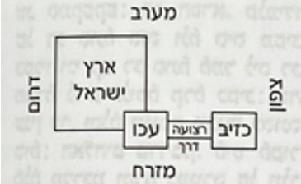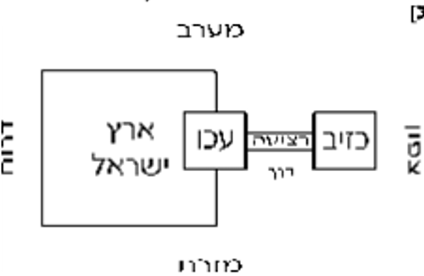
Artcroll 2020 Oz VeHadar Murchav 2016
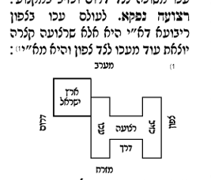
Vilna HaChadash 2006

It does not have the western boundary because clearly that is the Mediterranean
This is in contrast to Kidushin 72a, where MaHarshal does add a map to Rashi even though there is no empty space in Bomberg 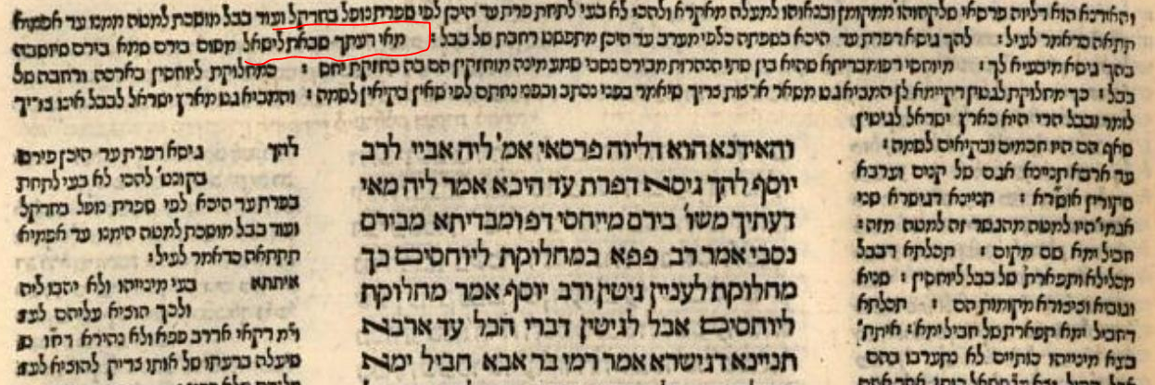 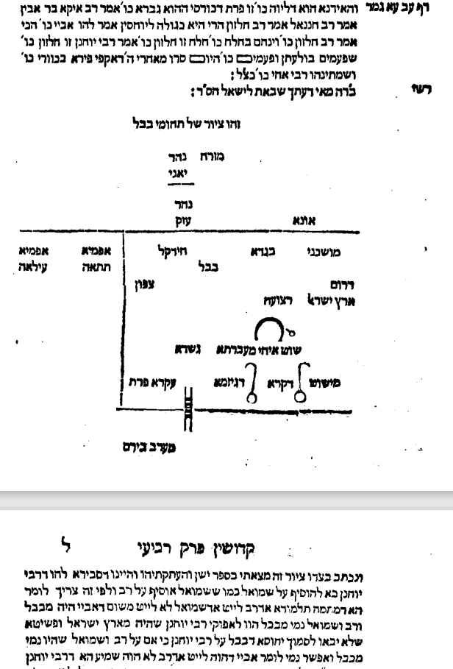
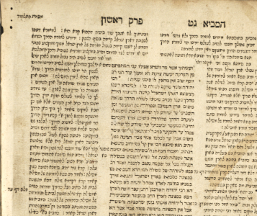
In 1714, R. Yehuda Aryeh Leib ben Yosef Shmuel, Av Beis Din of Frankfurt-am-Main, arranged to have the Talmud printed in Amsterdam by Samuel ben Solomon Marquis and Raphael ben Joshua de Palacio. They began printing with Berachos, but were forced to discontinue printing in 1717 due to the Haskamos issued for the 1697-1699 Frankfurt-am-Oder edition of the Talmud. Yehuda Aryeh Leib, however, resumed printing three years later in Frankfurt-am-Main at the press of Johann Koelner. Printing began with Kiddushin, possibly with the intent of publishing only those tractates not printed in Amsterdam. In fact, whether due to greater demand than originally anticipated or for other reasons, the entire Talmud was printed in Frankfurt-am-Main.
The editors note the sources for their text and likely for the diagrams as well. - Chochmas Shlomo - Chochmas Manoach - Chidushei Halachos of the Maharsha - Maharam Lublin - Sifrei Hashas of Yosef Shmuel ben Zvi – seemingly these were concentrated on Zeraim, Kodshim and Taharos The volume on Meseches Shabbos was published in 1715 and the top 4 appear in the Hakdamah: 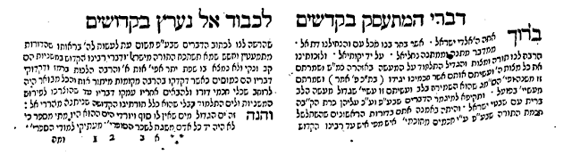 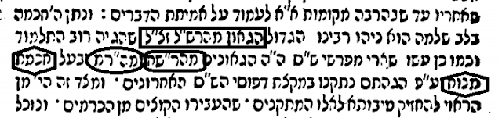
I have found instances where the diagram in the Amsterdam/Frankfurt Shas seems to come from Omek Halacha, as it was republished around the same time as the Amsterdam/Frankfurt am Main edition of the Gemara. But as seen above, the map in Omek Halacha bears no resemblance to the one in the Frankfurt Gemara

