“ שורה אחת כמין גאם – “תמונה מטעה
פסחים ח׃
Eli Genauer
מתברר שמהר״ם לובלין ייצג נכון את ה"גמא", אך "טעות הדפוס" פשוטה הפכה את ראשו

The use of diagrams or pictures by commentators to “illustrate” their points is well known. One of the more famous of these might be the Menorah as drawn by the Rambam himself.

The standard Vilna Shas contains over 100 diagrams included in Rashi’s commentary. Some are fairly simple such as the shape of a triangle.

I would like to focus on an illustration by מהר״ם לובלין dealing with the laws of "בדיקת חמץ". I will show how a simple mistake in printing resulted in an upside-down view of Maharam’s opinion.

On Pesachim 8b, the Gemara discusses the opinion of Bait Shammai is terms of which part of a wine cellar needs to be searched for Chametz
בית שמאי אומרים שתי שורות וכו׳: אמר רב יהודה, שתי שורות שאמרו מן הארץ ועד שמי קורה, ורבי יוחנן אמר שורה אחת כמין גאם
רש״י- גאם - היא גימ"ל יוונית ועשויה כמין כף שלנו פתוחה שורה אחת כמין גאם היינו שורה בזקיפה ושורה עליונה בשכיבה כאדם הבודק כותל הבית מבחוץ והגג:
It should be fairly easy to figure out what Rav Yochanan means if we know what the Greek letter Gamma (גימ"ל יוונית) looks like.
מהר״ם לובלין (שי"ח-שע"ו) gives us his opinion and draws a letter.
We find his commentary in the Vilna Shas in the back (Vilna 1881), below the section of the Maharsha. He writes “רצונו לומר כזה” and then this picture
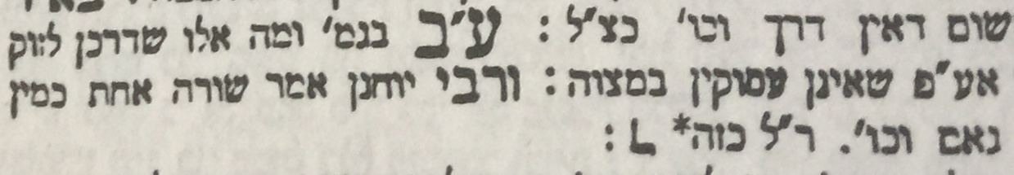
(All Gemara editions are courtesy of hebrewbooks.org)
However, this is what the Greek letter Gamma looks like
In terms of the arrangement of the wine barrels, it should look like this
To review, a Gamma looks like this 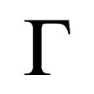……and Maharam has it shaped like this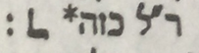

גמא נראית כך ולמהר”ם זה מעוצב כך
It is almost exactly the reverse of how it is rendered in the MaHaram’s commentary!

Questions
1.Was the Maharam unaware of the shape of the letter Gamma?
2. The opinion of Beit Shammai is that the row facing the front and the row on top need Bedikah. A drawing like this is therefore incorrect.
The answer to the problem with Maharam’s drawing
The comments of the Maharam were first printed in Venice in 1619 under the name of מאיר עיני חכמים
You can see that in this first edition, the letter that is used to “illustrate” the opinion of Rav Yochanan is a real Gamma
תוכל לראות שבמהדורה ראשונה זו, אפשר לראות את דעתו של הרב יוחנן הוא גמא אמיתית
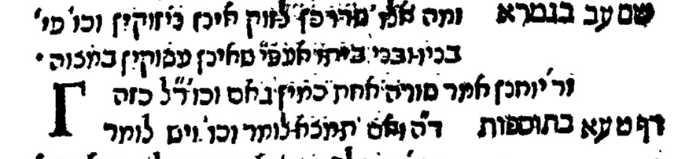

It stayed that way in the Frankfurt am Main edition of 1709,
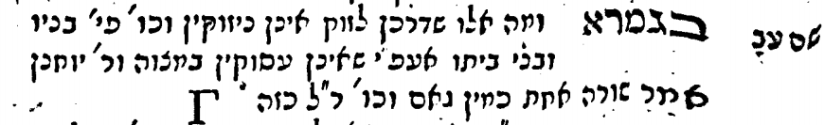

in the Wilhelmsdorf edition of 1737,
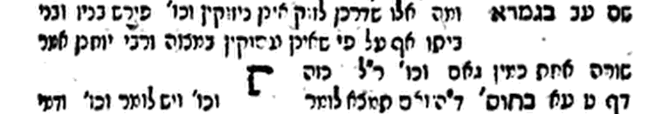
and in the Furth edition of 1767
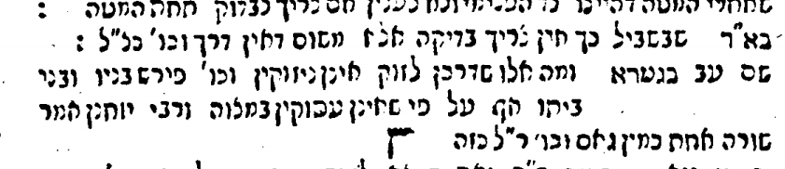
However, at some point in time, it began to look like this
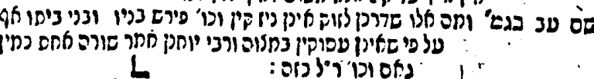
Polonia edition of 1809
It continued that way in Zhitomir 1861
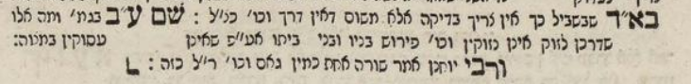

It finally ended up that way incorrectly in the authoritative Vilna edition
It turns out that Maharam Lublin represented the Gamma correctly, but a simple printer’s error turned its head upside down.

Drawing of the Temple Menorah, in Maimonides's own hand, in a manuscript of his Perush Hamishnayot, illustrating his comments on Menachot 3:7. Reproduced in Y. Kafih's edition, Jerusalem, 1967, vol 3 p 79
Bava Metziah 23b
With regard to some of the newer editions of the Talmud, I noted that Shas Nehardea (2008) corrects the mistake….. …….while others do not

