מסכת שבת דף ס׃ אין בין יום טוב לשבת אלא אוכל נפש בלבד
שינויים במסורת הש״ס
The מסורת הש״ס is an indispensable tool in studying Gemara. When you look at the text of the Talmud and see an asterisk (*), your eyes move immediately to the left or right margins to see what the מסורת הש״ס has to say. Most often it refers you to other places in Talmudic literature where the same subject is discussed. Those references serve to broaden your knowledge base and oftentimes help you understand your own “Sugya” better. There are other times that the מסורת הש״ס corrects the text, and there is even one time where it provides a diagram to illustrate what the Gemara is saying (see below for that unique example). The cross referencing of sources seems like such a basic idea to assist in learning, but this tool wasn’t always available to those swimming in the sea of the Talmud. When it finally became available, it was in a very rudimentary state and use of it was still quite challenging. We will use the Gemara Shabbat 60b to show the changes that have come over this important resource and why its form today is so much more helpful than when it first appeared.
The מסורת הש״ס was first printed in Salonika in 1523 under the name מסורת התלמוד. The title page does not indicate an author and looks like this
https://hebrewbooks.org/pdfpager.aspx?req=42599&st=&pgnum=1
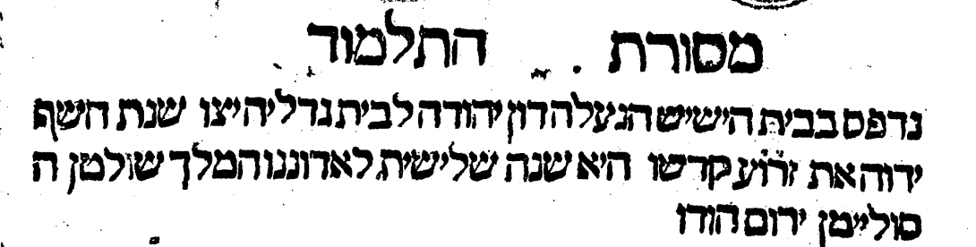
The printing year is calculated using the word ז׳ר׳ו׳ע׳ (5)383. (1523)
If we look at Shabbat 60b, we find that the Sugya of "אין בין יום טוב לשבת אלא אוכל נפש בלבד" is cross referenced as follows:
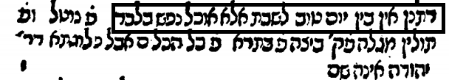
What is says is
פ׳ נוטל, ופ׳ תולין, מגילה פק׳ (פרק קמא), ביצה פ׳ בתרא פ׳ כל הכלים, אבל פלוגתא דרבי יהודה אינה שם".
Since the original מסורת התלמוד was not based on the Venice Bomberg edition (1520-1523) which had just appeared, it does not contain its page numbers.
- First we are told to look in Masechet Shabbat in Perek “נוטל” (17th Perek “כל הכלים נוטלין) where we find the referenced source in our Gemarot on 124a. This source does not include the Tanna Rabbi Yehuda’s opinion that מכשירי אוכל are also permitted on Yom Tov.
- Second, we are told to look at Perek “תולין”, (20th Perek), where we find the referenced source on Daf 137b. This source does include Rabbi Yehuda’s dissenting opinion.
- Third, we are told to look at Megillah “Perek Kamma”. Here we find the main recording of this Halacha, as a Mishnah on 7b. It is followed by Rabbi Yehuda’s opinion which is stated in the subsequent Gemara.
- Finally, we are told to look in the last Perek of Beitzah called “כל הכלים. It turns out that there are two references in this Perek, on Beitzah 28a which includes Rabbi Yehuda’s opinion and 36b where it is stated without Rabbi Yehuda’s dissenting opinion. Most likely it is to this source on Beitzah 36b that is referred to by the מסורת התלמוד when it states "אבל פלוגתא דרבי יהודה אינה שם".
The next iteration of the מסורת התלמוד we will look at is in the Basel 1581 edition of Masechet Shabbat 60b. By then, the name had been changed to מסורת הש״ס, and it had been improved somewhat by Rabbi Yehoshua Boaz (author of Shiltei Giborim). Only three references are listed, but possibly it is because only those include the Mishnah followed by Rabbi Yehuda’s opinion. The designation of Amud Aleph or Bet is missing.
https://books.google.co.il/books?hl=iw&id=X8BSAAAAcAAJ&q=%D7%91%D7%A1%D7%99%D7%9C%D7%99%D7%90%D7%94#v=onepage&q=%D7%91%D7%A1%D7%99%D7%9C%D7%99%D7%90%D7%94&f=false
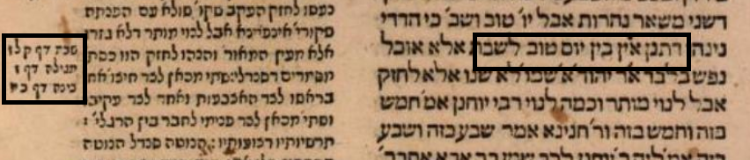
The next Gemara we will examine was printed Amsterdam in 1715. The מסורת הש״ס contained within it had been markedly improved by Rav Yosef Shmuel of Cracow but here no difference is seen from the Basel edition.
(private collection)
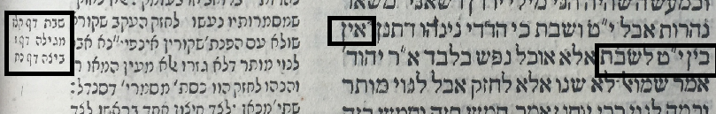
However, we do find an improvement lower down on 60b, this helpful diagram which shows the shape of a "כלבוס" (provided by מסורת הש״ס), appears for the first time on the printed page of the Talmud.
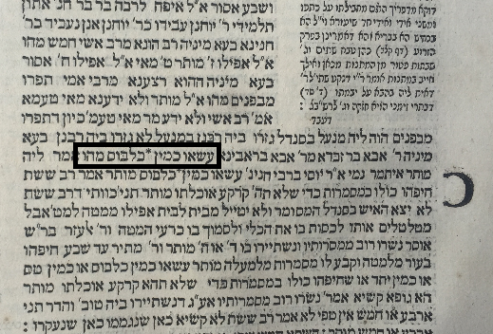
Finally, we have the Vilna Shas of 1881 which goes back to listing all the sources in Talmud Bavli (even those which do not include Rabbi Yehuda’s opinion) as was done in 1523 by מסורת התלמוד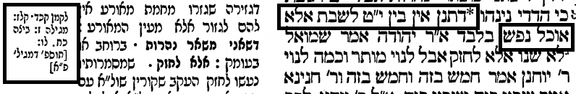
It also includes the Amud number and a reference to the Tosefta Megilla Perek Aleph, although it leaves out that it is Halacha 8.
It is clear that the מסורת הש״ס has undergone some major changes since its beginning. However, it was a helpful tool to those who studied the Talmud and should be appreciated for its revolutionary nature when first introduced.

