"וְהוּא שֶׁיֵּשׁ חִיּוּב חַטָּאת בֵּינֵיהֶם"
מסכת שבת פ.
אלי גנאור
Summary: There are really two issues with this diagram displayed in the Vilna Shas
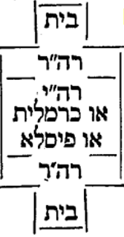
- It is placed incorrectly on the page
- The diagram as shown is really multiple diagrams, one showing a case where there is a Reshut HaYachid in between two Reshuyot HaRabim and the person is Patur, and the second showing where there is a בקעה or פִּיסְלָא in between and the person is Chayav. Combining the cases is very confusing. The Maharshal renders it as one diagram, just showing the case where there is a Reshut HaYachid in between and the person is Patur, while commenting in words on other scenarios.
תָּנוּ רַבָּנַן: הוֹצִיא חֲצִי גְרוֹגֶרֶת וְחָזַר וְהוֹצִיא חֲצִי גְרוֹגֶרֶת, בְּהֶעְלֵם אֶחָד — חַיָּיב, בִּשְׁתֵּי הֶעְלֵמוֹת — פָּטוּר. רַבִּי יוֹסֵי אוֹמֵר: בְּהֶעְלֵם אֶחָד לִרְשׁוּת אַחַת — חַיָּיב, לִשְׁתֵּי רְשׁוּיוֹת — פָּטוּר. אָמַר רַבָּה: וְהוּא שֶׁיֵּשׁ חִיּוּב חַטָּאת בֵּינֵיהֶם. אֲבָל כַּרְמְלִית — לֹא. אַבָּיֵי אָמַר: אֲפִילּוּ כַּרְמְלִית. אֲבָל פִּיסְלָא — לֹא. וְרָבָא אָמַר: אֲפִילּוּ פִּיסְלָא. וְאָזְדָא רָבָא לְטַעְמֵיהּ, דְּאָמַר רָבָא: רְשׁוּת שַׁבָּת כִּרְשׁוּת גִּיטִּין דָּמְיָא.
One who carried out half of a dried fig into the Reshut HaRabim and then carried out another half of a dried fig, within one lapse of awareness, he is Chayav; within two lapses of awareness, he is Patur. Rabbi Yosei says: If he carried out the half-figs within one lapse of awareness to one Reshut he is Chayav; to two Reshuyot he is Patur. Rabba said, that is only in a case where there is a Reshut of a Chiyuv Chatat between them. However, if the two sections of the Reshut Harabim were separated by a Karmelit, no. Abaye said: Even if they were separated by a Karmelit, he is Patur. However, if the two sections were separated by a large beam, no. And Rava said: Even if the two sections were separated by a large beam, he is Patur. Rava follows his line of reasoning stated elsewhere as Rava said: The definition of a Reshut for Shabbat is like the definition of a Reshut for Gittin.

Rashi
לשתי רשויות - ושתיהן ר"ה אלא שיש הפסק ביניהם
והוא שיש חיוב חטאת ביניהם - שמופסקות ברה"י, אבל אם היה כרמלית מפסיקן כגון קרפף יותר מבית סאתים, או בקעה וב׳ בתים פתוחים אחד לרה"ר זה ואחד לזה והוציא חצי גרוגרת מבית זה לרשות זה וחצי גרוגרת מבית זה לרשות זה שהיא פתוחה לה חייב דכיון דלא מפסיק לה רה"י חדא רשותא הוא
פיסלא - עץ שוכב לרחבו של רה"ר וממלא כל רחבו והוציא חצי גרוגרת מביתו מכאן וחצי גרוגרת מכאן:
כרשות גיטין דמי - ולענין גיטין פיסלא רשות לנפשיה הוא כדאמרן בהזורק (גטין דף עז:) ההוא גברא דזרק גיטא לדביתהו בחצירו איגנדר גיטא ונפל בפיסלא ואוקי התם שהשאיל לה מקום בחצירו חד מקום מושלי אינשי תרי מקומות לא מושלי אינשי:
In the Vilna Shas, (1881) it looks like this. Note than even though there is a diagram, there is never an indication of exactly what it illustrates by the use of the word “כזה” somewhere in the Rashi text.
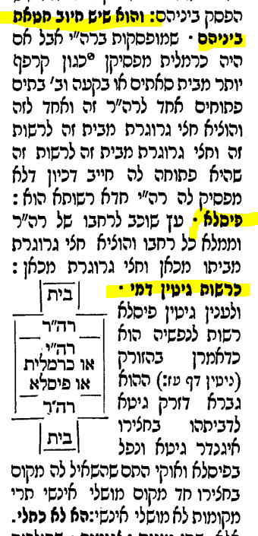
The way it is positioned on the page, the diagram seems to be illustrating either the Rashi with the Dibur HaMatchil of פיסלא (underneath it) or most likely, the Rashi of כרשות גיטין דמי (on the side of it).
In fact, the picture actually illustrates the Rashi of והוא שיש חיוב חטאת ביניהם. The picture shows a Bayit bordering on a Reshut HaRabim on one side. 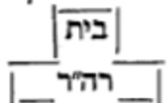
It shows the same setup on the other side, and in between, either a Reshut HaYachid, a Karmelit or a פיסלא. 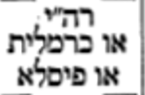. It turns out that the diagram in Rashi tries to combine two different scenarios; one where there is a Reshut HaYachid between two Reshuyot HaRabim, and one where there is something other than a Reshut HaYachid (a כרמלית or פִּיסְלָא ּ) between them.
The correct positioning of the diagram in the Dibbur HaMatchil of והוא שיש חיוב חטאת ביניהם is stated explicitly in the Chochmat Shlomo by MaHarshal (as shown in the Oz Vehadar edition of Masechet Shabbat)
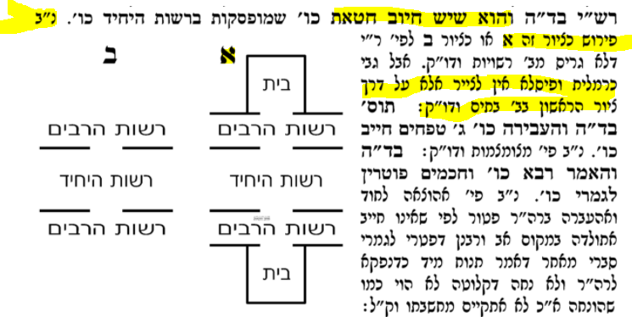)
We find the diagram more accurately positioned in the Amsterdam 1714 edition of Masechet Shabbat than in the Vilna 1881 edition as it is underneath והוא שיש חיוב חטאת,
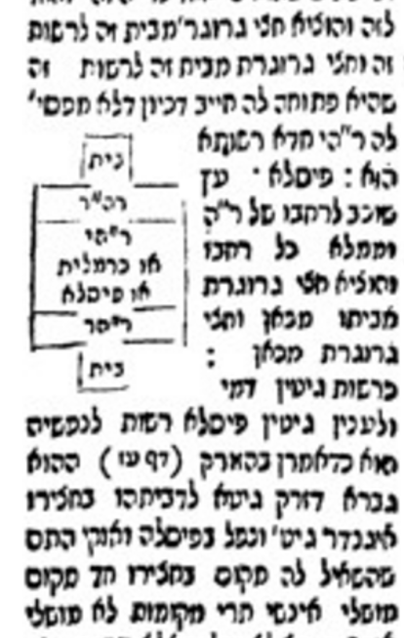
As we have seen, the diagram appeared in Chochmat Shlomo printed in 1582, and in a different form printed in a Gemara in 1714. From 1714 and on, the diagram did not appear in any printed editions of the Talmud but it was included in the Vilna Shas in 1881. The diagram printed in the 1714 edition tried to combine the case where the man is Patur (where there is a Reshut HaYachid in between) with those in which the person would be Chayav according to different opinions.
What was the origin of including this diagram in the Rashi text?
It did not appear in the Bomberg Venice edition of 1520 nor the Soncino edition which preceded it.
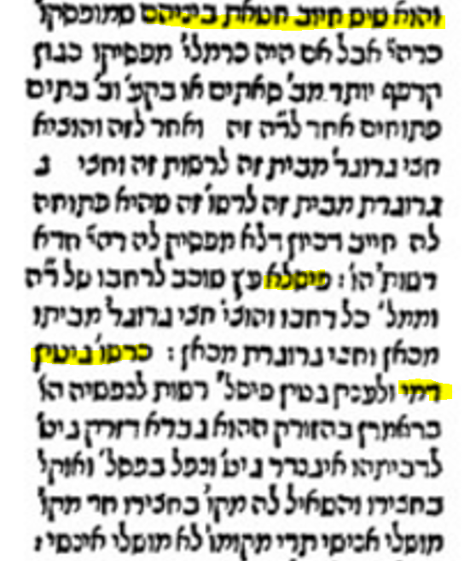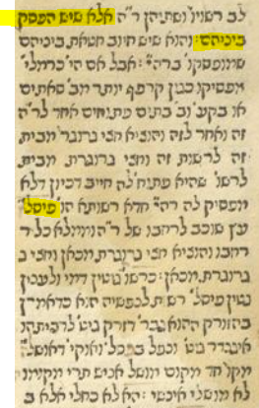
Bomberg 1520 Soncino
However, we do find a diagram with one scenario, that of a בקעה in between the two Reshuyot HaRabim, in the following manuscript
Vatican 138 –
Date מאה י"ג-י"ד
https://web.nli.org.il/sites/NLIS/en/ManuScript/Pages/Item.aspx?ItemID=PNX_MANUSCRIPTS990001861240205171&SearchTxt=Vatican%20138
It is clearly related to the Dibbur HaMaschil “ והוא שיש חיוב חטאת ביניהם”
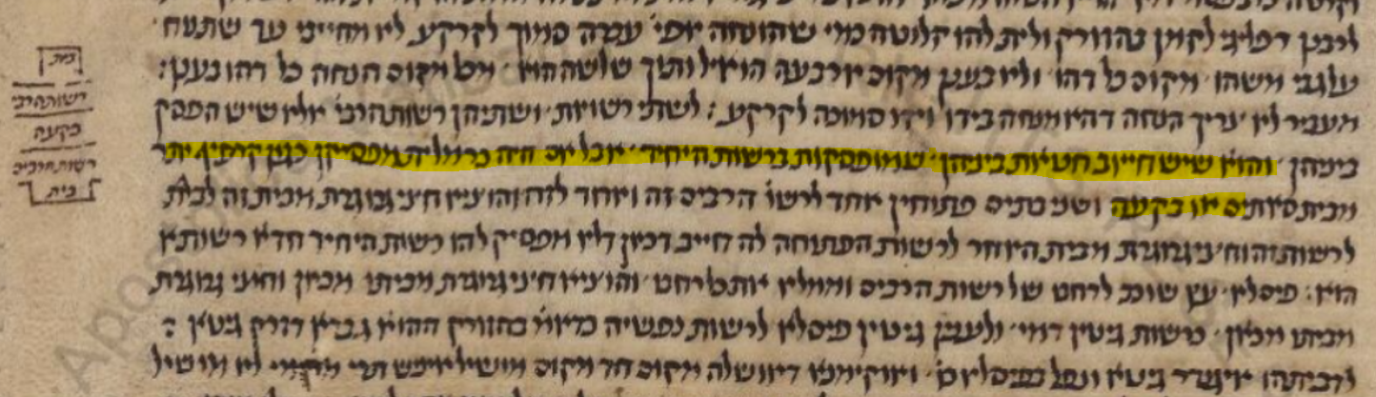

Close-up
We also have a manuscript called Paris 324 – 13th to 14th century – which shows the following:
https://web.nli.org.il/sites/NLIS/en/ManuScript/Pages/Item.aspx?ItemID=PNX_MANUSCRIPTS990001292290205171&SearchTxt=Paris%20324
It has a diagram and it clearly refers to Rashi of והוא שיש חיוב חטאת ביניהם – Also, it only has בקעה in between
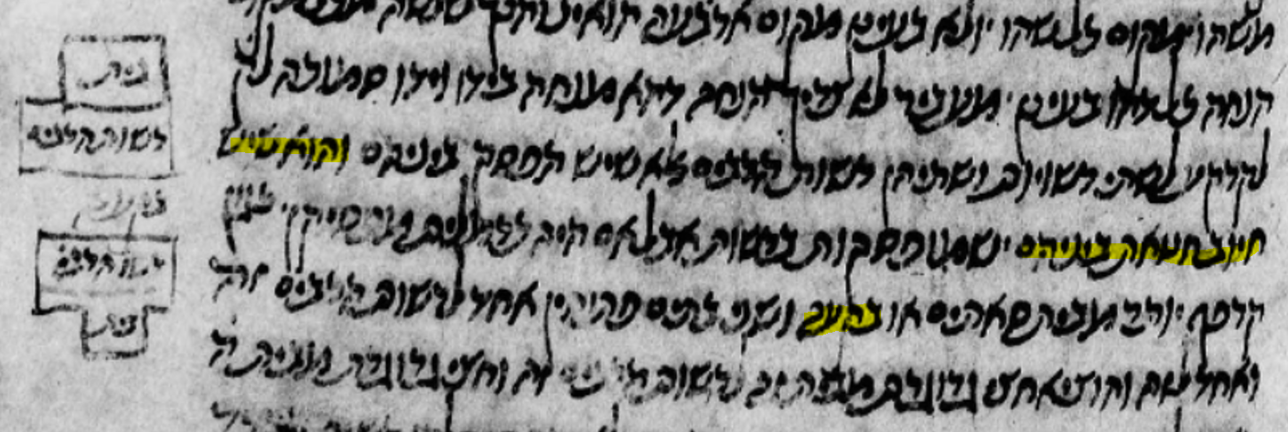

I could not find any other manuscripts with this type of diagram but it is clear from the two shown, and especially from MaHarshal that there was some “Mesorah” of a diagram being there and that it was related to the Dibbur HaMatchil of והוא שיש חיוב חטאת ביניהם

There are no major changes in depicting the diagram or the position of the diagram in Ov VeHadar, Vagshal/ Neharda, Artscroll or Vilna HaChadash This is how it looks in Oz VeHadar Murchav 2017 and in the Vilna Shas of 1881 vs. Vilna 1881
Note that Tziyur Bet illustrates the opinion of Tosafot who have a different Girsa in our Gemara. MaHarshal states that if you were plugging in כרמלית or פִּיסְלָא into the diagram, it would be in Tziyur Aleph which reflects the Girsa of Rashi.
This innovation is in line with my research into the evolution of diagrams, in that the Amsterdam 1714-1717 (and its continuation in Frankfurt am Main 1720-1723) either added diagrams or modified some of the diagrams that preceded it.
Other manuscripts I checked were London BL OR 5975, Parma 2087, JTS 6654. St. Petersburg, Ms. B 376 and JTS Ms 6499, none of which contained a diagram. This and the fact that it doesn’t say “כזה” anywhere in Rashi makes me believe the diagrams were a later addition to the two manuscripts. The fact that Maharshal includes a diagram indicates that to him, such an illustration was important.

