Masechet Shabbat 84B –
“ אַרְבָּעָה עַל אַרְבַּע רוּחוֹת הָעֲרוּגָה וְאַחַת בָּאֶמְצַע”
The Mishnah on 84b discusses the fact that five different types of seeds can be planted in a very small garden patch without violating the prohibition of כלאים. The Sugya itself is very complicated and includes the fact that Tosafot ( Bechorot 54a דבור המתחיל ״ דגן ודגן ״)claims that there is a טעות סופרים in Rashi in Bechorot when he writes that the Issur of כלאי זרעים is only מדרבנן.
I will only focus on two aspects of Rashi on this Mishnah
- Did the “original Rashi” include the explanation we have in the Vilna Shas on the דבורי המתחיל of וְאַחַת בָּאֶמְצַע and ד׳ מד׳ רוחות הערוגה
- Was the diagram in Rashi on וְאַחַת בָּאֶמְצַע included in the “original Rashi”
Here is the Mishna with the explanation of Rav Steinsaltz, who first explains why a Mishna dealing with כלאים is included in Masechet Shabbat
מַתְנִי׳ : מִנַּיִן לַעֲרוּגָה שֶׁהִיא שִׁשָּׁה עַל שִׁשָּׁה טְפָחִים שֶׁזּוֹרְעִין בְּתוֹכָהּ חֲמִשָּׁה זֵרְעוֹנִין, אַרְבָּעָה עַל אַרְבַּע רוּחוֹת הָעֲרוּגָה וְאַחַת בָּאֶמְצַע, שֶׁנֶּאֱמַר: ״כִּי כָאָרֶץ תּוֹצִיא צִמְחָהּ וּכְגַנָּה זֵרוּעֶיהָ תַצְמִיחַ״ — ״זַרְעָהּ״ לֹא נֶאֱמַר, אֶלָּא ״זֵרוּעֶיהָ״.
MISHNA: The Gemara continues to discuss an additional halakha based on a biblical allusion. From where is it derived that in a garden bed that is six by six handbreadths, that one may plant five different types of seeds in it? He may do so without violating the prohibition of sowing a mixture of diverse kinds of seeds in the following manner. One sows four types of plants on each of the four sides of the garden bed and one in the middle. There is an allusion to this in the text, as it is stated: “For as the earth brings forth its growth, and as a garden causes its seeds to grow, so will the Lord G-d cause justice and praise to spring forth before all the nations” (Isaiah 61:11). Its seed, in the singular, is not stated; rather, its seeds, written in the plural. Apparently, it is possible that several seeds may be planted in a small garden.
Rashi
מתניּ: שזורעין בתוכה ה׳ זרעונין - ולא הוי עירבוב שיש בה כדי להפריש ביניהם הפרש הראוי:
ד׳ מד׳ רוחות הערוגה - ממלא את כל הרוח עד סמוך לקרן:
ואחת באמצע - גרעין אחד ואע"פ שכל אצל הקרנות סמוכין זה לזה ואין ביניהם הרחקה ג’ טפחים ויונקים זה מזה אין כאן בית מיחוש דגבי כלאים היכרא הוא דבעינן דלא להוי עירבוב דהא אכלאים קפיד קרא אבל ליניקה לא חיישינן אפילו בכלאי הכרם דאורייתא כדתנן (ב"ב דף כו.) זה סומך לגדר מכאן וזה סומך לגדר מכאן ואע"ג דינקו מתתאי וכ"ש כלאי זרעים דרבנן דלא חיישינן ליניקה כדתנן גבי ראש תור לקמן בשמעתין וגבי ב’ שורות והרי יש כאן היכר גדול רוח זו זרועה צפון ודרום וזו זרועה מזרח ומערב אבל בין זרע האמצעי לזרעוני הרוחות צריך הרחקה כדי יניקה דאין שם היכר ואי הוו מקרבי הוי עירבוב והמפרש ד’ גרעינין בד’ הרוחות טועה דאי ההרחקה משום יניקה ט’ זרעונין יש לזרוע בו ד’ בד’ הקרנות ואחד בכל רוח ורוח באמצעו וא’ באמצע הערוגה ויש בין כל אחד ואחד ג’ טפחים כשיעור יניקה טפח ומחצה לכל אחד הלכך לכל הרוח הוא ממלא עד סמוך לקרן ואפילו אין בין זרע שברוח זו לזרע שברוח זו ג’ טפחים לא איכפת לן דלענין כלאים היכר בעלמא הוא דבעינן כדפרישית:
זרועיה - ובגמ׳ מפרש היכי משמע ה׳ זרעונים בו׳ טפחים:
Rashi focuses on how five different types of seeds can be planted in a small garden patch. He explains that four different types of seeds can be planted on the north, south, east and west sides of the garden, each filling up the entire side, except that an empty space needs to be left in each corner. The fifth seed must be planted exactly in the middle so that it is three Tefachim away from the seeds which rim the garden. According to Rashi, even though the seeds planted along the borders are not three tefachim apart one seed from the other seed, as long as there is a ״היכר״ that they are not mixed together, it does not violate the Issur of Kilayim (which is translated as Ta’arovet). This despite the fact that we normally require different seeds to be planted three Tefachim from each other so that they do not acquire nourishment from the same source. The fifth seed though must be planted in the middle because it is not clear that it is different from the others and therefore needs to be three Tefachim away from the seeds which rim the garden. The best illustration I found of this is from Peirush Chai. As you can see, it illustrates the different types of seeds planted along each border, and the different seed planted in the middle. It shows that the middle seed is always three Tefachim away from the seeds planted along the borders and that an empty space is left in each corner.
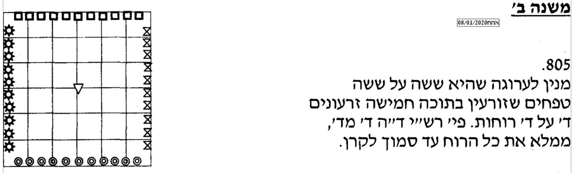

This is how it looks in the Vilna Shas. (1881) As you can see, there is a diagram included in the Dibur HaMatchil of וְאַחַת בָּאֶמְצַע or ד׳ מד׳ רוחות הערוגה with the notation of “כזה” in parentheses. It is fairly accurate in that it shows the one seed in the middle, the four empty spaces in the corners, and rows of other seeds planted alongside the four directions.
Did the “original Rashi” include the explanation we have in the Vilna Shas on the דבורי המתחיל of וְאַחַת בָּאֶמְצַע and ד׳ מד׳ רוחות הערוגה and if so, was a diagram a part of the text?
Tosafot clearly had a Girsa which included the דבור המתחיל of ואחת באמצע as they say that Rashi maintains that כלאי זרעים is מדרבנן which is one of the main points of our Rashi who writes “כלאי זרעים דרבנן “
ארבע על ארבע רוחות הערוגה - באמצע הרוח כדמוכח בגמרא לפי מה שאפרש בעז"ה ומה שפירש הקונטרס דכלאי זרעים דרבנן אינו נראה לר"י
The first printed Masechet Shabbat is important for determining the proper text of Rashi because obviously it was based on a manuscript or a group of manuscripts.
Soncino (circa 1489-1498), has the same Girsa as the Rashi in the Vilna Shas. (Note: In terms of the Nusach in the Mishnah, Dikdukei Sofrim writes “ואחת באמצע ליתא בדפוס שׂנצינו בטעות ”

As you can see, though, there is no diagram, space left for a diagram or is the word כזה found anywhere
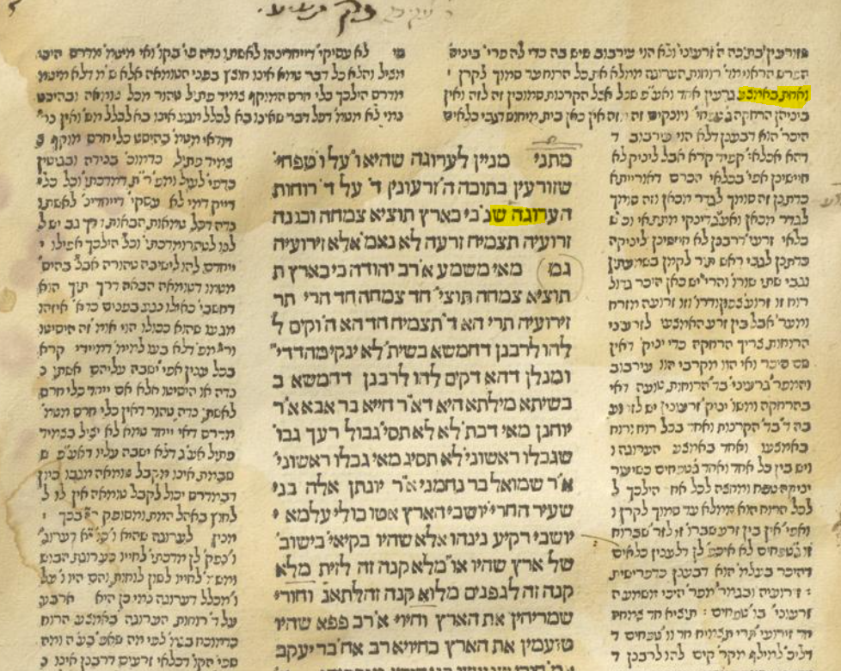
The Bomberg edition of 1520 is important for the same reason and it also has the same text as present day Gemarot, also without leaving space for a diagram.
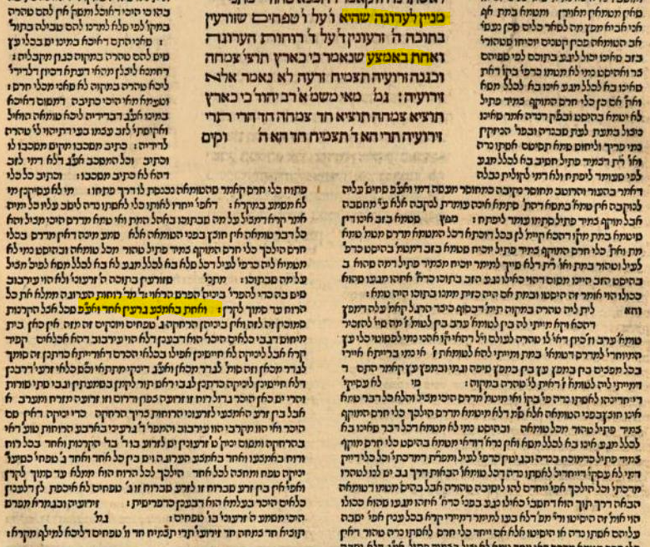
Chochmat Shlomo (Cracow 1582) indicates that there was a Dibur HaMatchil of “וְאַחַת בָּאֶמְצַע”, but despite adding a diagram to his comments on Rashi 86a, does not include one here.
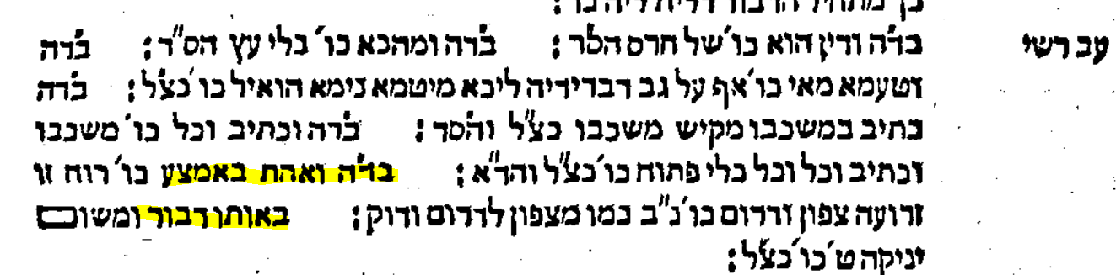
The diagram is not in Giustiani Venice edition of 1550 ,Basel 1580, in Amsterdam 1645, nor Frankfurt/Oder Berman 1697, nor is there a space left open for it,
I think we can conclude that there was a precedent for the text we have based on the earliest printed editions which were based on manuscripts, but no precedent for a diagram being included in the original Rashi
The first time a diagram is included in a printed edition is Amsterdam 1715– It also adds the word כזה after ״גרעין אחד״. Based on my research, this edition added diagrams when it thought they were needed.
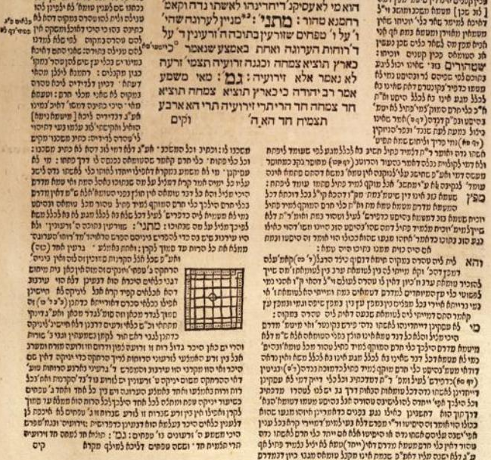
Afterwards, the diagram became part of printed editions, including Proops Amsterdam 1754, Vienna 1792, and Warsaw 1859. By including it in the Vilna 1881 edition, the Romm printers set it as the standard for all editions going forward.
When I started looking at manuscripts of Rashi on Masechet Shabbat, I was not surprised that they lacked a diagram, because there was no indication in the early printed editions that one existed. What did surprise me is that most of our Rashi was gone! The fact that these manuscripts were written in four different styles of script indicates that they came from divergent sources and argues for their authenticity
Vatican Ebr. 138 – Date,13th-14th century – Script, Ashkenazic
Rashi’s comments on “ד׳ מד׳ רוחות הערוגה “and “ואחת באמצע “are missing. The text goes right from the end of the first Rashi on the Mishnah of שזורעין בתוכה ה׳ זרעונין to the last Rashi on the Mishnah, ״זֵרוּעֶיהָ״
Of course, there is no diagram
https://web.nli.org.il/sites/NLIS/en/ManuScript/Pages/Item.aspx?ItemID=PNX_MANUSCRIPTS990001861240205171&SearchTxt=Vatican%20Ebr.%20138
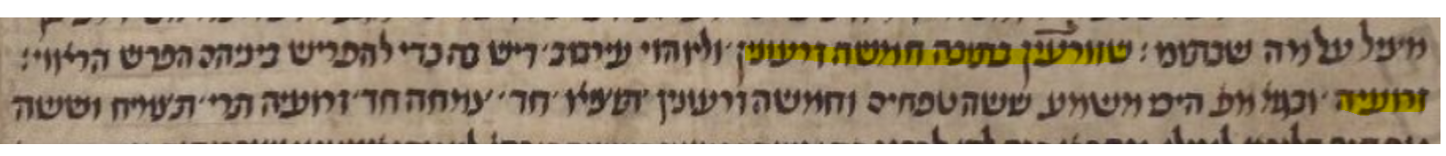
Paris 324 – Date, 13th-14th century- Script, Sephardic
https://web.nli.org.il/sites/NLIS/en/ManuScript/Pages/Item.aspx?ItemID=PNX_MANUSCRIPTS990001292290205171&SearchTxt=paris%20324
It is the same as Vatican Ebr. 138 above
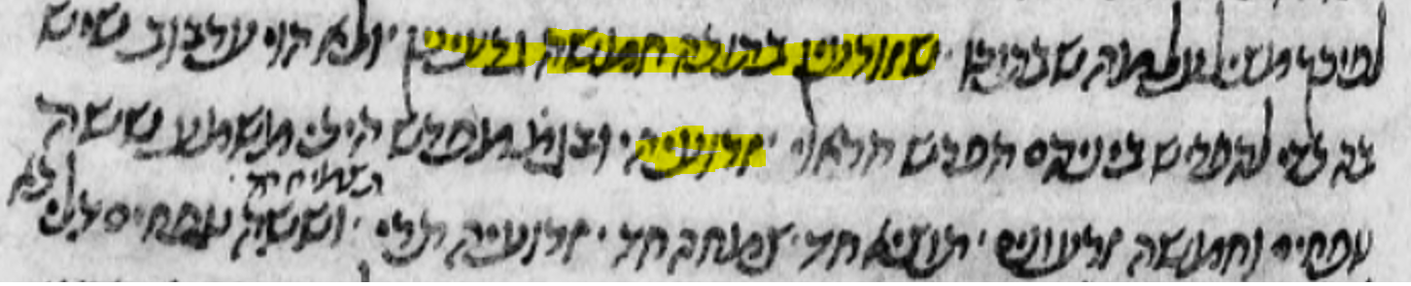
JTS Ms. 6499 – Date 14th century- Script, Italian?
It also skips from שזורעין בתוכה ה׳ זרעונין to the דבור המתחיל of ״זֵרוּעֶיהָ״ but it does have diagram of a field on the side, which looks as if it had been added later on.
https://web.nli.org.il/sites/NLI/English/digitallibrary/pages/viewer.aspx?presentorid=MANUSCRIPTS&docid=PNX_MANUSCRIPTS990000545300205171-1#|FL57617289
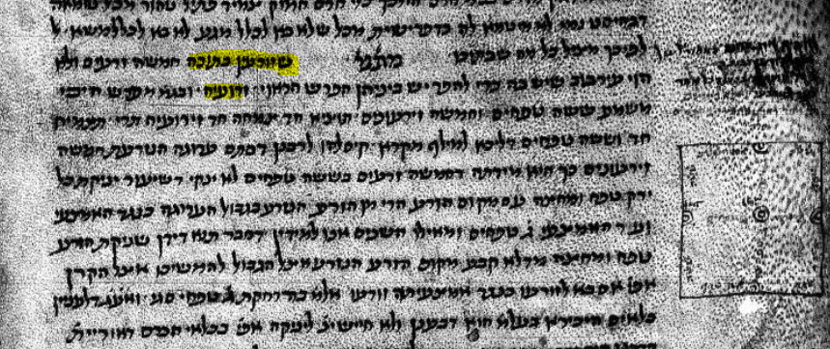
JTS 6654 – Date, 14-15th century – Script, Byzantine
In the main body of the text the two Rashis are also missing, but there seems to be an addition on the side.
https://web.nli.org.il/sites/NLI/English/digitallibrary/pages/viewer.aspx?&presentorid=MANUSCRIPTS&docid=PNX_MANUSCRIPTS990001128750205171-1#|FL151546105
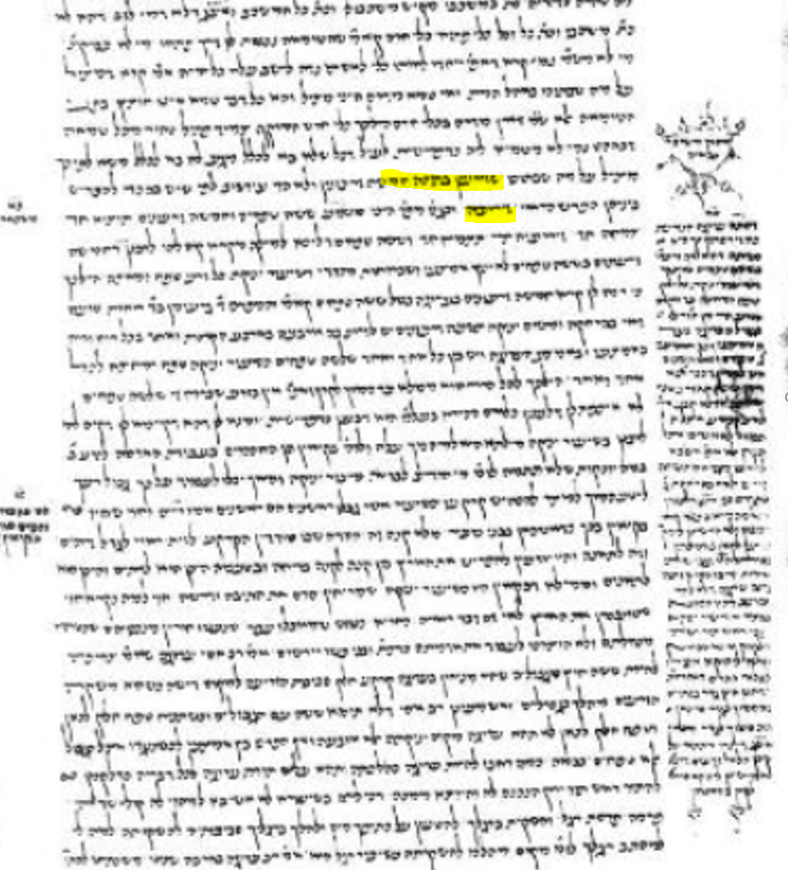
Here is a closeup of the text which shows the missing Rashi
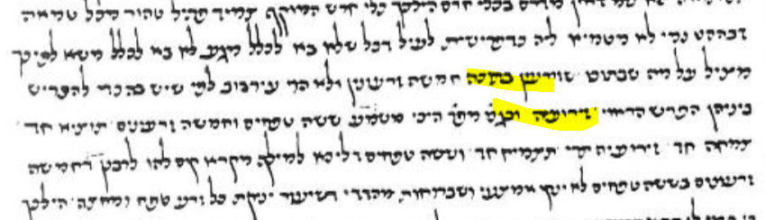
A very long explanation of the case in our Mishnah appears on the side. The illustration on top is just decorative and is not related to the appearance of the garden patch. It does seem to indicate that it reflects Seforim Achairim but it is not the same as the text of Rashi which we have.
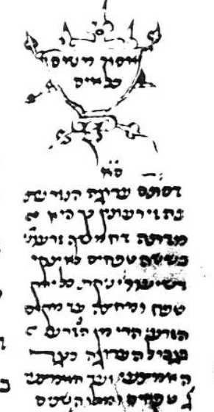

It starts out like this
דסתם ערוגה הנזרעת בה׳ זרעונין כך היא מדתה דחמישה זרעונין בששה טפחים לא ינקי דשיעור יניקה כל ירק בטפח ומחצה עד מקום הזרע...
It is different than our Rashi which begins
ואחת באמצע - גרעין אחד ואע"פ שכל אצל הקרנות סמוכין זה לזה ואין ביניהם הרחקה ג’ טפחים ויונקים זה מזה אין כאן בית מיחוש

Here is a manuscript which is even later than the previous one. In the main body of the text the two Rashis are also missing, and there is no hint of a diagram
St. Petersburg, Ms. B 376- Date, 15th century – Script, Byzantine
https://web.nli.org.il/sites/NLIS/en/ManuScript/Pages/Item.aspx?ItemID=PNX_MANUSCRIPTS990000840900205171&SearchTxt=%D7%A4%D7%A8%D7%95%D7%A9%20%D7%94%D7%AA%D7%9C%D7%9E%D7%95%D7%93%20%D7%9C%D7%A8%D7%A9%22%D7%99%20%D7%A9%D7%91%D7%AA
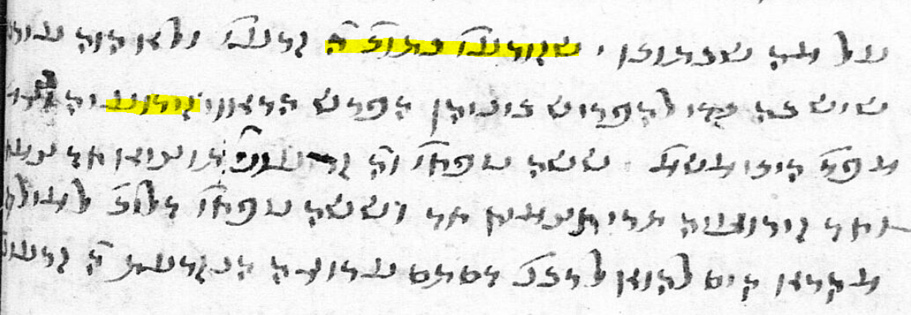
Does the truncated Rashi in the five manuscripts makes sense if read in sequence?
The Mishnah says
מִנַּיִן לַעֲרוּגָה שֶׁהִיא שִׁשָּׁה עַל שִׁשָּׁה טְפָחִים שֶׁזּוֹרְעִין בְּתוֹכָהּ חֲמִשָּׁה זֵרְעוֹנִין
This definitely needs elucidation because it is hard to imagine that you can plant five " זֵרְעוֹנִין " in a 2-foot square garden patch without running into the איסור of כלאים. So, Rashi says that he is aware of the issue and tells us that it can be done and still keep the proper distance
שזורעין בתוכה ה׳ זרעונין - ולא הוי עירבוב שיש בה כדי להפריש ביניהם הפרש הראוי:

If you assume that five “זֵרְעוֹנִין“ are individual plants, then the next part of the Mishna is not too difficult. It tells you how to do it, and now we know what Rashi meant when he said there would be a proper הפריש ביניהם

אַרְבָּעָה עַל אַרְבַּע רוּחוֹת הָעֲרוּגָה וְאַחַת בָּאֶמְצַע.

You would plant one plant in the middle and one on each of the four sides. Maybe in the corner, maybe in the middle.
The next part of the Mishna needs explanation because it is unclear how the Pasuk "proves" that it is five so Rashi tells us that the Gemara explains it.
But if Rashi introduces the idea that planting on four sides means planting an entire row up until each corner, then Rashi needs to tell us why that works even though it is counterintuitive. Rashi has to explain that the most important issue with Kilayim is whether a היכר exists and if it does, this constitutes a הפריש even though two plants draw nourishment from the same ground. Rashi includes in his explanation a “Kal Va’chomer proof” from Kilayai HaKerem which is Me’De’Oraita and Kilayai Zeraim is Mi’De’Rabanan, and thus discusses the issue that disturbed Tosafot.

Dr Ezra Chwat, of the manuscript division of the National Library of Israel, in a private email commented on the missing text of Rashi as follows: “It is truly disturbing to find these texts missing in manuscript, particularly when such variant roots are represented. Even so, between Tosafot and Soncino this is covered well, and should be accepted as part of the text.”

The Mishna appears in Kilayim 3:1 משנה כלאים ג:א עֲרוּגָה שֶׁהִיא שִׁשָּׁה טְפָחִים עַל שִׁשָּׁה טְפָחִים, זוֹרְעִים בְּתוֹכָהּ חֲמִשָּׁה זֵרְעוֹנִים, אַרְבָּעָה בְּאַרְבַּע רוּחוֹת הָעֲרוּגָה, וְאֶחָד בָּאֶמְצַע. It does not include the explanatory Torah verse of שֶׁנֶּאֱמַר: ״כִּי כָאָרֶץ תּוֹצִיא צִמְחָהּ וּכְגַנָּה זֵרוּעֶיהָ תַצְמִיחַ״ — ״זַרְעָהּ״ לֹא נֶאֱמַר, אֶלָּא ״זֵרוּעֶיהָ
This has to do with whether Rashi actually maintains that the prohibition of Kilayai Zeraim is only Rabbinic in nature. Rashi in Bechorot דגן ודגן - חיטין על שעורין ושעורין על חיטין:גפנים וזיתים אינן כלאים זה עם זה. דגן ודגן כלאי זרעים מדרבנן. דגן ותירוש כלאי כרם מדאורייתא: Tosafot in Bechorot דגן ודגן שהם כלאים זה בזה כו’ - כתוב בקונטרס דכלאי זרעים של דגן ודגן דרבנן ודומה שטעות סופר הוא דכאן משמע שהוא דאורייתא
In 1714, R. Judah Aryeh Leib ben Joseph Samuel arranged to have the Talmud printed in Amsterdam by Samuel ben Solomon Marquis and Raphael ben Joshua de Palacio. They began printing with Berakhot, but were forced to discontinue printing in 1717 due to the Haskamot issued for the 1697-1699 Frankfurt on der Oder edition of the Talmud. Judah Aryeh Leib, resumed printing in 1720 in Frankfurt-am-Main at the press of Johann Koelner.
It looks as if the 4 seeds on the various sides are just one seed (as in the middle) and not an entire row, but it is very difficult to tell from the diagram.

