מסכת שבת צ״ח׃ "והבריח התיכון בתוך הקרשים תנא בנס היה עומד"
By: Eli Genauer

In the Vilna Shas מסכת שבת צ״ח׃ one can see a closeup “picture” of one of the boards of the Mishkan ("קרש"). Instead of illustrating specific words of Rashi or Tosafot, it is a general diagram of one of these boards and tries to paint a picture of a number of statements of the Gemara on this particular Daf. By its positioning on the page, it looks as if it depicts something in a comment of Rashi, but we are unable to find any words in Rashi which “fit” the main part of the picture. We do not find this picture in any manuscript of Rashi, nor do we find it in any printed Gemara until one which was printed in Amsterdam in 1715. From this Amsterdam edition, it eventually made its way to the Tzurat haDaf of the Vilna Shas and it is what we see today. In many ways, its addition to the actual page of Gemara is quite unusual.
A close up of the picture in the Vilna Shas (Vilna 1881) and its position on the page
https://hebrewbooks.org/pdfpager.aspx?req=14314&st=&pgnum=197
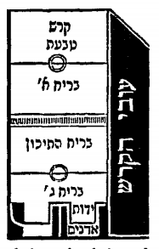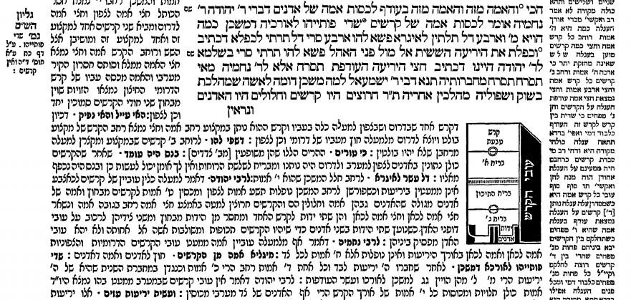

The Gemara in Masechet Shabbat on Daf 98a and b deals with the laws of carrying, by discussing some of the details of the boards ("קרשים") which made up the walls of the Mishkan. To understand this discussion, it would help to be able to picture what each board looked like. Manuscripts of Gemarot though generally do not contain pictures, and a check on the invaluable website “Hachi Garsinan” shows that no manuscript of these pages has a picture to illustrate what a board looked like. One might expect Rashi in his description of some of the statements of the Gemara to state his opinion and then write "כזה". Then we could expect to find an illustration in any of the number of Rashi manuscripts we have, and we could expect that this illustration (or an empty space for it) would appear in subsequent printed editions. Here we have none.
It seems to have appeared out of nowhere on Daf 98b in Masechet Shabbat in an edition of the Talmud printed in Amsterdam in 1715. As you can see, the rendering in the Vilna Shas is very close to the one from Amsterdam.
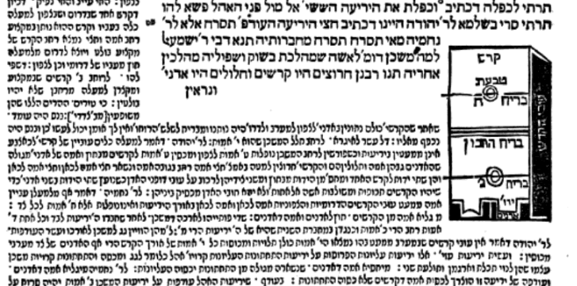
Amsterdam Shas 1715 (Google books) Vilna Shas 1881
https://books.google.com/books?id=id9jAAAAcAAJ&printsec=frontcover&source=gbs_ge_summary_r&cad=0#v=onepage&q=%D7%94%D7%AA%D7%99%D7%9B%D7%95%D7%9F%20%D7%91%D7%AA%D7%95%D7%9A%20%D7%94%D7%A7%D7%A8%D7%A9%D7%99%D7%9D%20&f=false
It is trying to illustrate two statements of the Gemara, one in the middle of the Daf and one at the very bottom.
- "והבריח התיכון בתוך הקרשים תנא בנס היה עומד" - “The middle bar in the middle of the beams passed through them and stood miraculously”. This means that the middle bar (הבריח התיכון) which connected the beams all around, was inserted in the “thickness” part of the beams ("עובי הקרש") and made its way miraculously around the corners of the walls.
- "תנו רבנן חרוצים היו קרשים וחלולים היו האדנים" - “The Sages taught, the bottoms of the beams (Kerashim)were grooved and the sockets were hollow.” This deals with a completely different aspect of the beams which is how they were shaped on the bottom (and only according to Rabbi Nechemya)
The picture in the Vilna Shas primarily shows that there were three rods (“בריחים”) which connected one board to the next. The rods on the top and bottom went through outer rings, but the rod in the middle went through the width of the board.( "עובי הקרש") It also shows the sockets on the bottom ("אדנים") and the grooves ("ידות") inserted in them which provided stability to the boards as they stood.
I asked a number of people which Rashi they thought this picture illustrates and, because of its placement on the page, all said בנס היה עומד. However, if you look at that Rashi, it does not speak about the fact that the middle rod went through the thickness of the board, but rather the miraculous nature of how the rod bent as it turned the corner. This picture illustrates mostly the statement הבריח התיכן בתוך הקרשים on which Rashi does not comment. Also, it does not explain why there is such detail on the bottom of the picture showing the grooves going into the base. It is a very helpful picture but its origin in unclear and its placement on the page is misleading.
The Mesivta edition of Oz Vehadar also understands that this picture illustrates the words והבריח התיכון בתוך הקרשים. They indicate that Tziyur 6 which except for the detail on the bottom looks very similar to the one in the Vilna Shas, illustrates that statement.
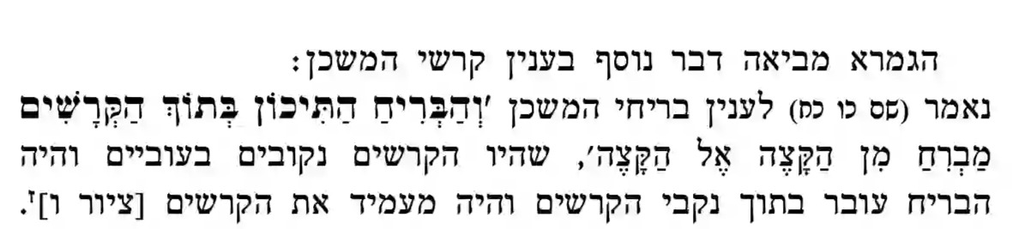
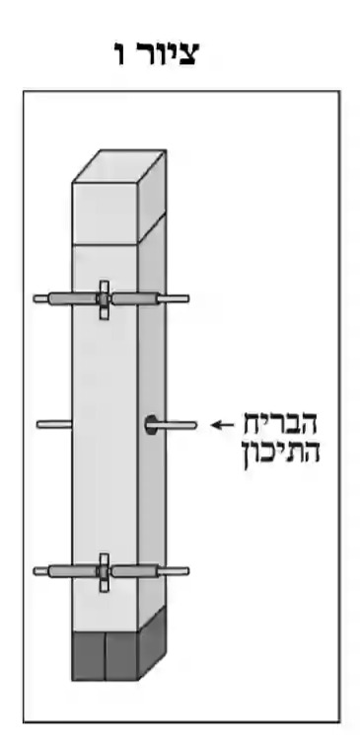

Why did the editors of the Amsterdam 1715 Shas insert a picture like this? Perhaps they were inspired by diagrams that appeared in a book called Omek Halacha by Jacob ben Simcha Bunim Koppelman which had just been reprinted in Amsterdam in 1710. It has a picture of the grooves that fit into the sockets that is associated with the second aspect of this picture.
https://hebrewbooks.org/pdfpager.aspx?req=20813&st=&pgnum=37
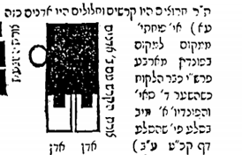

Adding such a picture to a Daf of Gemara was a revolutionary act at that time and once added, it became part of the page. It shows the fragility of what we think of as the Tzurat HaDaf. In truth, the main part of the picture showing the middle rod going through the width of the board is not at all aligned with a comment of Rashi. Understanding that it just tries to give a picture of the "קרש" will make it easier to understand for people who study this page.

The Soncino edition of 1489 and the Bomberg edition of 1521 do not leave an empty space for a diagram on this page. There is also no diagram contained in Chochmat Shlomo and Chochmat Manoach, two books which would often add diagrams missing in the early printed editions of Gemara.
The “newer” versions of the Talmud (Vagshal/Nehradea, Vilna HaChadash and Oz Vehadar) which are based on the Vilna Shas change the picture a bit. This may show the ambivalence that the editors of these new editions have towards this “picture”. Most times, they leave the diagrams the same as in the Vilna Shas.
The categories of work employed to build the Mishkan formed the basis for the Melachot of Shabbat. In this case, the boards of the Mishkan were transported from one location to another giving rise to issues relating to the domains created thereby.
https://fjms.genizah.org/
The manuscripts I checked on the KTIV website of the National Library of Israel were ones known as Parma 2087, Vatican 138, and Paris 324. All have no diagram in this entire Perek despite containing other diagrams of Rashi in other Perakim. (The two other manuscripts I checked of the total five that were available did not have diagrams in other Perakim either). The general website address for KTIV is https://web.nli.org.il/sites/nlis/en/manuscript
In 1714, R. Judah Aryeh Leib ben Joseph Samuel arranged to have the Talmud printed in Amsterdam by Samuel ben Solomon Marquis and Raphael ben Joshua de Palacio. They began printing with Berakhot, but were forced to discontinue printing in 1717 due to the Haskamot issued for the 1697-1699 Frankfurt on der Oder edition of the Talmud. Judah Aryeh Leib, resumed printing in 1720 in Frankfurt-am-Main at the press of Johann Koelner. For more information on this edition see “Printing the Talmud : from Bomberg to Schottenstein” Sharon Liberman Mintz; Gabriel M Goldstein; Yeshiva University Museum.; Center for Jewish History ,2005. Article by Marvin J Heller, page 254
In the book רש״י ,חייו ופירושיו",כרך ב׳, הוצאת הקדש רוח יעקב, תשנ״ז” page 497, the author Rav Rephael Halpren states that there are 101 diagrams in Rashi included in the Vilna Shas, 51 of them in Masechet Eruvin. He then proceeds to enumerate all of them, including this one on Shabbat 98b. From the positioning of it on the page it certainly does look that way.
Jacob ben Simcha Bunim Koppelman (1555–1594) was a talmudic scholar distinguished for his broad erudition and interest in secular sciences. Early in his life he embarked upon mathematical and astronomical studies, in addition to intensive occupation with traditional Jewish learning. He is the author of Omek Halakhah (Cracow, 1593). In it he elucidates the laws appertaining to Kilayim, Eruvin, etc., with the aid of diagrams and models. https://www.encyclopedia.com/religion/encyclopedias-almanacs-transcripts-and-maps/koppelman-jacob-ben-samuel-bunim This is it as it appears in the first edition (Cracow 1593) https://hebrewbooks.org/pdfpager.aspx?req=45068&st=&pgnum=39

