Sukkah32 a- דַּעֲבִיד כְּהֶימְנֵק.
Mishna Sukkah 29b. All translation from Rabbi Steinsaltz on Sefaria
לוּלָב הַגָּזוּל וְהַיָּבֵשׁ — פָּסוּל. שֶׁל אֲשֵׁירָה וְשֶׁל עִיר הַנִּדַּחַת — פָּסוּל. נִקְטַם רֹאשׁוֹ, נִפְרְצוּ עָלָיו — פָּסוּל. נִפְרְדוּ עָלָיו — כָּשֵׁר……
A lulav that was stolen or that is completely dry is unfit for use in fulfilling the mitzva of the four species. The lulav of a tree worshipped as idolatry [Asheira] and a lulav from a city whose residents were incited to idolatry, which must be burned along with all the city’s property, are unfit. If the top of the lulav was severed or if the palm leaves were severed from the spine of the lulav, it is unfit. If its leaves, although still attached, were spread and are no longer completely joined to the spine, it is fit.
Gemara 31b on the bottom, continuing on top of 32a
נקְטַם רֹאשׁוֹ. אָמַר רַב הוּנָא: לֹא שָׁנוּ אֶלָּא נִקְטַם, אֲבָל נִסְדַּק — כָּשֵׁר.
The Mishna continues: If the top of the lulav was severed it is unfit. Rav Huna said: They taught that it is unfit only when it was completely severed; however, if the top merely split, the lulav is fit.
וְנִסְדַּק כָּשֵׁר? וְהָתַנְיָא: לוּלָב כָּפוּף, קָווּץ, סָדוּק,..— פָּסוּל. . אָמַר רַב פָּפָּא: דַּעֲבִיד כְּהֶימְנֵק.
The Gemara asks: And is a split lulav fit? But isn’t it taught in a baraita: A lulav that is bent at the top, that is thorny, split,…. is unfit. .Apparently, a split lulav is unfit?? Rav Pappa said: The split lulav in the Baraita is so split that it is shaped like a fork [heimanak], with the two sides of the split completely separated, and it appears that the lulav has two spines.
What is a הימנק?
Rashi gives us a lot of information –
אלא דעביד כי הימנק - יפויצפו"ר של ברזל של סופרים שיש לו שני ראשים וראשו אּחד מפוצל(split) כך גדל הלולב כמין שתי שדראות מחצית עלין לכאן ומחצית עלין לכאן:
- A הימנק is a יפויצפו"ר של ברזל של סופרים.
- It has two “ראשים”.
- One ראש is split in such a way that the lulav grows like it has two spines.
- Half the leaves are on one side and half the leaves are on the other side.
Peirush Chai
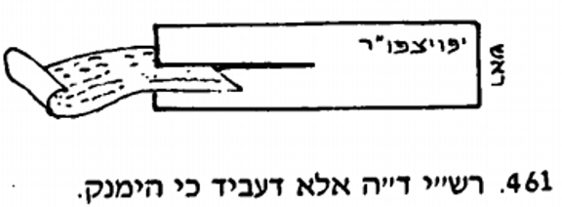
Otzar Lo’azay Rashi
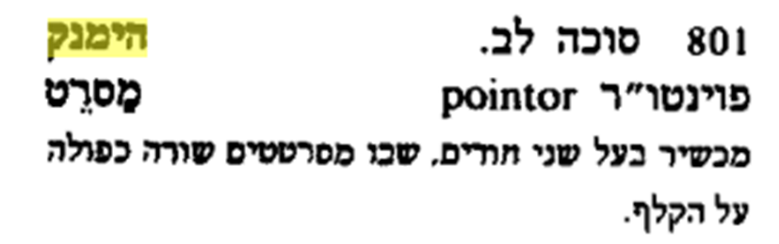
Jastrow
המנק …Succ. 32ᵃ דעביד כהימנק (Ms. M. והוא דעביד לה כי הימניק) when the palm-branch is formed like a himnek (Rashi: like the top of the stylus).
HaMetargaim
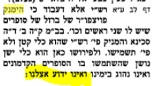

Oz Vehadar Hahod VeHaHadar 2014

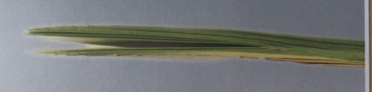
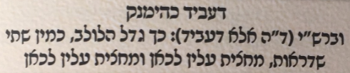

Daf Yomi Advancement Forum introduces us to the idea that a הימניק is like a two tined fork.
“This is what the Beraita is referring to when it says that סָדוּק is not Kosher, דעביד כהימנק [that which a split Lulav is invalid refers to one whose tip] appears as that of an iron scorer (O.F. pointer) [which resembles a two-tined fork]”
We find that idea in Sefer HeAruch by Nathan ben Yechiel of Rome (1035-1106)
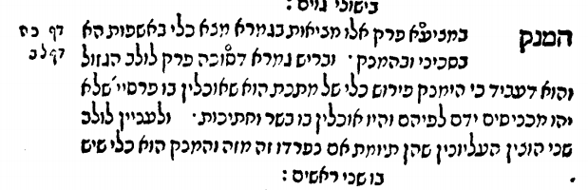
It is illustrated in the Steinsaltz Noe’ Edition
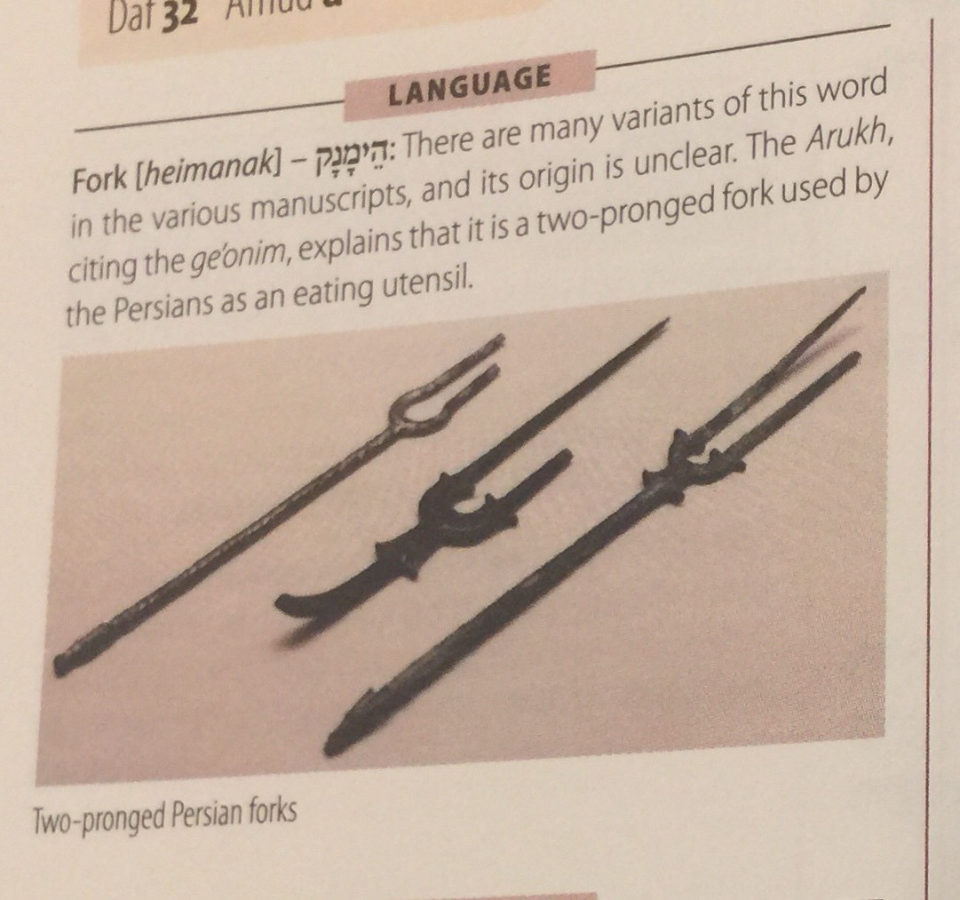
So far, we have two items/utensils which are identified as a הימניק
- Some kind of utensil used by Sofrim which has two ראשים
- A fork which has two ראשים ( a two pronged fork)

We now introduce a very unusual picture and caption from Peirush Chai. It references the Rosh and the Rif…and the Chazon Ish. It seems that the Chazon Ish understands that according to the Rosh and the Rif, a lulav which has the characteristics of a הימניק is configured like this. The leaves themselves are all split, but not from each other.
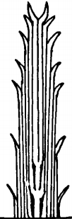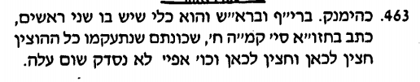
Here is the Chazon Ish
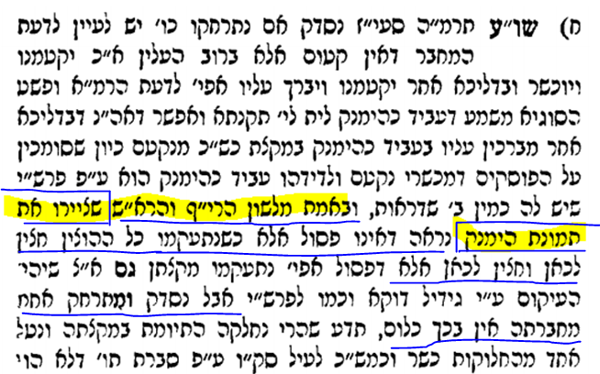

This is the Rosh as presented in the standard Vilna Shas. (First edition, Vilna 1882) The part of the Rosh which is crucial is
ואם נסדק ועביד כהימנק פסול והוא כלי שיש לו שני ראשים וזו היא צורתה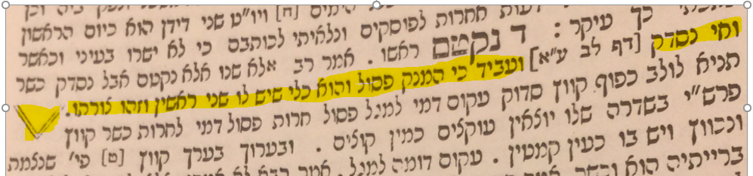
We do not have manuscripts of the Rosh today to be able to see whether the diagram was presented as a “V”. The first time the Rosh was printed was in 1521 in the back of a Shas, that of Daniel Bomberg in Venice 1521.(the first complete edition of Shas) Here is a bit of the history of this diagram as it was presented in earlier printed editions.
Bomberg 1521 65a left column – This edition was copied from a manuscript. The וזו היא צורתה is presented as a Tzadik Sofit. It gives the impression of being a vessel which starts out as one and then splits into two.
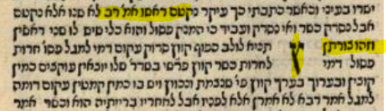
Here it is in Basel 1580. It is now a “Y”, which is quite similar to the Tzadik Sofit
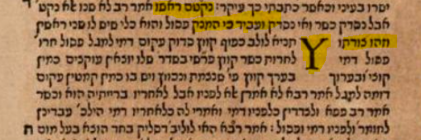

The illustration then goes missing in all printed editions for the next 137 years. Here is one printed in Cracow in 1603. (It is similarly absent in Amsterdam 1646 and Frankfurt an der Oder 1698)
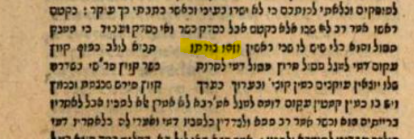
The illustration finally appears as a “V” in an edition printed in Amsterdam in 1717
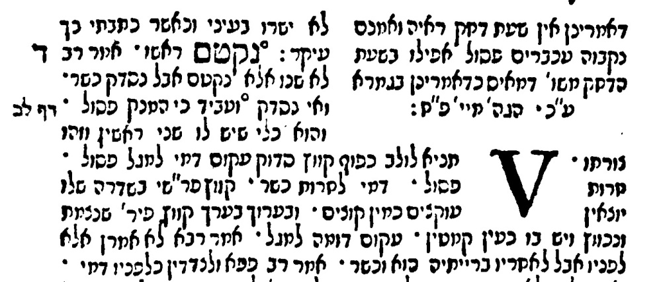
It appears that way in Slavuta 1801 and Zhitomir 1862
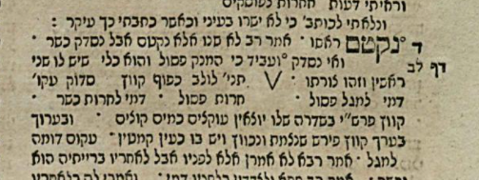
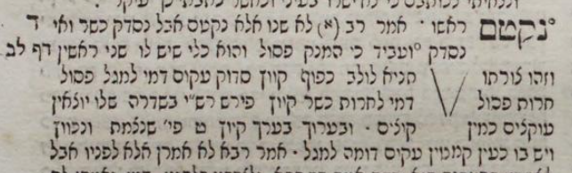
It is interesting to note that Oz Vehadar changed their illustration recently from that of a “V” to one of a Tzadik Sofit, similar to Bomberg 1521
This is from 2008
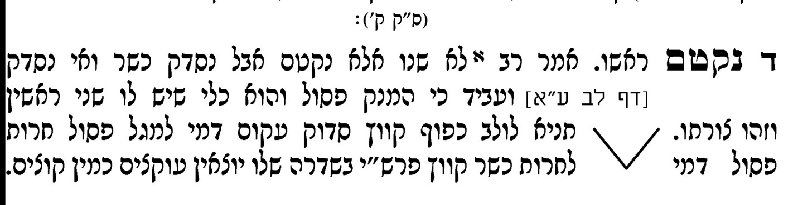
This is from 2016 ( Oz VeHadar Murchav)
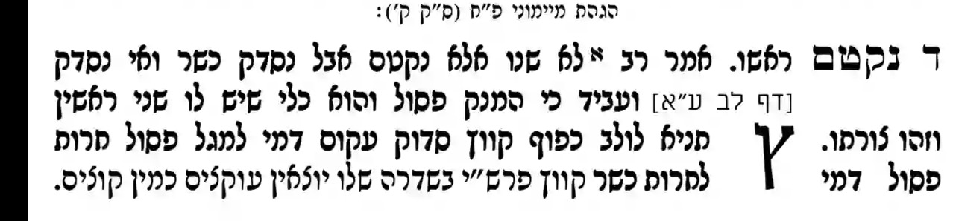

Chazon Ish mentioned the Rif alongside the Rosh. Let us now look at how the picture as drawn in the Rif. Here we are very fortunate because we have a very early manuscript of the Rif known as Oxford Huntington 135. It is dated from the 1100’s not long after when the Rif lived. (1013-1103). Notice the language of the Rif is the same as the Rosh, indicating that the Rif may have been the source for the Rosh. כלי שיש לו שני ראשים וזו היא צורתה . (Chazon Ish certainly felt they were similar). As you can see, the picture is very much like a Tzadik Sofit.
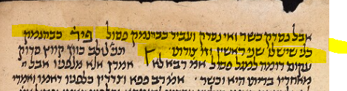
Although meant to represent a vessel with two heads, the picture does look like a Tzadik Sofit.

The illustration in LEIPZIG UBL B.H. 5 ( 1200’s) is similar
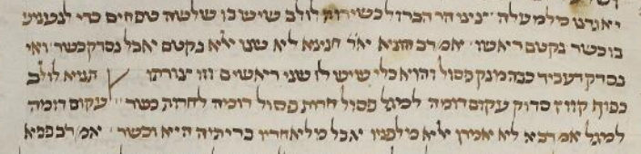
The Hamburg State and University Library Carl von Ossietzky, Hamburg, Germany Ms. Levy 162
13th-14th century – Here it looks more like a Tzadik Sofit and something like this may have served as a model for the printed editions.
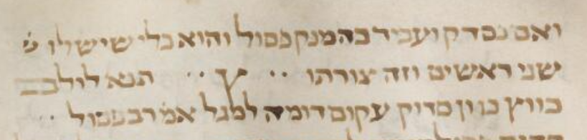
The only outlier in terms of manuscripts is Austrian National Library, Vienna, Austria Cod. hebr. 199 = 13th century. Here the illustration is that of a “V”. We will discuss this later.
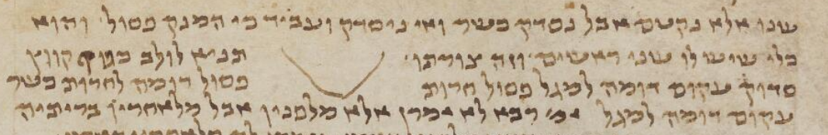
Nowadays, most Gemaros have the Rif at the end. This is how the Rif looks in the classic Vilna Shas.
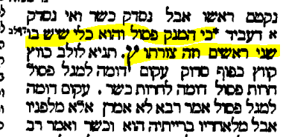
It is interesting to note that even though the Vilna Shas did print a Tzadik Sofit in the Rif, they stuck with a “V” shape in the Rosh.
The reason why the Rif had the Tzadik Sofit is most likely because it started out that way in the first printed edition in Constantinople in 1509. It was then printed like that in all subsequent printings of the Rif.
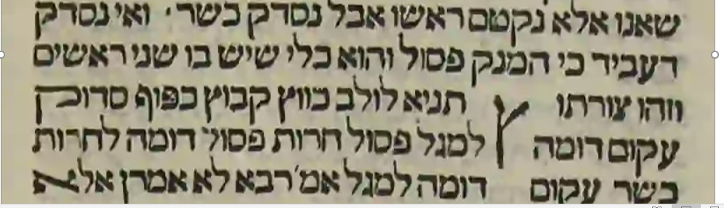
Here is a Rif printed in Amsterdam in 1720 around the same year as the Rosh with the “V” was printed there.
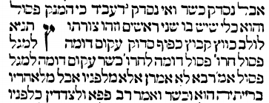
It was very exciting to discover that the same illustration even preceded that of the Rif and that was in the Peirush of Rabbeinu Chananel (965-1055). Rabbeinu Chananel ben Chushiel (Hebrew: חננאל בן חושיאל‎), was a student of one of the last Geonim. He is best known for his commentary on the Talmud.
Here is an email from Dr Ezra Chwat who is the head of the department of manuscripts at the National Library of Israel

What's special here is that the illustration is already found in Ra”ch,( Rabbeinu Chananel) which would make it the first illustration in Rabbinic literature. It seems that even in the made-for-written-media works of the Gaonim, like Sheiltot, HG (Halachot Gedolot), HP (Halachot Pesiktot), they didn't use this feature of the "New Technology", so Ra”ch can be accredited as the first innovator. Rif here is only copying from Ra”ch.

The image in print shows that the early printers didn't ignore the illustrations in the manuscripts before them, but because they only had letter images available, they simply didn't have the technology to represent them. (Except for הימנק which the tsade sofi is sufficient.) The Kasha is on Basel and Amsterdam.

You'll see in the edition that is Paris 312, (Italy 13th, transcribed by the known Rishon ריבב"ן), the הימנק lacks a stem, so it's more like a V. This may reflect an alternative tradition, not necessarily in Rif-Rach, but possibly inbred from Rashi, like you found in ms ONB 199. How this shows up in Amsterdam is beyond me.
Ezra Chwat

This is the most authoritative manuscript of Rabbeinu Chananel. It was used in the Vilna Shas as mentioned in the Achrit Davar
Vatican Library, Vatican City, Vatican City State Ms. ebr. 126 - 12th-13th century
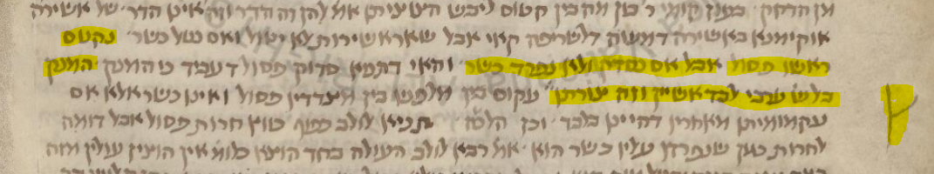
Here is how it is presented in Al HaTorah
https://library.alhatorah.org/?r1=Rif_Sukkah_15a

- בסדר מועד, ומסכתות ברכות, חולין, ומסכתות קטנות, נוסח הפנים נקבע על פי כ"י אוקספורד הונטינגטון 135 (נויבואר 550).

{בבלי סוכה לב ע"א} ואי נסדק ועביד [כבהמנק] פסול (פיר') והוא כלי שיש לו שני ראשין {פי' ר"ח} וזו צורתו .
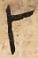
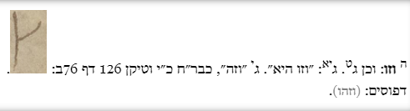

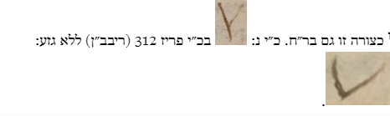

This is Rabbeinu Chananel in Vilna Shas 1882. This is Rabbeinu Channanel in Oz Vehadar
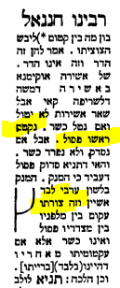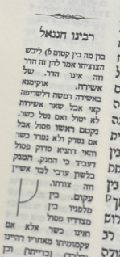

Finally, I was able to find another “proof” that the original diagram looked like this 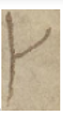 from a surprising place.

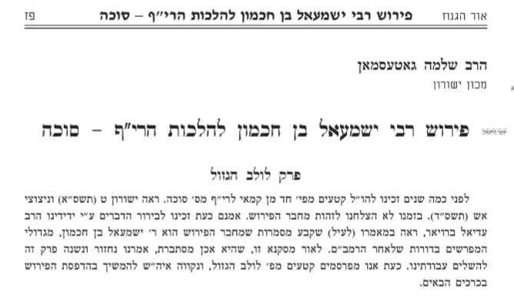
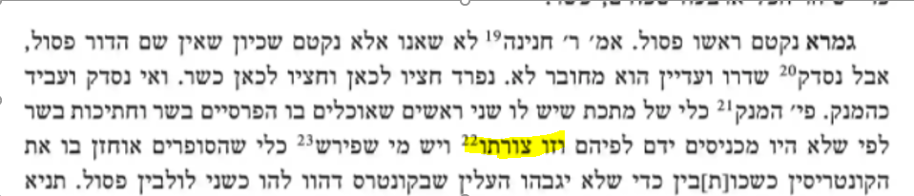
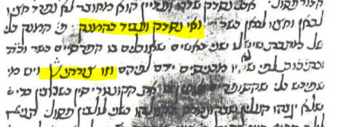
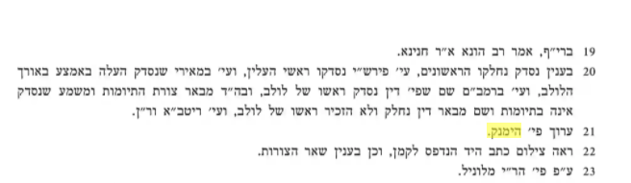
Addendum
Mishna Brurah with Pesakim of Chazon Ish – Oz VeHadar
