אַחְוִי לֵיהּ, נִרְאֶה מִבִּפְנִים וְשָׁוֶה מִבַּחוּץ
Sukkah 19a
Eli Genauer
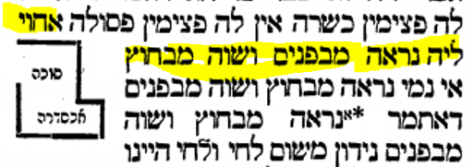
Summary: Although an illustration appears in the text of the Gemara, there is no basis for it to be there. The source is Maharshal who only draws a picture to illustrate the Gemara but does not say that the picture belongs within the text.
למרות שנראה שהיא חלק מהגמרא, אין תקדים ממשי לתמונה זו שתופיע בטקסט התלמודי.
Background
The Gemara in Sukkah 18a discusses the following scenario for making a Sukkah in a courtyard surrounded by houses, where the courtyard has a portico (אַכְסַדְרָה)
אַתְּמַר: סִיכֵּךְ עַל גַּבֵּי אַכְסַדְרָה שֶׁיֵּשׁ לָהּ פַּצִּימִין — כְּשֵׁרָה. שֶׁאֵין לָהּ פַּצִּימִין, אַבָּיֵי אָמַר: כְּשֵׁרָה, וְרָבָא אָמַר: פְּסוּלָה.—
It was stated: If one placed Schach on a portico that has posts on its open side, the Sukkah is kosher. If one placed Schach on a portico that does not have posts on its open side, Abaye said: The Sukkah is kosher and Rava said: The Sukkah is pasul.
Here are the two possibilities. (All drawings from Peirush Chai available on hebrewbooks.org)
An אַכְסַדְרָה which does have posts. Both Rava and Abaye agree that if you put Schach over the middle area, it is a kosher Sukkah because the posts act as walls.
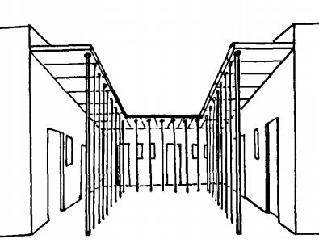

An אַכְסַדְרָה which does not have posts. If you put Schach in the middle area, Abaye says it is kosher and Rava says it is pasul

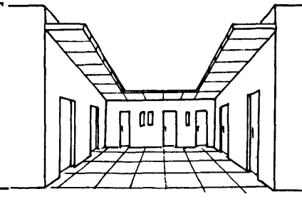

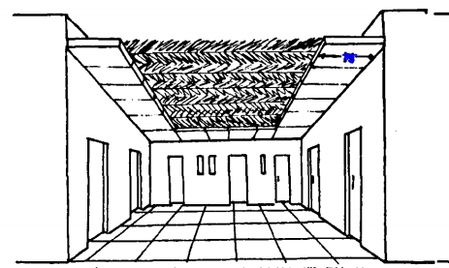
The Gemara continues on 19a
רַב אָשֵׁי אַשְׁכְּחֵיהּ לְרַב כָּהֲנָא דְּקָא מְסַכֵּךְ עַל גַּבֵּי אַכְסַדְרָה שֶׁאֵין לָהּ פַּצִּימִין. אֲמַר לֵיהּ: לָא סָבַר מָר הָא דְּאָמַר רָבָא: יֵשׁ לָהּ פַּצִּימִין כְּשֵׁרָה, אֵין לָהּ פַּצִּימִין פְּסוּלָה!
The Gemara relates: Rav Ashi found Rav Kahana, who was putting Schach for a Sukkah atop a portico that did not have posts. He said to him: Doesn’t the Master hold in accordance with that which Rava said: If it has posts, the Sukkah is kosher; if it does not have posts, it is pasul?

אַחְוִי לֵיהּ, נִרְאֶה מִבִּפְנִים וְשָׁוֶה מִבַּחוּץ……..
Rav Kahana showed him that in this Sukkah the disparity between the Sukkah and the portico was visible from the inside and even from the outside. From outside, the portico and the Sukkah appeared to be one continuous structure. However, from inside, one of the walls of the portico was visibly thicker than the wall of the Sukkah, and that one Tefach thickness serves as the third wall of the Sukkah
This is an illustration of נִרְאֶה מִבִּפְנִים וְשָׁוֶה מִבַּחוּץ.
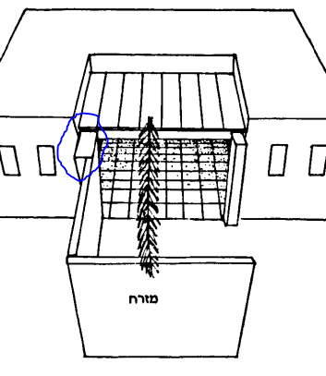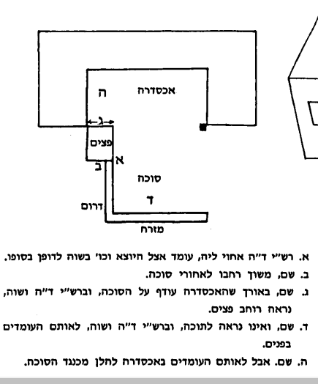

This is the way the diagram is presented in the Vilna Shas (1882
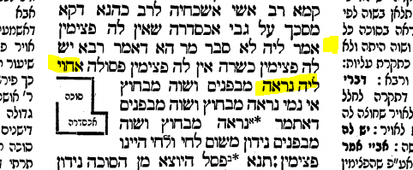

The Oz Vehadar Friedman edition illustrates it in a more precise manner by showing the relative dimensions more accurately. I have turned it upside down so it parallels the Peirush Chai drawing

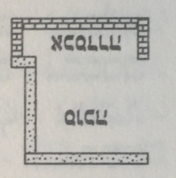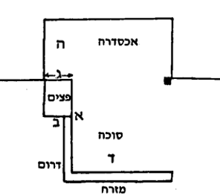
Do we find this illustration in any manuscript or early printed edition of the Gemara?
There is no picture in any of the 9 manuscripts of Masechet Sukkah appearing on Hachi Garsinan
for example
BL Harley, 5508
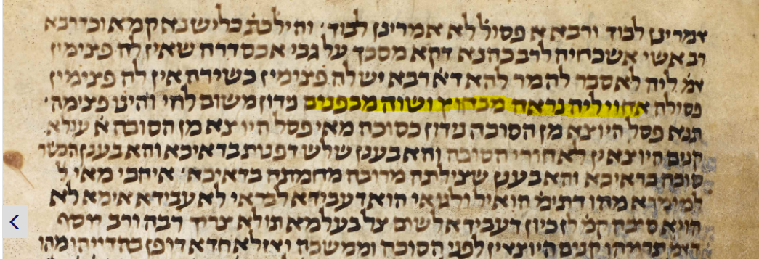

JTS Rab 1608,
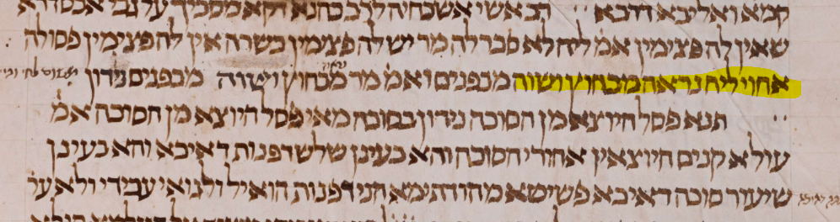

The Dfus Rishon of Soncino Pesaro, (circa 1515) which was based on a manuscript, also does not have this illustration.
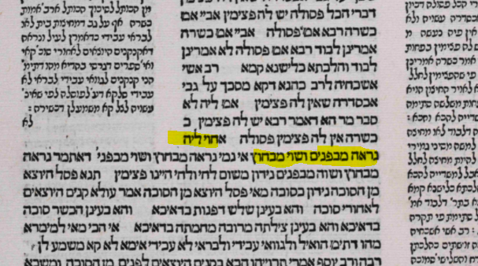
Neither does the Bomberg edition of Sukkah in 1521.
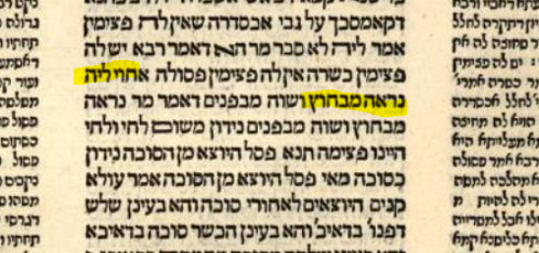
The source for it eventually appearing in the printed editions is Chochmat Shlomo (Cracow 1582) This Sefer was used extensively by later printed editions of the Talmud to fill in or add pictures missing in previous printed editions. In this case, I believe Maharshal was just illustrating what the words of the Gemara mean, but he is not indicating that the illustration is part of what Rav Ami and Rav Asi wrote.
Notice that he doesn’t say מצויר זה הציור, which would indicate that his manuscript had this picture.
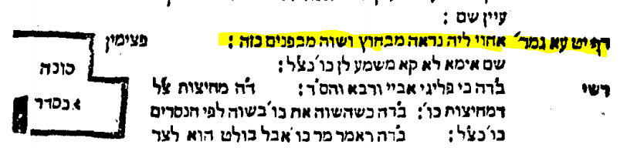
Some examples of where Maharshal indicates that his manuscript included a picture(s) are as follows
Sukkah 4a
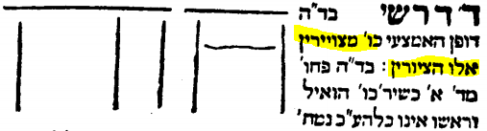
Sukkah 4b
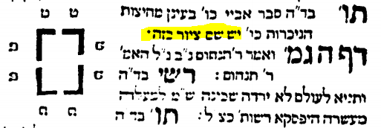
Omek Halacha (Cracow 1593) records it in a similar manner by just saying “Kazeh” but not specifying that the picture was drawn in the text.
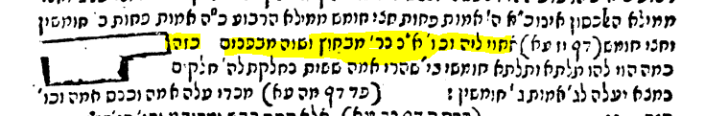

The Frankfurt/Oder edition which ordinarily followed the instructions of Chochmat Shlomo, correctly did not place it in the text of the Gemara
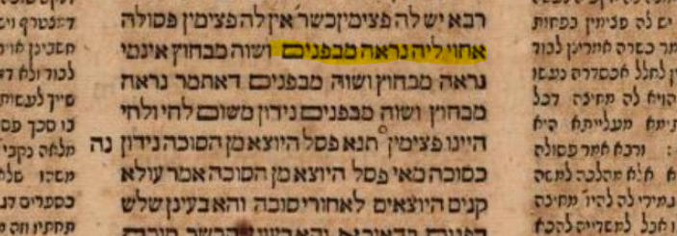

The first time we see it in print in a Gemara is Amsterdam 1717. I believe it misunderstood Maharshal and placed the picture in the text of the Gemara .
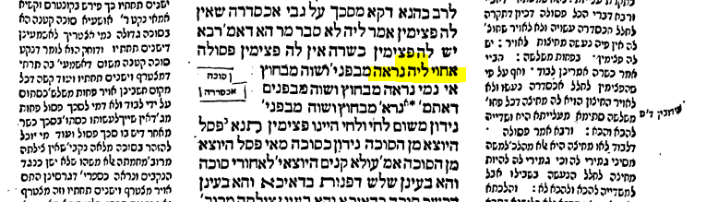
Traveling on through printing history, the diagram improved a bit.
Amsterdam Proops 1752 – similar to 1717 in terms of space considerations
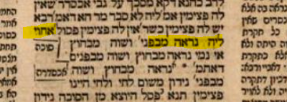
Vienna 1793
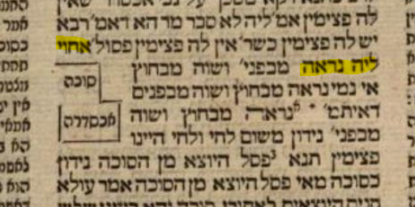

And finally looked like this in the Vilna Shas.
Though it appears to be part of the Gemara, there is no real precedent for this illustration to be included within the Talmudic text.

