Sukkah 7a ״ויעמידנו כנגד ראש תור״

Oz VeHadar Illustrates that ״אין חדש תחת השמש״

Eli Genauer

The first Mishnah in Masechet Sukkah tells us that a Sukkah needs to have at least three walls to be Kosher. The Gemara on Sukkah 6b clarifies this requirement as follows

תָּנוּ רַבָּנַן שְׁתַּיִם כְּהִלְכָתָן וּשְׁלִישִׁית אֲפִילּוּ טֶפַח, רַבִּי שִׁמְעוֹן אוֹמֵר שָׁלֹשׁ כְּהִלְכָתָן וּרְבִיעִית אֲפִילּוּ טֶפַח

The first opinion is that two walls need to be complete walls, but the third wall need only be one Tefach. Rav Shimon says that three walls need to be complete walls and the fourth one can be only a Tefach. The Gemara goes on to explain that the Machloket is based on the famous question of יש אם למקרא or יש אם למסורה.

The Gemara asks וְאוֹתוֹ טֶפַח הֵיכָן מַעֲמִידוֹ..According to the first opinion, where does that Tefach of the third “wall” go?

The Gemara answers אָמַר רַב מַעֲמִידוֹ כְּנֶגֶד הַיּוֹצֵא… Rav says, he positions it at the end of the far wall.

Rashi explains what is meant by ״כנגד היוצא״

כנגד היוצא - מקום שהמחיצה כלה באיזה שירצה אם השתים מזרחית צפונית יעשה הטפח בסוף הצפונית במקצועו לצד מערב או במזרחית לצד דרום:

The place where the wall comes to an end on whichever side he wishes. If the two full walls are on the north and east, he should make the Tefach sized wall in the at the edge of the northeast wall towards the west, or the east towards the south. In the authoritative Vilna Shas (Vilna 1881) Rashi looks like this

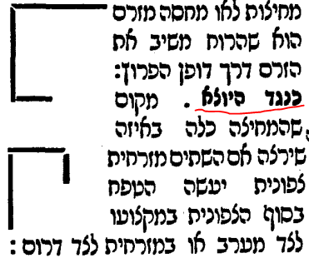

The source of these two diagrams in Rashi is the MaHarshal in the Sefer Chochmas Shlomo. In the Dfus Rishon printed in Cracow in 1582, it looks like this

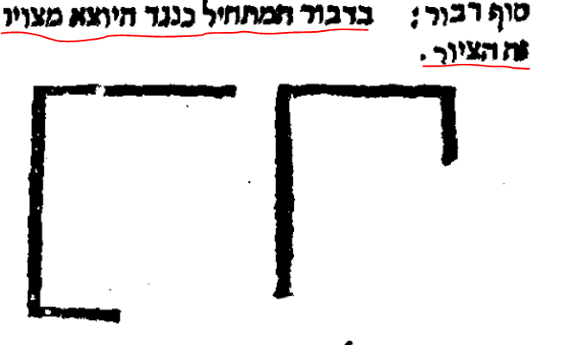

The Gemara then records the question of Rav Kahana and Rav Asi to Rav: ויעמידנו כנגד ראש תור

Let him establish that "wall” (which is a Tefach) opposite the head of a (diagonal) line?

שתיק רב Rav was silent[1]

Rashi then explains what the Gemara means when it asks about the third wallויעמידנה כנגד ראש תור

ויעמידנו כנגד ראש תור - (ראש שורה) במקצוע צפונית מערבית באלכסון או מזרחית דרומית כשהמחיצות מערבית צפונית דנראה נוטה לב' מחיצות ומיחזי כארבע מחיצות ראש תור היא תלם מענה של סוף שדה שהתלמים כלים והולכין באלכסון זה ארוך מזה מעט

In the northwest corner diagonally or in the southeast corner when the walls are west and north, because then it looks as if it is ‘leaning” towards the two walls and makes it look as if there are four walls…

In the Vilna Shas (Vilna 1881) it looks like this.

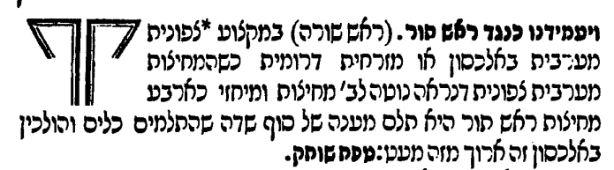

Here again the source of these two diagrams is the Chochmas Shlomo.[2]

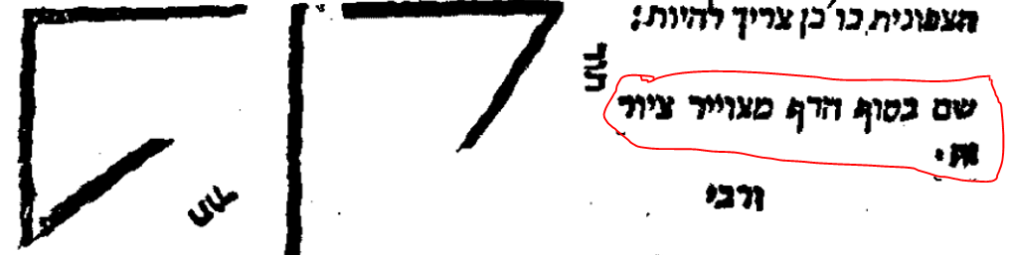

The Chochmas Shlomo was included in the Vilna Shas at the back of the Gemara underneath the MaHarsha. There we find the comment of MaHarshal, though changed a bit from the Dfus Rishon, nevertheless indicating that the two pictures should be placed after the last Rashi on 6b. This is the way it looks in the Shas Vilna HaChadash (Jerusalem 2008)

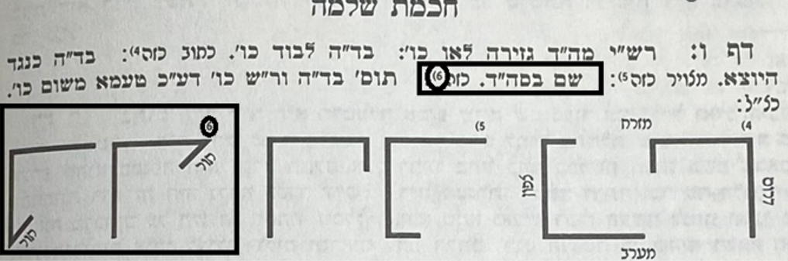

It says “שם בסוף הדף,כזה”. It is referring to the comment of Rashi with the “דבור המתחיל” of “ויעמידנה כנגד ראש תור” on 7a, and it is telling you that the pictures (indicated by the number 6) belong at the end of the page and are relevant to the next page. [3] [4]

The original Vilna Shas (1881) ascribes a different picture to the Chochmat Shlomo, and as we will see, it caused difficulty for anyone using the Vilna Shas to study this Gemara

Here is original Vilna Shas-1881[5]

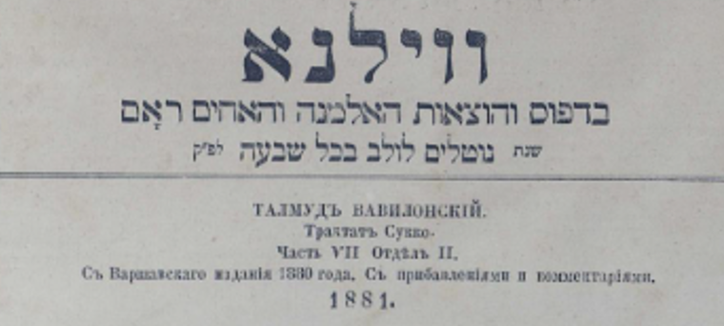

<https://viewer.rsl.ru/ru/rsl01006617259?page=140&rotate=0&theme=white>

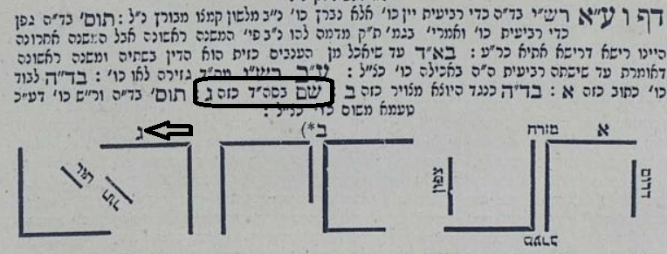

The picture ascribed to Maharshal is this 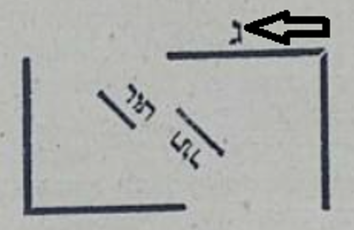

while we know that it was really this! 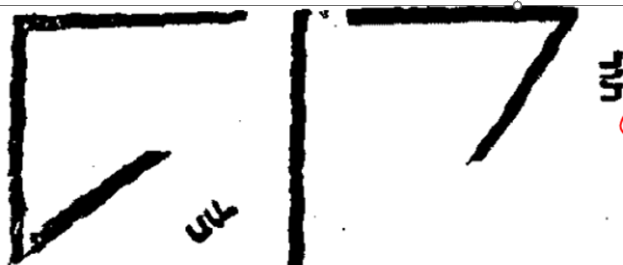[6]

This is extremely important because Maharam Lublin disagrees with the picture drawn by MaHarshal and proposes his own diagram in Rashi. MaHaram’s new diagram is exactly the one ascribed to Chochmas Shlomo in the Vilna Shas

He writes that his picture accords with the Lashon of Rashi and that of Tosfos and says that Maharshal’s picture does not accord with the words of Rashi or the words of Tosfos

ובספר חכמת שלמה ראיתי שצייר בענין אחר,אבל לא יתישב לפי ציורו לא פרוש רש״י שכתב ומחזי לד׳ מחיצות ולא לשון התוספות .........

“ I have seen in the Sefer Chochmas Shlomo that the picture is drawn in a different matter, but according to this picture, Rashi’s words of “ it looks like four walls” does not make sense, nor does the diagram accord with the words of Tosfos…”

Here is Maharam Lublin in Oz VeHadar Friedman, Jerusalem 2021.

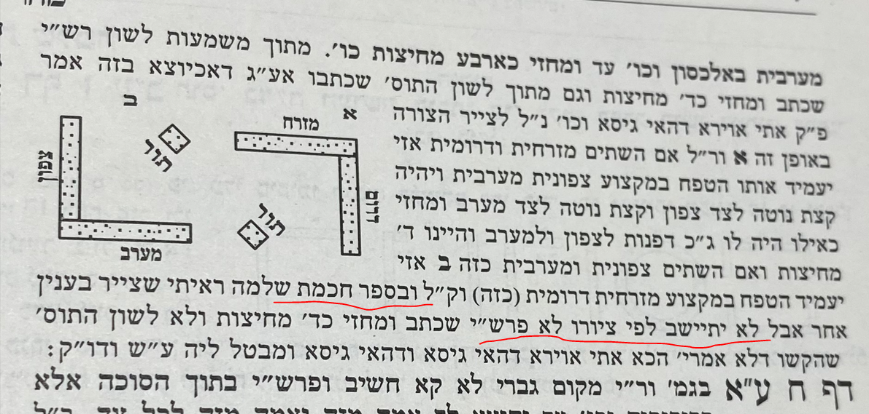

Here is the Tosfos cited by MaHaram Lublin

ויעמידנו כנגד ראש תור – אע"ג דאכיוצא בזה אמר פ' קמא דעירובין (דף י:) אתי אוירא דהאי גיסא ודהאי גיסא ומבטל ליה גבי והרחב מעשר אמות וגבי עור העסלא, הכא דטפח מחיצה דאורייתא והלכתא גמירי לה לא אתי אוירא ומבטל לה.

It is clear that Tosfos imagined a scenario where there was empty space on either side (אוירא דהאי גיסא) of that third Tefach sized “wall” and clearly that is not the case in Maharshal’s diagram

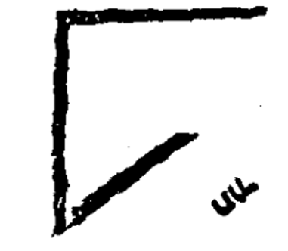

*Is there any way to determine which diagram if any was in the original Rashi? (that of MaHarshal or that of MaHaram Lublin?)?*

We do not have an autograph copy of Rashi on any Masechta. On top of that, we have very few manuscripts of Rashi on Sukkah up until the dawn of printing. We do have an “עד נוסח” though and it seem to go in the direction of MaHaram Lublin.

The reason Bomberg left a space for a drawing in that Rashi is because it was based on the Soncino Pesaro edition of 1515 which included a diagram for the Rashi of ויעמידנו כנגד ראש תור[7]

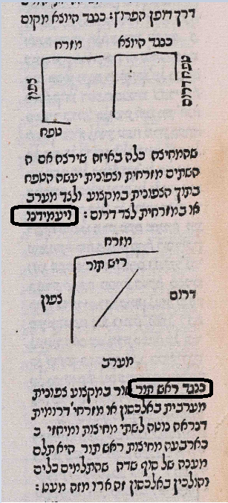

This is like the diagram of MaHaram Lublin. The editors of the Soncino Pesaro edition must have had a Rashi manuscript which had a diagram similar to this (they never originated their own diagrams)

*The Evolution of this picture in Oz VeHadar through the years*

2008 – Same as Vilna Shas of 1881

2016 – Pictures moved to the side

2018- In a radical deviation from the Vilna Shas, we are now given both MaHarshal **and MaHaram Lublin’s** opinion as to what belongs in this Rashi

Sukkah 7a Oz VeHadar 2008 From Otzar

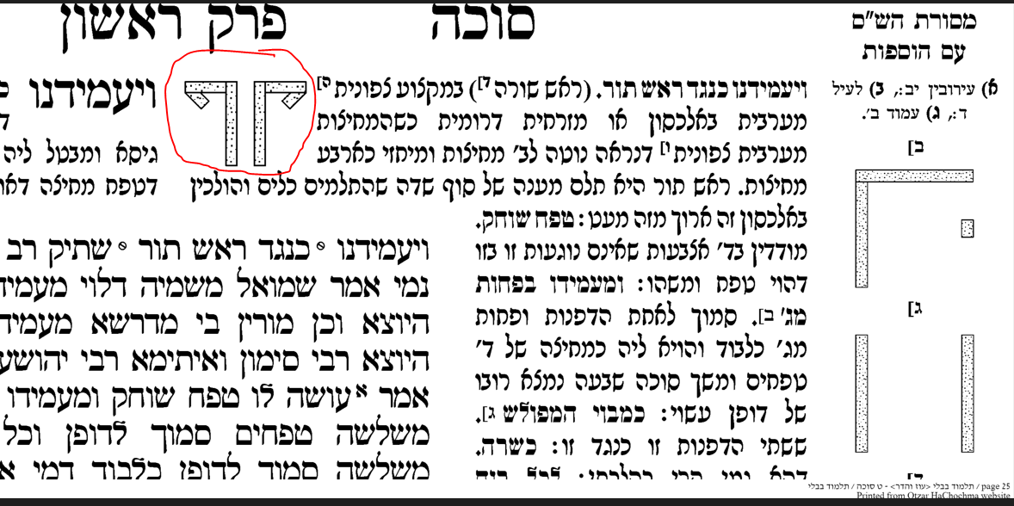

Oz VeHadar Murchav Jerusalem 2016 – Just MaHarshal but on the side

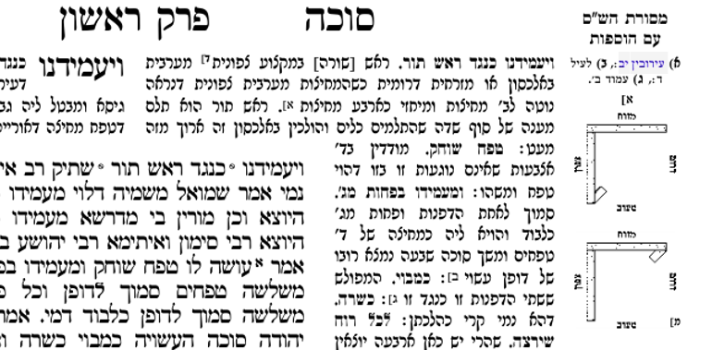

Oz VeHadar Friedman 2018 and 2021 – changed from 2006 and 2016. Now includes MaHaram’s opinion

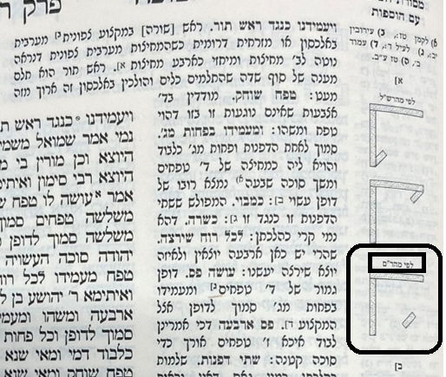

*Was this truly a radical step?*

It turns out that the Amsterdam 1717 edition of Sukkah anticipated by 300 years the Oz VeHadar 2018 edition by including both MaHarshal and MaHaram Lublin’s opinion! (״כזה או כזה״)

Amsterdam 1717[8]

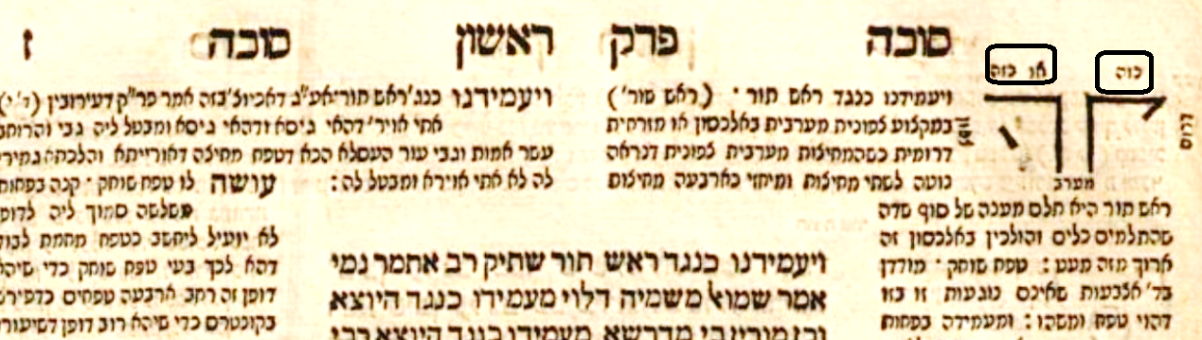

1. There are two opinions as to why Rav was silent. One opinion is that he agreed with the question and the other is that he dismissed the question.
2. The MaHarshal writes that the two diagrams on the bottom belong “בסוף הדף”, (on the bottom of Sukkah 6b), yet we find that particular Rashi on the top of 7a. The situation is explained by the fact that the Chochmas Shlomo was based on the second Bomberg edition printed in Venice in 1526.

   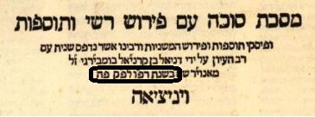

   Maharshal compared the Nusach of the Bomberg edition with Kitvei Yad which he had. He sometimes suggested Hagahot M’Sevara and he often filled in diagrams which were missing from Bomberg. In this case, Sukkah 6b looked like this

   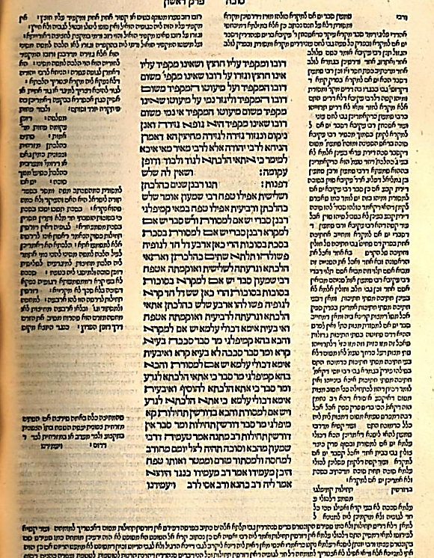

   Bomberg left a space for a diagram in the middle of the Dibbur HaMatchil of Kneged HaYotzei, and a space for another diagram at the very end of that comment. We know that the drawing of Maharshal applies to the first Rashi on 7a because it indicates the place where the “**תור**” should be, something discussed in that Rashi 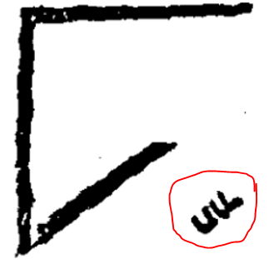 ויעמידנו כנגד ראש **תור.** There was no space left on 7a for this diagram
3. This is noted by the Oz Vehadar edition of 2021 which writes

   

   רע״א=Rosh Amud Aleph
4. Other editions of Shas which included the Chochmas Shlomo did not treat this comment so well. For example,

   this is from a Shas printed in Vienna in 1812. It is unclear which picture the words “שם בסוף הדף כזה” is referring to. Also, look at how “תור”is spelled.

   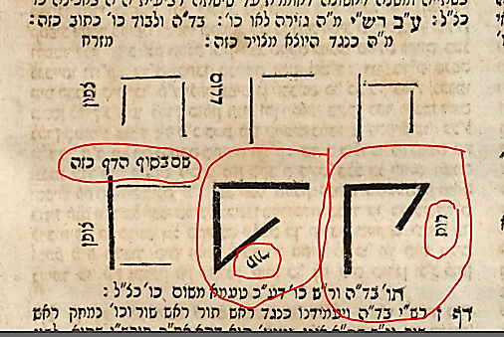
5. It is possible that the source of the error of the Vilna Shas came from the Warsaw Shas printed in 1880. The Nusach is very similar, even to using a Gimmel as the identifier.

   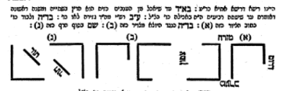

   Warsaw 1880

   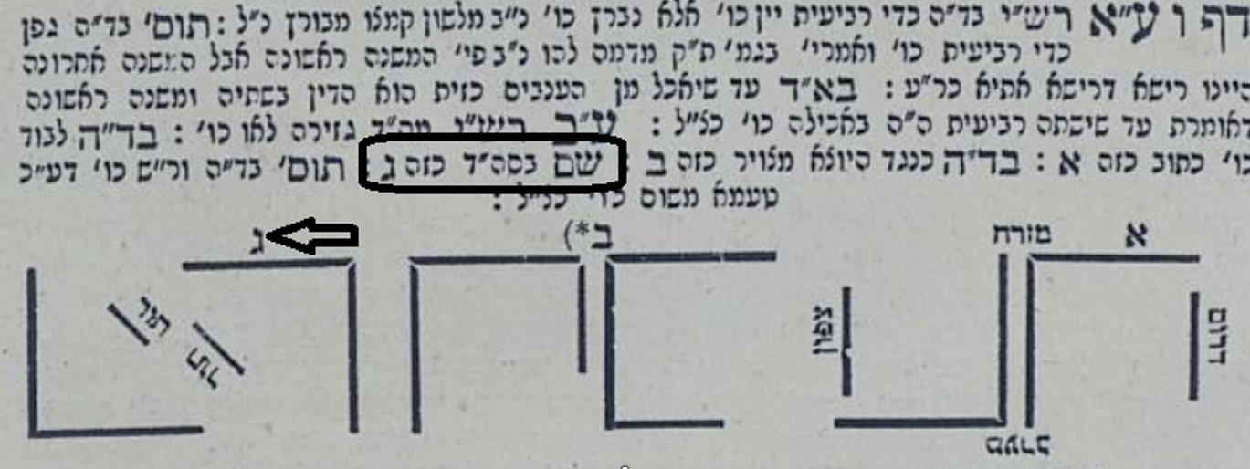

   Vilna 1881
6. This mistake is not noted in HeAkov L’Mishor even though he notes a different mistake in MaHaram Lublin

   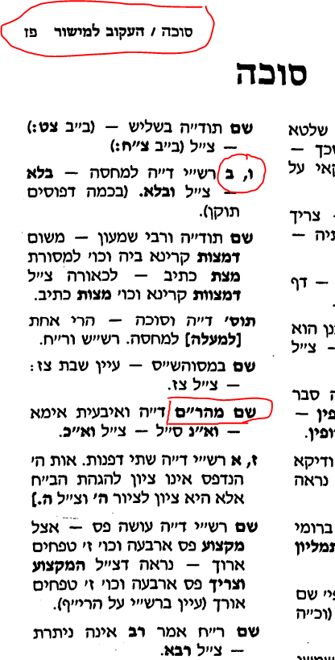
7. You will note that the diagram in the Soncino Pesaro edition is different than the diagram which MaHarshal drew, something which will be discussed subsequently.
8. Ahrend

   

   