Sukkah 7b - סוּכָּה הָעֲשׂוּיָה כְּכִבְשָׁן
Eli Genauer
What is the origin of the illustration of a circle which appears in the text of the Gemara?
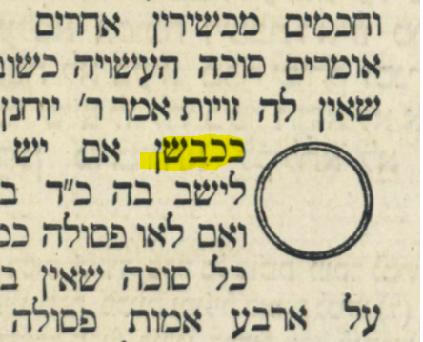

The Gemara on 7b states that “אֲחֵרִים” are among those who maintain that only a Sukkah which is like a Dirat Keva is Kosher
אָמַר אַבָּיֵי: רַבִּי, וְרַבִּי יֹאשִׁיָּה, וְרַבִּי יְהוּדָה, וְרַבִּי שִׁמְעוֹן, וְרַבָּן גַּמְלִיאֵל, וּבֵית שַׁמַּאי, וְרַבִּי אֱלִיעֶזֶר, וַאֲחֵרִים — כּוּלְּהוּ סְבִירָא לְהוּ: סוּכָּה דִּירַת קֶבַע בָּעֵינַן
Translation from Rabbi Steinsaltz provided by Sefaria.
The Gemara proves this from this statement of אֲחֵרִים
אֲחֵרִים — דְּתַנְיָא, אֲחֵרִים אוֹמְרִים: סוּכָּה הָעֲשׂוּיָה כְּשׁוֹבָךְ — פְּסוּלָה, לְפִי שֶׁאֵין לָהּ זָוִיּוֹת.
Acḥairim, as it is taught in a baraita that Acḥairim say: A sukka built in a circular shape like a dovecote is unfit, because it does not have corners, and a permanent residence is one with corners.
Rabi Yochanan disagrees with אֲחֵרִים and maintains that another type of round structure (a כבשן) could be used as a Sukkah
אָמַר רַבִּי יוֹחָנָן: סוּכָּה הָעֲשׂוּיָה כְּכִבְשָׁן……..
Rabbi Yoḥanan said: With regard to a Sukkah that is shaped like a furnace and is completely round………)
This translation by Rabbi Steinsaltz follows Rashi who states that a כבשן is round.
Rashi actually tells us two things. 1. That a כבשן is round 2. That Rabbi Yochanan disagrees with אֲחֵרִים who say that a round Sukkah is not Kosher.
ככבשן – עגולה, דלית ליה כאחרים
It’s clear that the text of the Gemara that Rashi used did not have a circle drawn in near the word כבשן. If the text of Rashi’s Gemara contained such a circle, why would Rashi need to tell us that a כבשן was round?
All other Rishonim felt the need to explain that a כבשן is round, thereby indicating their text did not contain a circle.
Ritva’s Gemara text did not have a circle drawn on it, because in explaining the word כבשן, he says “meaning, it is round”
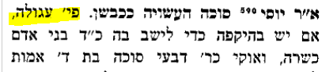
Rabbeinu Chananel had another Girsa, which explained in the body of the text that a כבשן was round. His text also had no need for an illustration , as “round” is “round”.
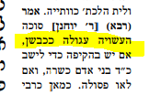

Nevertheless, this is the way it appears in Masechet Sukkah in the Vilna Shas (1882). The picture shows us that a כבשן is round without having to consult Rashi.
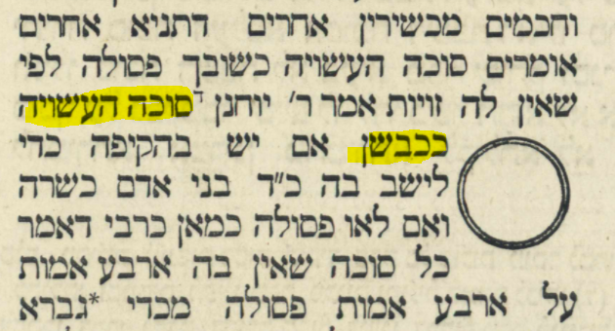

The first evidence we find of the circle within the Gemara text is Soncino Pesaro c.1515. The overarching question is what was the source for Soncino Pesaro putting in this picture within the Gemara? Presumably, it was based on a manuscript of the Gemara that was available to them.
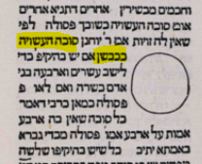
Bomberg/Venice 1521 which was based on Soncino, left an empty space in the Gemara text presumably for a circle
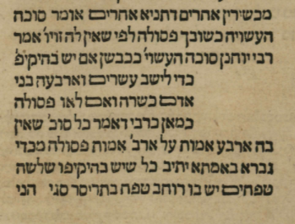
The space remained empty in Basel 1580
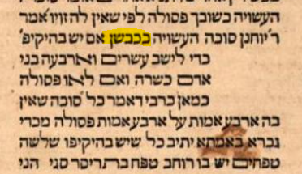

It finally appears in a printed manner (though somewhat oversized) in Frankfurt/Oder 1698
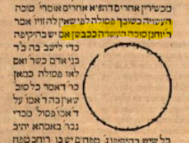
The Frankfurt/Oder edition followed the directions of Chochmat Shlomo (Cracow 1582) which specified that the circle should go in the text of the Gemara.
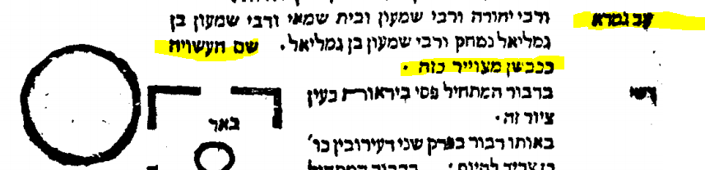
However, none of the 6 manuscripts of this Gemara on the Hachi Garsinan website of the Friedberg Manuscript Society reflect this illustration https://fjms.genizah.org/
BL Harley 5508
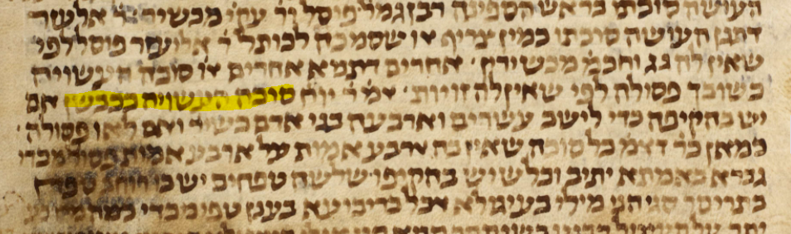
Munich 140
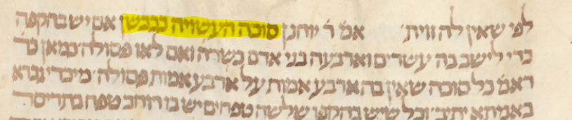

Munich 95
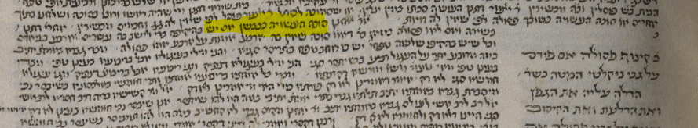
JTS Rab 218
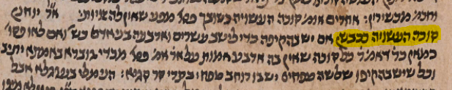

JTS Rab 1608
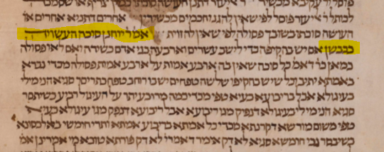
Oxford heb e 51
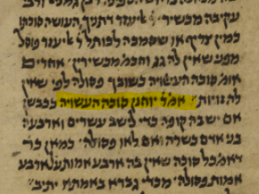

Hillel Geshuni of the Friedberg Manuzcript Society stated “I do not know any manuscript of the Gemara that had drawings, except for those with Rashi.”

All of the Rishonim explain that a כבשן was circular, thereby indicating that the manuscripts they were using did not include a drawing of a circle. None of the manuscripts available to us have such a drawing either. On the other hand, the Dfus Rishon which was based on a manuscript included a drawing of a circle and Maharshal indicates that the circular drawing be included in the text of the Gemara.
צריך עיון

